

NOTE :

In this Service Manual, no information is repeated from the Operation Manual, as it may be
appreciated.

Service should only be done by persons who have mastered the servicing and
maintenance of this device, as well as having further qualifications, especially in the areas
of electronics and physics.

We ask the users of this Service Manual bring to our attention any possible mistakes.
We would also appreciate any suggestions for supplements and improvements to this
Service Manual.


CAUTION !

Before opening this device, always unplug the main power !

Service Manual CS-800
as from Serial No. 0951000xxx

0.1 Overview of the CS-800 modifications 0.1-5
1 FAULTS
1.1 IR-cell test display ++++ see 2. 3 1
1.2 Gas flow too high or too low 1
1.3 The gas flow rate fluctuates 1
1.4 No combustion 1
1.5 Bad combustion 1
1.6 Electronic drivers malfunctioning 1
1.7 The furnace does not close 1
1.8 The analysis takes too long 1
1.9 Development of dust when closing the furnace 1
1.10 Erratic results 1
1.11 The results are always 0.0000% or 00.0 ppm 1
1.12 Beeper responding 1.12-1
1.13 The life time of the combustion tube is too short 1
1.14 The LED for the infrared cell temperature regulation does not flash 1
1.15 The fuse burns out at the beginning of combustion 1
1.16 The fuse blows at the end of the analysis 1
1.17 Large collection of dust when opening the furnace 1
1.18 No or low oxygen pressure 1
1.19 Saved data are lost 1
1.20 Noise or drift of the infrared baseline 1
1.21 Dust in the oxygen carrying tube when the furnace opens 1
1.22 The word Eltra appears on the display 1
1.23 The oxygen pressure falls when the furnace opens 1
1.24 Combustion without pressing " START " 1
1.25 The crucible cracks or melts 1
1.26 The analysis doesn´t start 1.26-1
1.27 Vibrations on setting 2 1.27-1
1.28 The analysis cycle stops only 25 seconds after start 1.28-1
1.29 The chopper motor doesn`t rotate 1.29-1
1.30 High carbon results are erretic….…………………………………………………..1.30-1

2 ADJUSTMENT, TEST AND FUNCTION EXPLANATIONS
2.1 Gas flow controller adjustment and jumper setting 2.1-1
2.2 Pressure switch 1
2.3 Infrared zero-baseline, control and adjustment 1
2.4 IR-source voltage setting 1
2.5 Temperature regulation of the IR-cell 1
2.6 Pneumatics 1
2.7 Pressure regulation 1
2.8 Closing cone, adjustment 1
2.9 Linearisation 1
2.10 Programming the balance 1
2.11 1
2.12 Induction generator control 1
2.13 Diagnostic printous 1
2.14 Setting check up 2.14-1
3 SERVICE
3.1 IR-paths, cleaning and replacing 3.1-1
3.2 IR-source 3.2-1
3.3 Infrared electronics 3.3-1
3.4 Infrared power supply 3.4-1
3.5 Chopper ++++ see 3. 2 3.5-1
3.6 Infrared temperature regulation 3.6-1
3.7 Leak checking 3.7-1
3.8 Replacing EPROMs 3.8-1
3.9 Clearing memory 3.9-1
3.10 Electronic reset 3.10-1
3.11 Coding IR-ranges 3.11-1
3.12 Adding new channels 3.12-1
3.13 Cleaning the solenoid valves 3.13-1
3.14 Replacing the flow sensor 3.14-1
3.15 Installing an AC-power stabiliser 3.15-1
3.16 Additional safety features for furnace pneumatics (optional) 3.16-1
3.17 Installing a halogen trap 3.17-1
3.18 Gas saving mode 3.18-1
3.19 Upgrade for copper analysis without accelerators 3.19-1
3.20 Upgrading of analysers with electronic rack for
using the new Windows software 3.20-1

4 MISCELLANEOUS
4.1 Ordering numbers 4.1-1
4.2 Wiring and gas flow diagrams 4.2-1
4.3 Starting through external key 4.3-1
4.4 External report of analysis condition 4.4-1
4.5 Spare parts kits 4.5-1
4.6 Maintenance CS-800 4.5-1

0.1 Overview of the CS-800 modifications:

Up to S/N0766xxxxxx

The CS-800 analysers are equipped with a flow sensor with optical elements and with the
corresponding board HF-3 and HF-4.

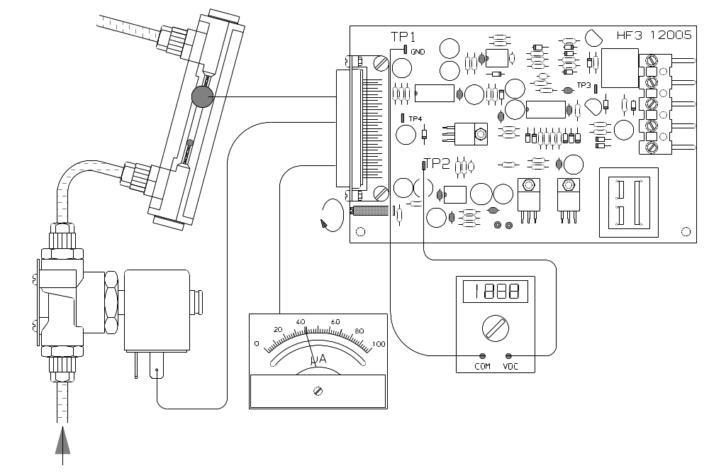

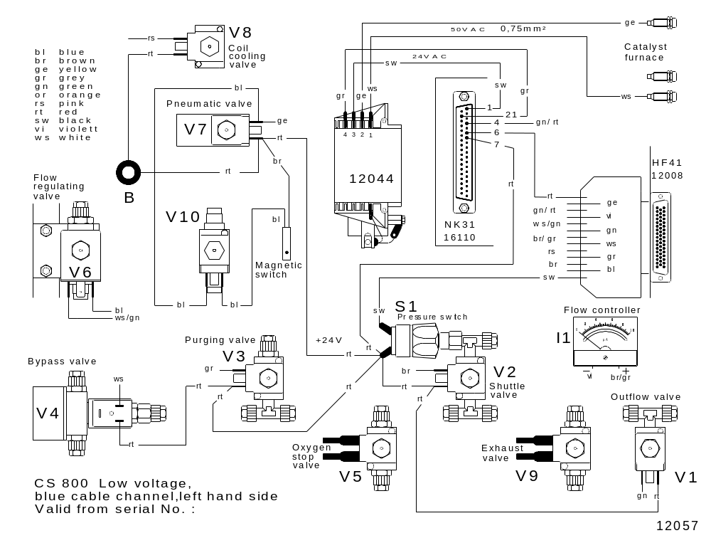

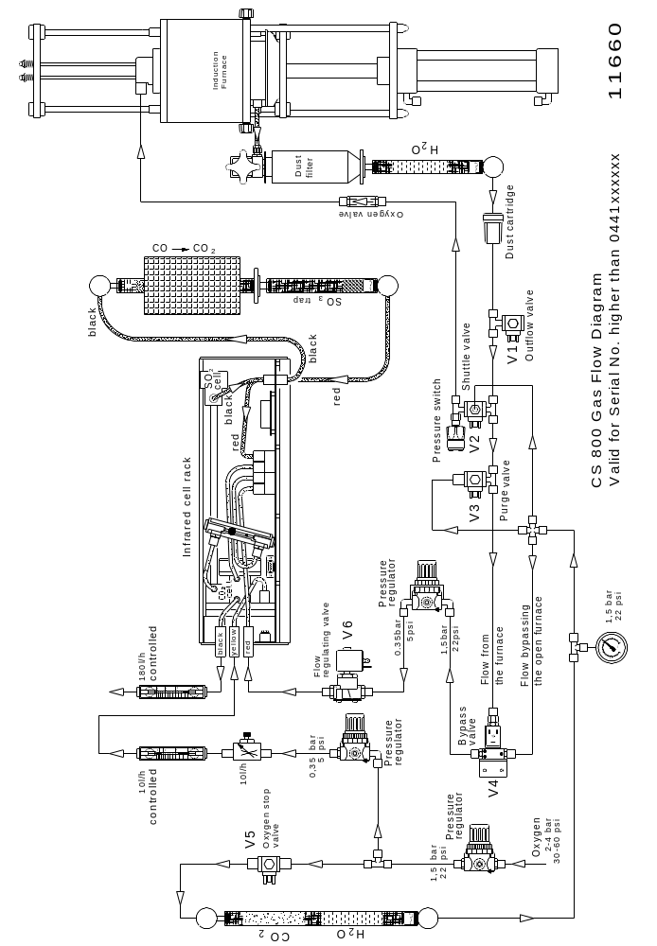

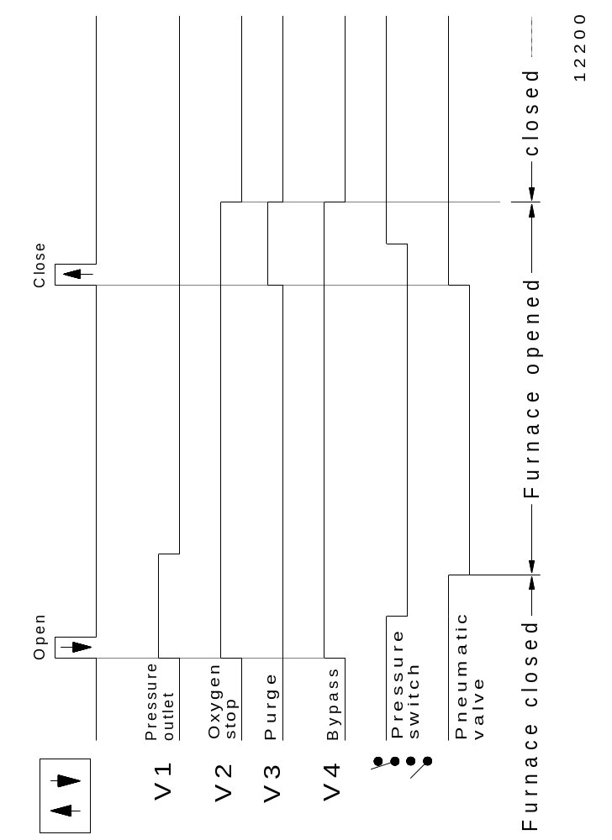

From S/N 0767xxxxxx

The CS-800 is equipped with a flow sensor employing a pressure transducer, and with the
corresponding boards HF-41 and later the HF-42.
These boards also offer:

- Current limit for the induction furnace ( on board HF 41/42 adjustment )

- Oxygen flow only during combustion ( on board jumber )

- Gas saving mode by controlling the oxygen flow ( start / stop ) by the software

This function has been included later in the software, from SN / 1080xxxx
Analysers from SN / 0767 to SN / 1079 can be upgraded with this function.
For description see “corresponding service manual”

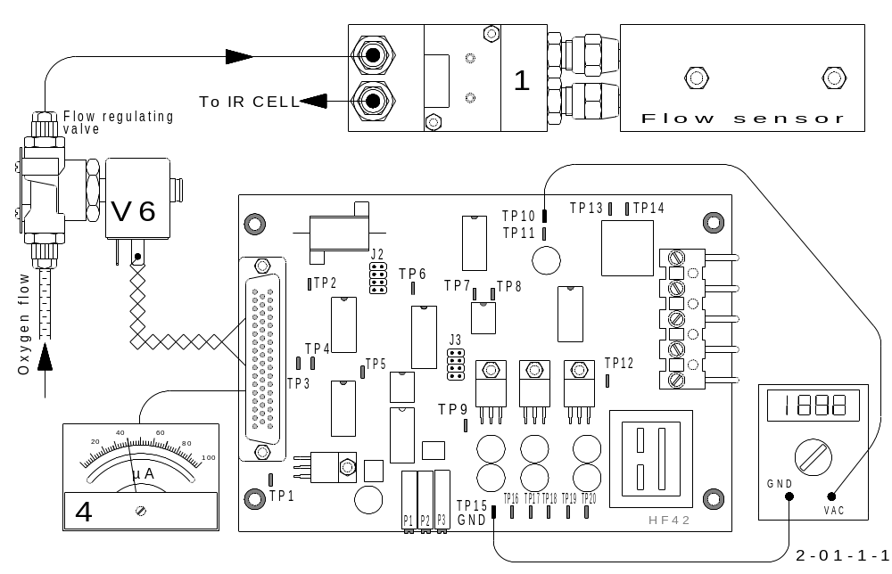

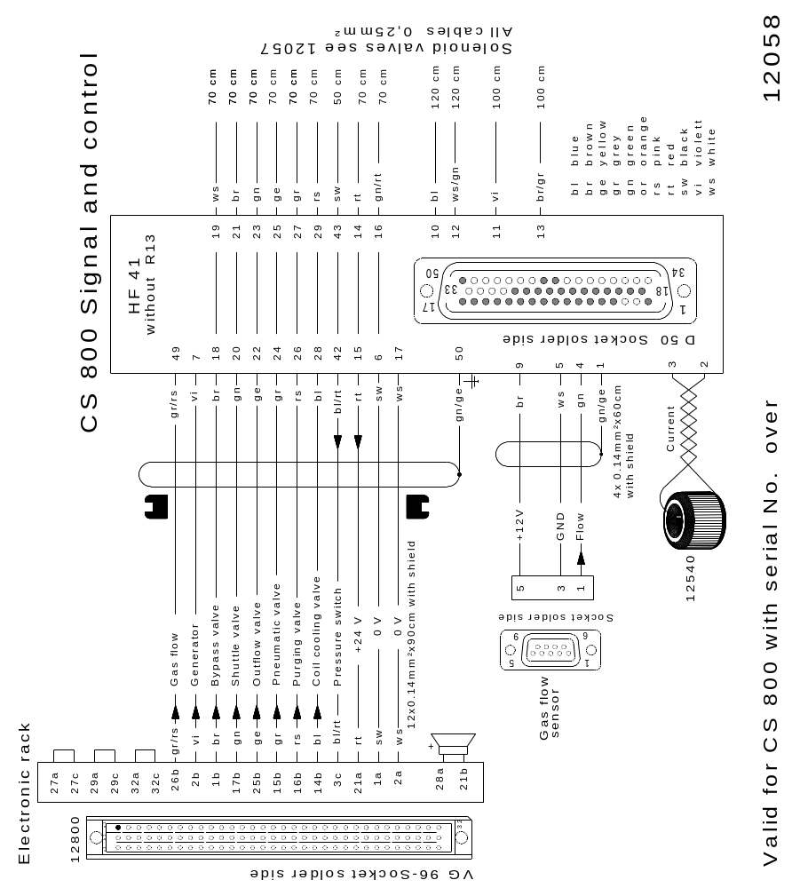

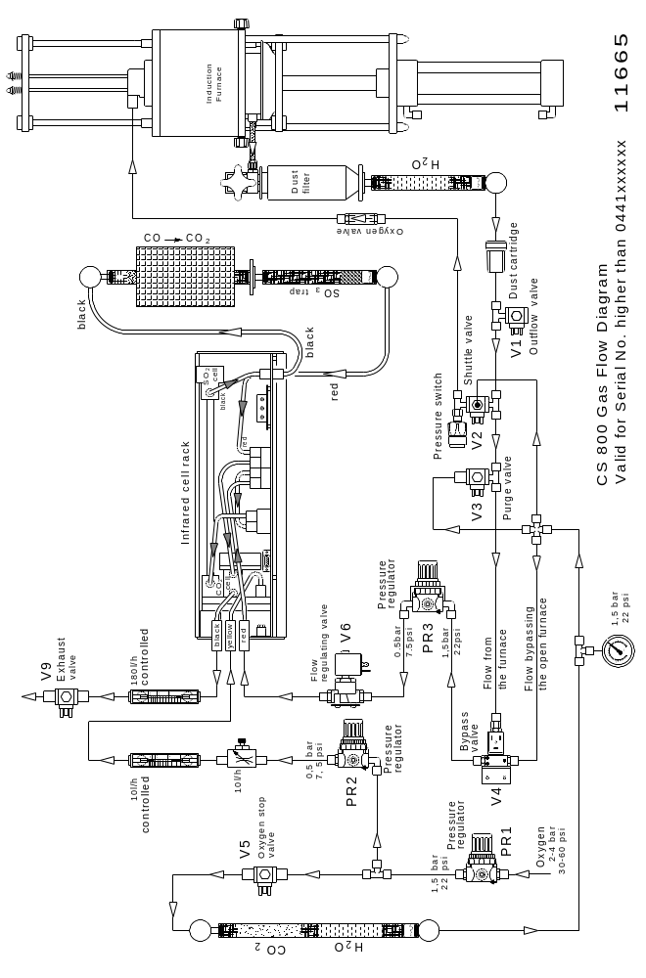

From S/N 0951xxxxxx

The CS-800 has an additional purging inlet on top of the combustion chamber.

- The position of the solenoid valves is rearranged and their controlling software is modified accordingly. Therefore, a very good care has to be taken when changing the EPROMS.

- The wiring has also changed. It has been modified to be used with the IR-4, and the four IR-cell rack. As the 4-cell software was not available, the CS-800 was equipped with the still available with the 3-range IR-cell using an adapter and the 3-cell software
up to SN / 1079xxxx.
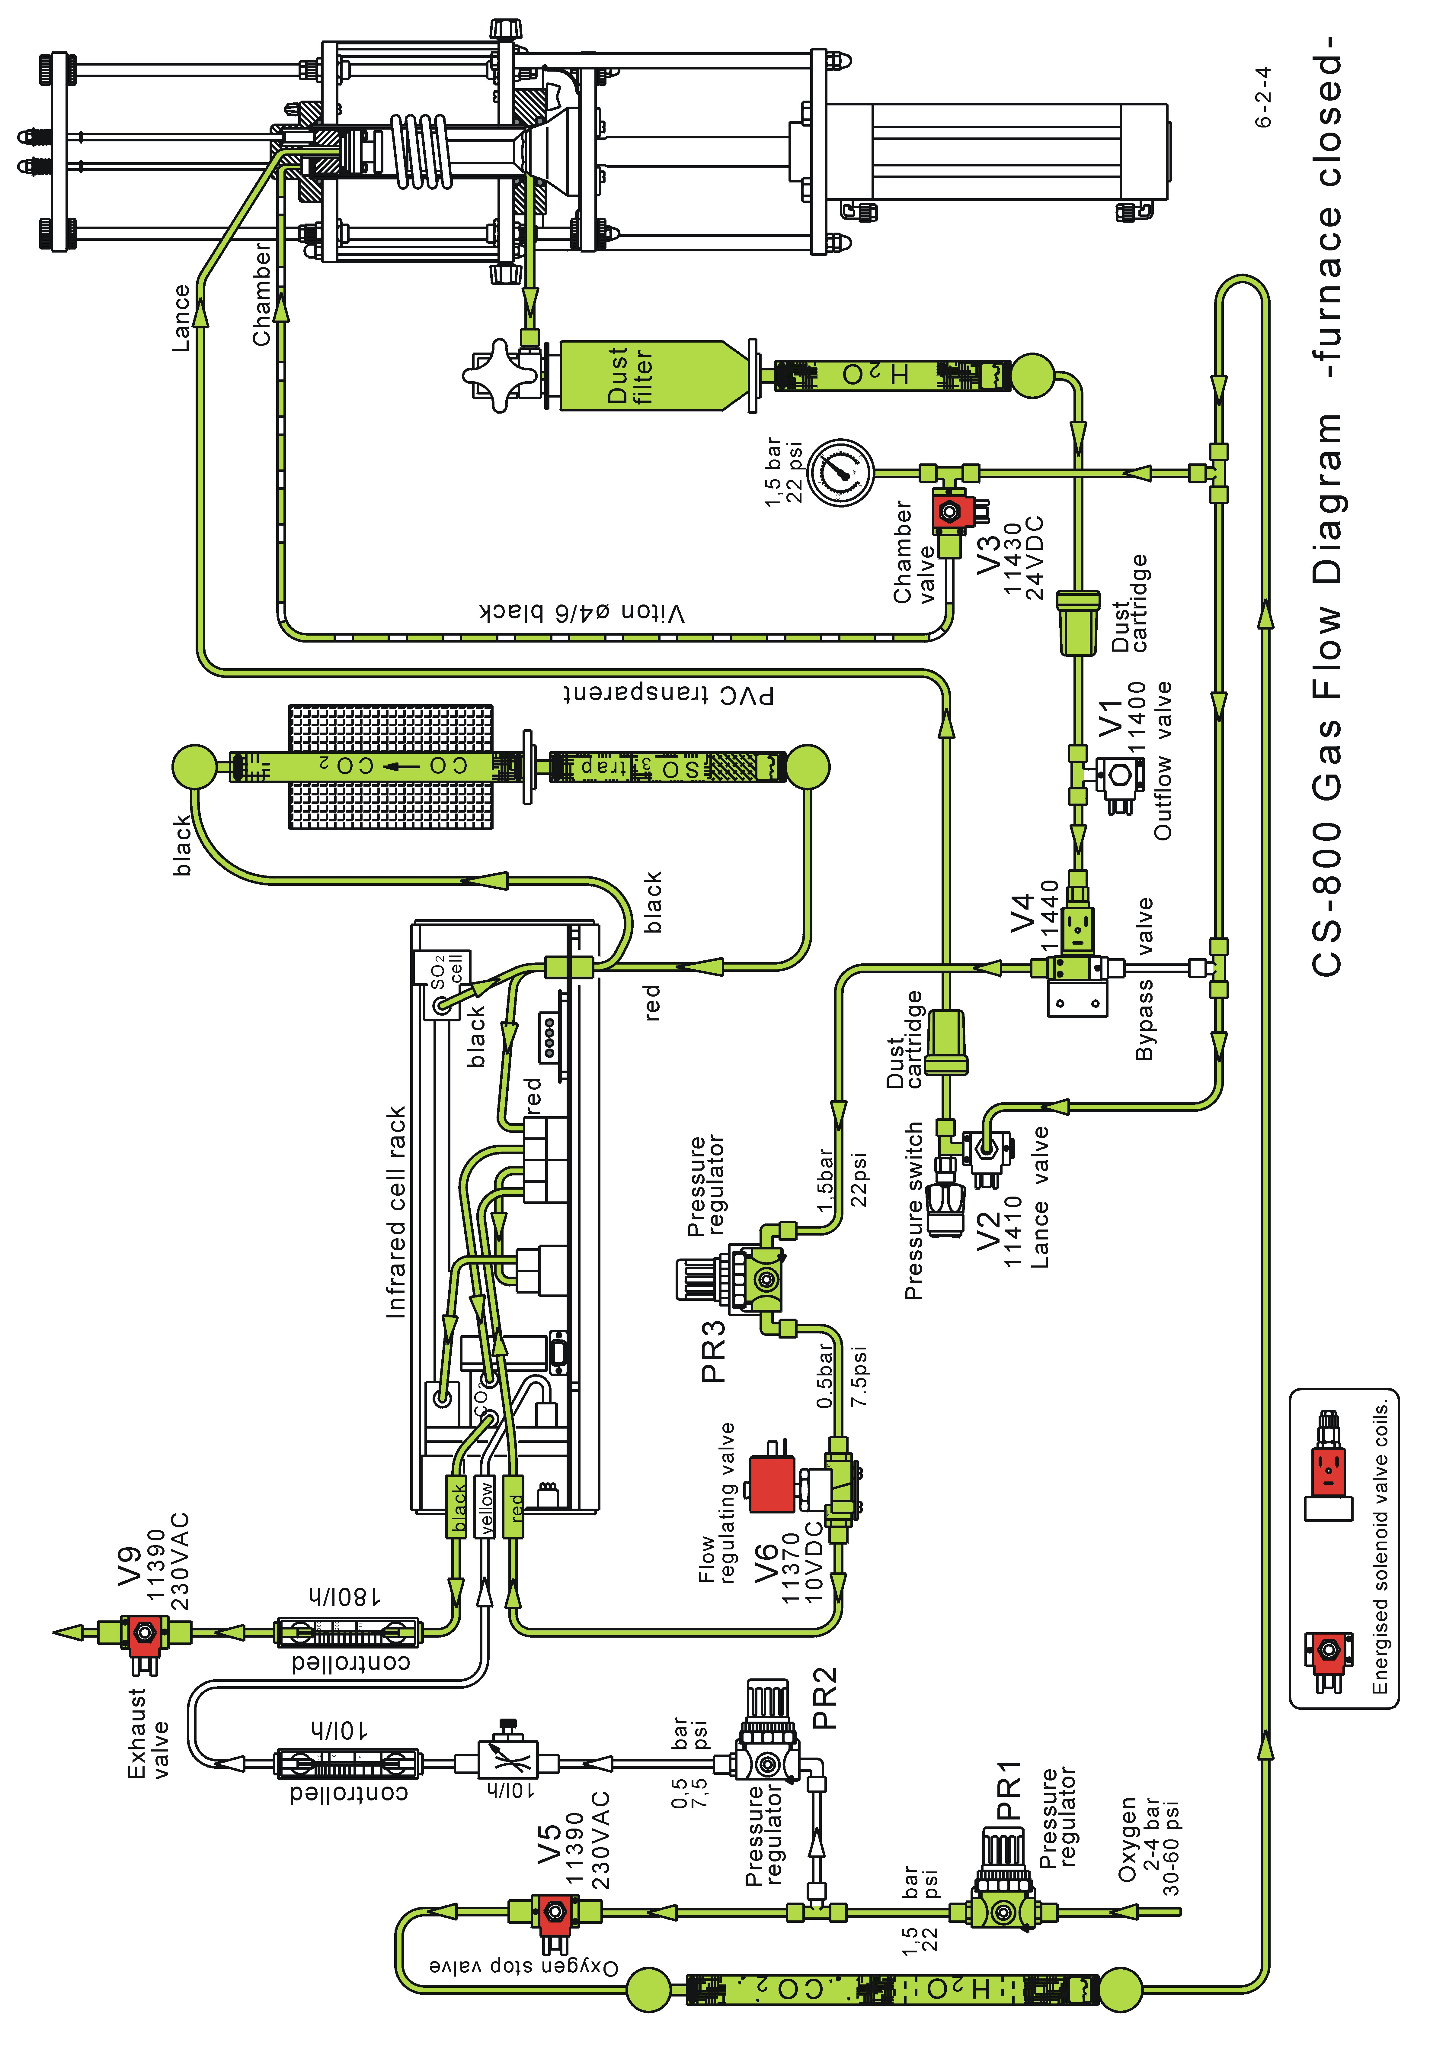

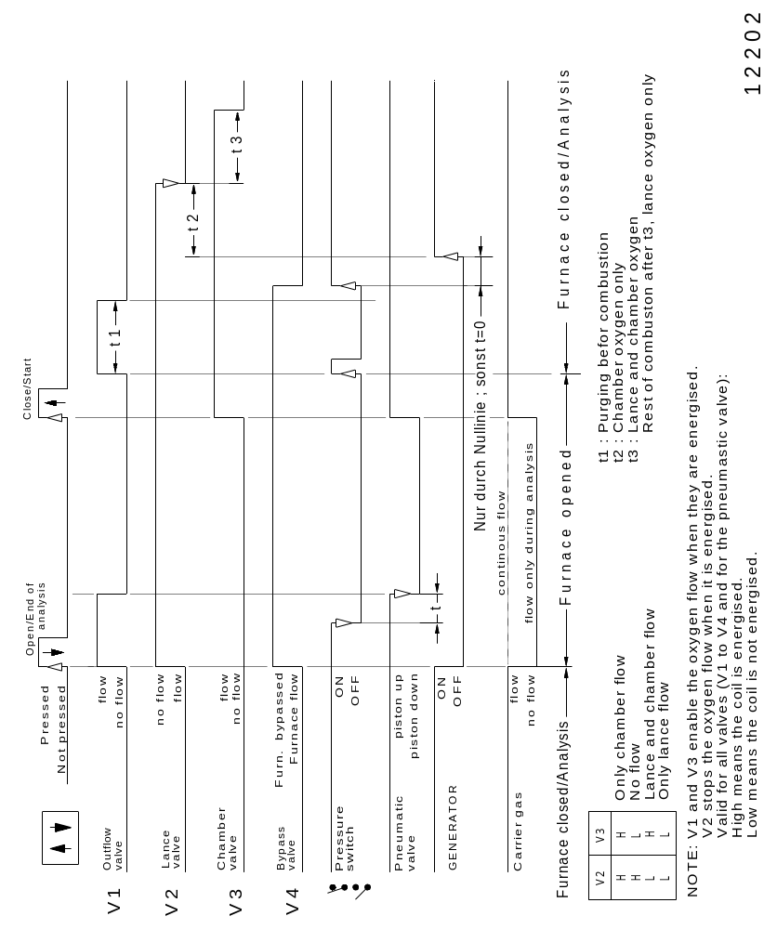

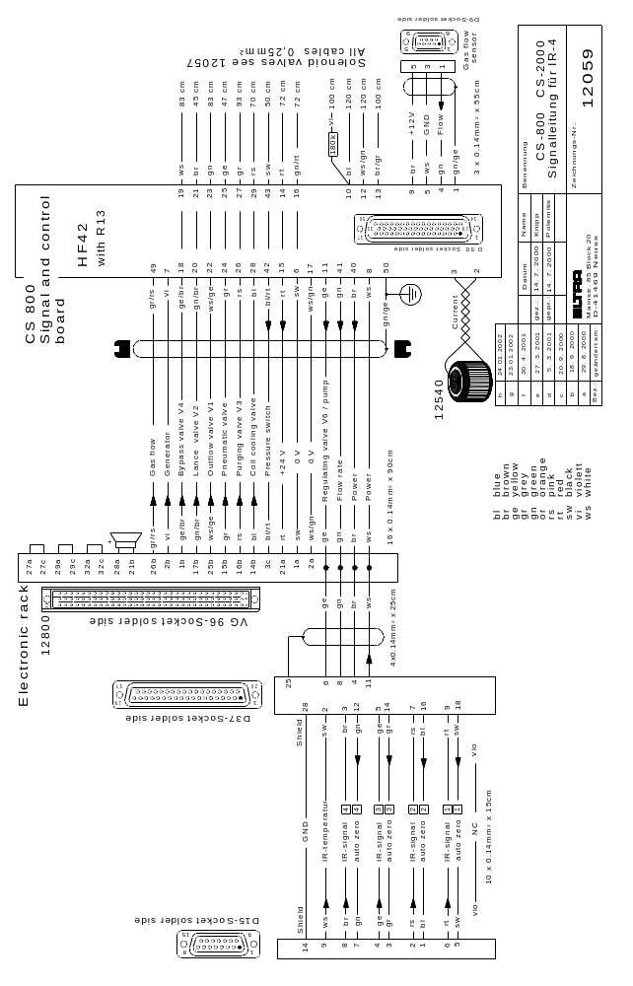

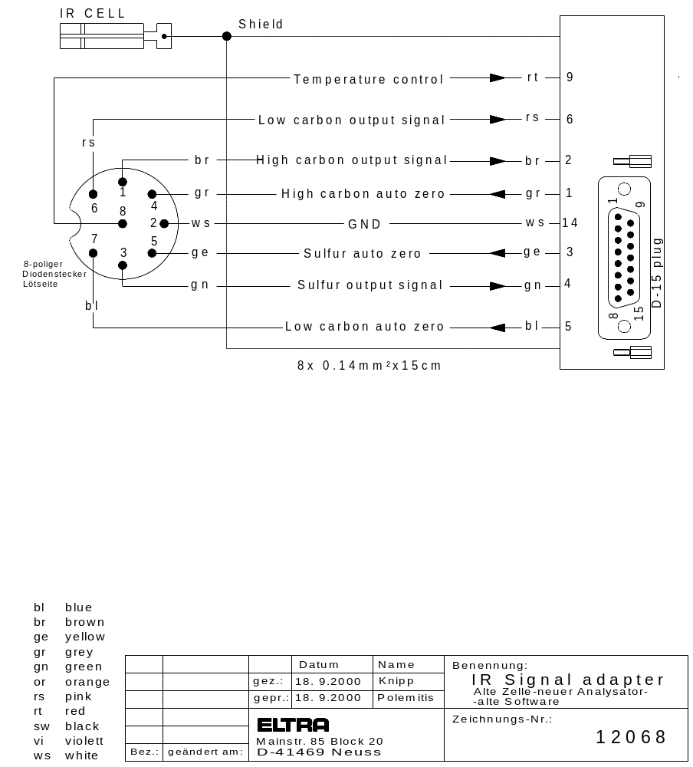

From S/N 1080xxxxxx

The CS-800 is equipped with the four IR-cell rack. All electronic boards as well as the chopper motor ARE DIFFERENT to those of the previous 3-range IR-cell.

The software changed to the four IR-range version !!!

The gas saving mode is available and selectable in the PC software PLOTCS.
When an analysis has not been carried out for a period of time, the analyser will
automatically switch to “ Gas Conservation Mode “. This effectively means the carrier gas flow rate is reduced to a minimum, only < allowing a small amount of oxygen to circulate through the IR-cell etc. The period of time before the Gas Conservation is activated, can be modified via the PC Software. It is also possible to have carrier gas flow only during combustion.
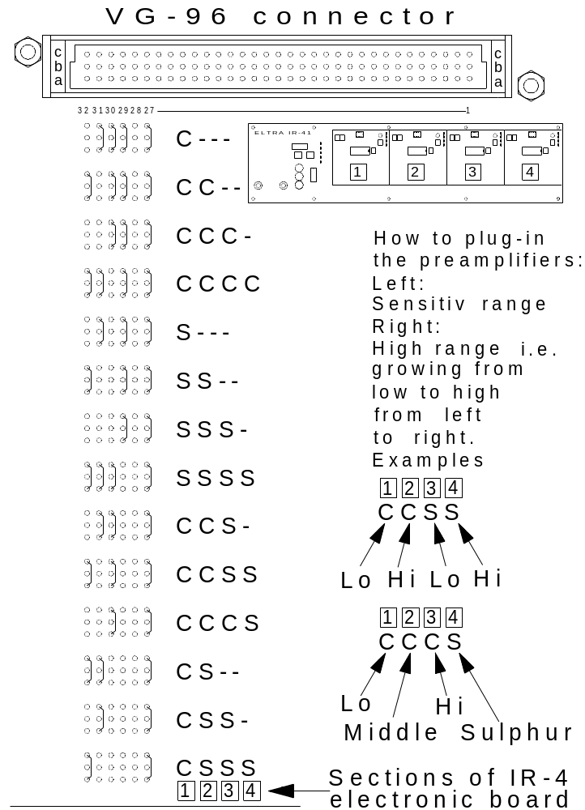

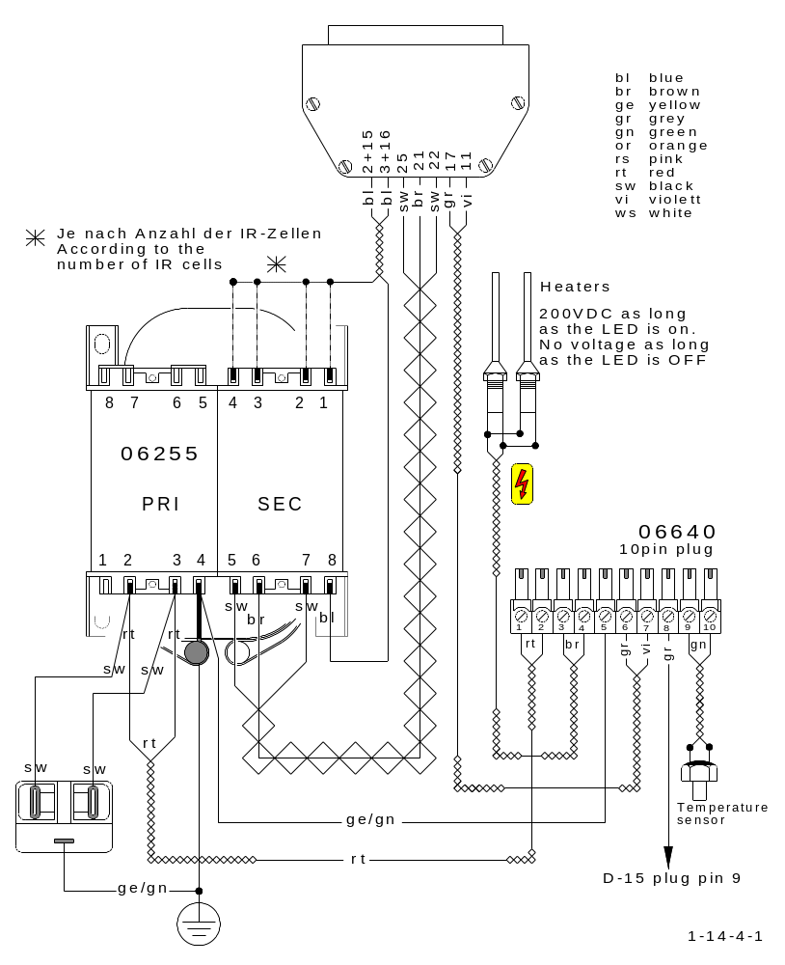

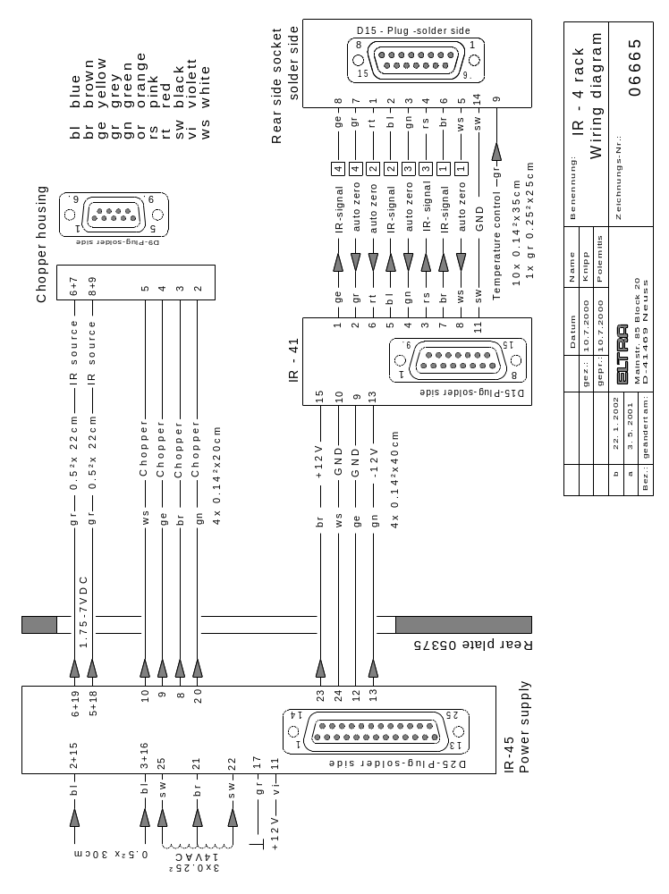

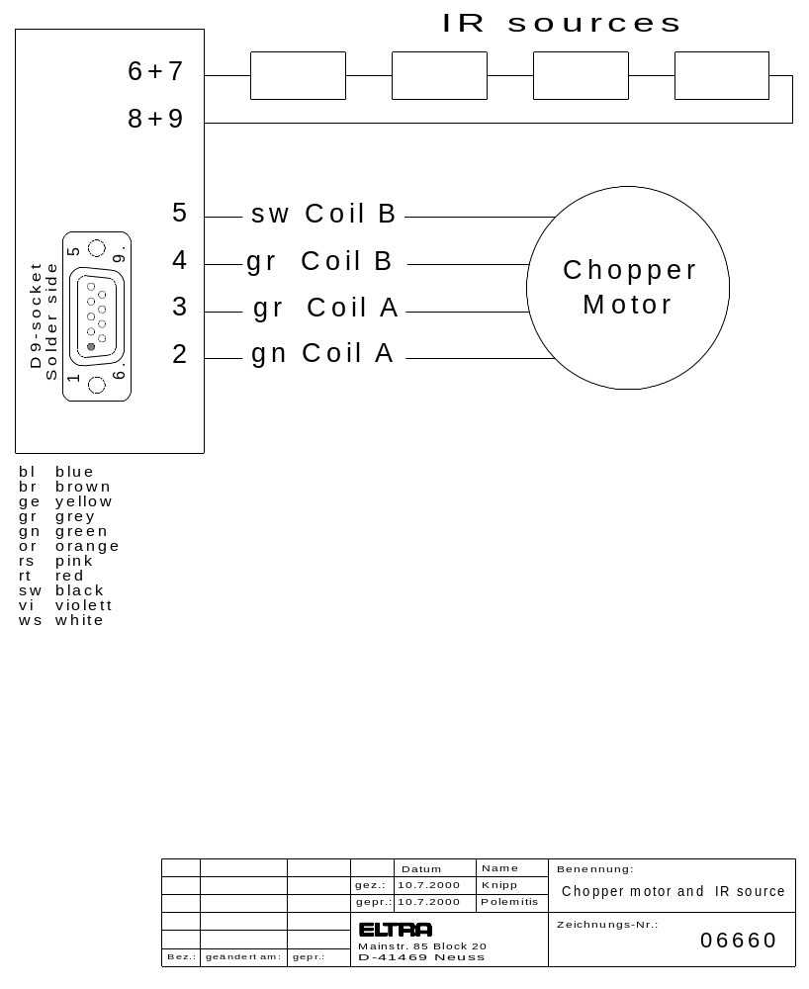

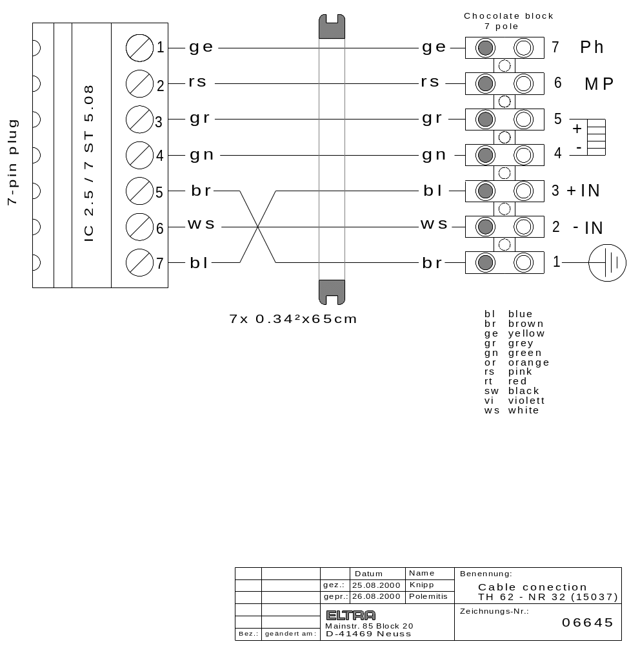

From S/N 1557xxxxxx

The electronic unit is replaced by the board UNI 1.3 and the electronic rack is removed. The corresponding wiring diagram is 12061.
The modification took place in the second half of 2004.
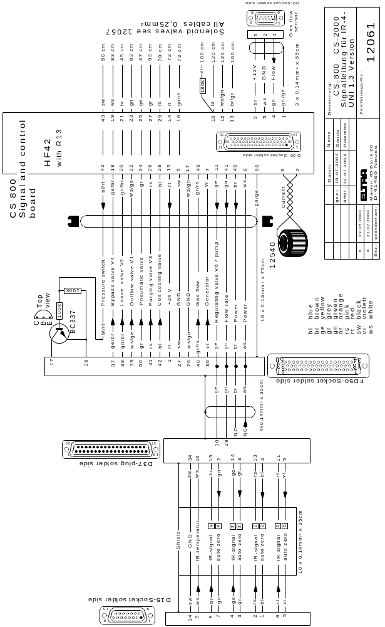

1 FAULTS

1.1 IR-cell test display: ++++ see 2. 3
also after five minutes of oxygen flow:
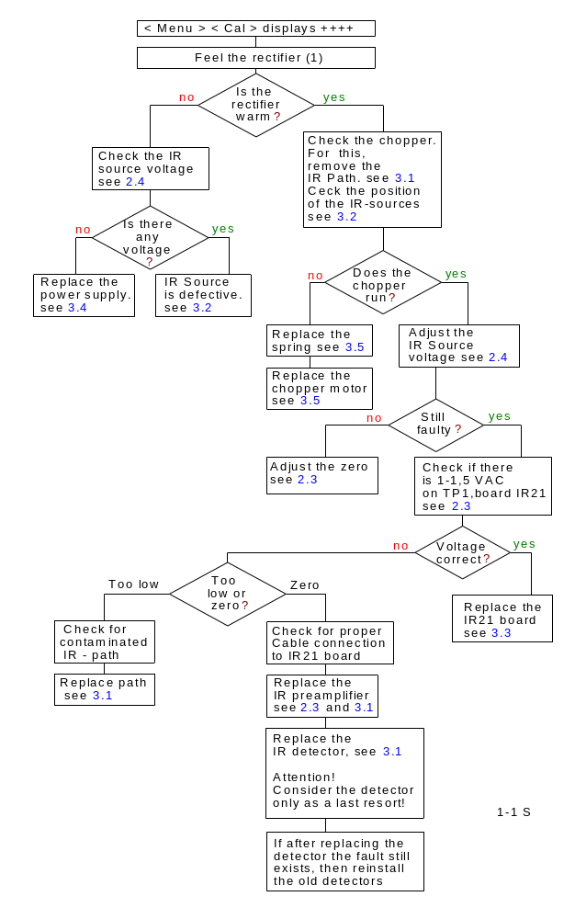
If the range is higher than 10 V, ++++
then the problems are as follows:

1). Too much contamination of
the IR-paths:
In case the analyser has more
than one cell, and if not all of
them shows ++++, then a
contamination is very likely.

2). The IR-Sources:
The sources are bent or
de-adjusted through
transport. See Remark:

3). Chopper:
The chopper is not running.
This is obvious when the paths
are clean and the IR-sources
are in place.

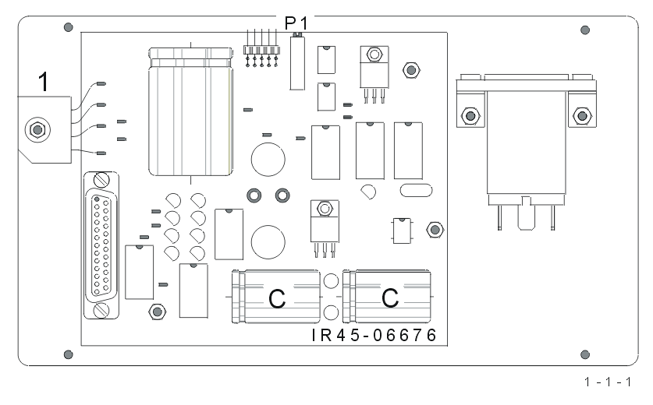

Remark:
In most cases the problem is
in the IR-sources or in the
power supply. During a rough
transportation the IR-sources
may be bent causing the
problem. See 3.2. We
experienced that it is very
popular for the new IR-detector
and preamplifiers. We can only help if you send
us a copy of the flow diagram of this chapter, after drawing a line along the path you followed according to the condition you found.
Asking for detectors, preamplifiers and boards. Without following this diagram is useless.

1.2 Gas flow too high or too low:

Valid for induction furnace operation:
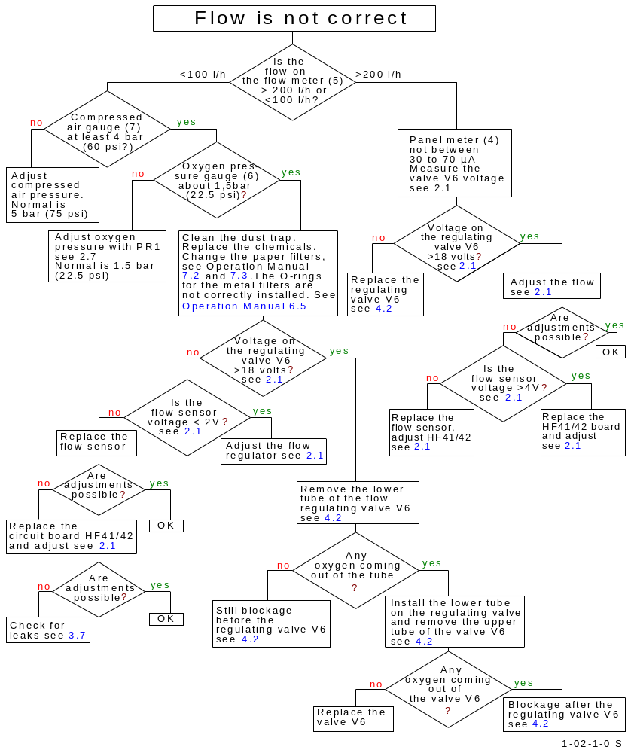

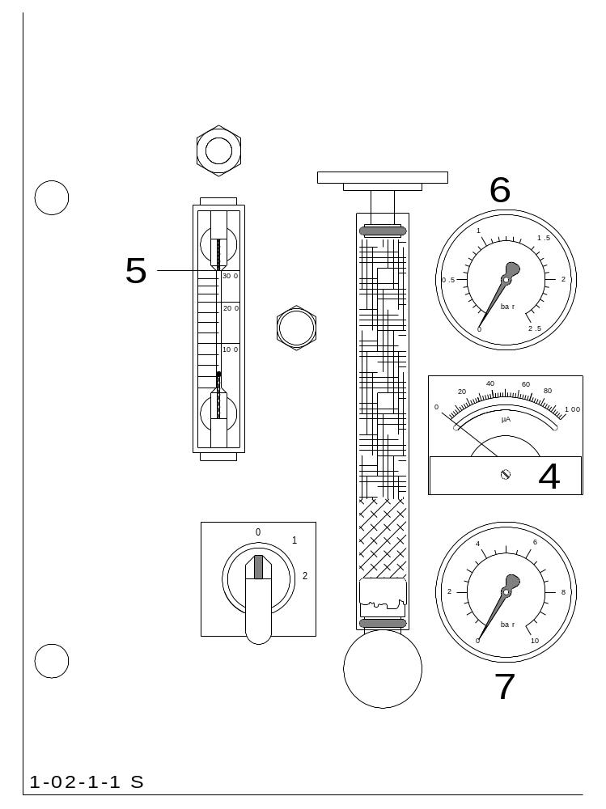

4 Panel meter indicating the control of the gas regulation valve
5 Gas flow meter 300 l/h
6 Oxygen pressure gauge
7 Compressed air pressure gauge

1.3 The gas flow rate fluctuates:

The flow rate is electronically regulated, therefore there should be no significant variation from the set value.
In case of a fault however, the automatic regulation of the flow rate is no longer possible and the gas flow fluctuates. This can be caused, for example, by an excessive obstruction of the gas flow system or by a faulty component hat needs to be replaced, see 1. 2 and
2. 1
Most of the time, the problem lies in the saturation of the dust trap or of the chemicals.

In case the flow becomes lower and the µA-meter goes higher during combustion, it is obvious that the flow regulator is working. Therefore the problem must be a restricted oxygen supply. When the accelerators start burning they take a lot of oxygen, so that the pressure in the furnace goes down, and as a result for this the flow also goes down.

The restriction can be in:
- the hole in the ceramic shield
- the furnace outlet
- the connection from the furnace outlet to the metal filter housing
- the inlet of the metal filter housing
- the metal dust filter
- the anhydrone
- the paper filter
- the filter cartridge

Please note that the restrictions can also be outside the analyser, for example a faulty pressure regulator on the oxygen bottle, a too low adjustment of the pressure on the regulator, not properly opened outlet tap of the regulator, a too long and too thin tube, or this tube is somewhere bent or pressed or, or, or.

If the problem is only a long thin tube, the problem can eventually be solved by increasing the pressure on the pressure regulator of the bottle.

As a hint, when you open the furnace the pressure on the analyser’s oxygen gauge should go from 1.5 bar down to 1.4 bar but not lower. If it goes much lower, it means that the incoming oxygen is restricted on the way from the bottle to the analyser.

1.4 No combustion:

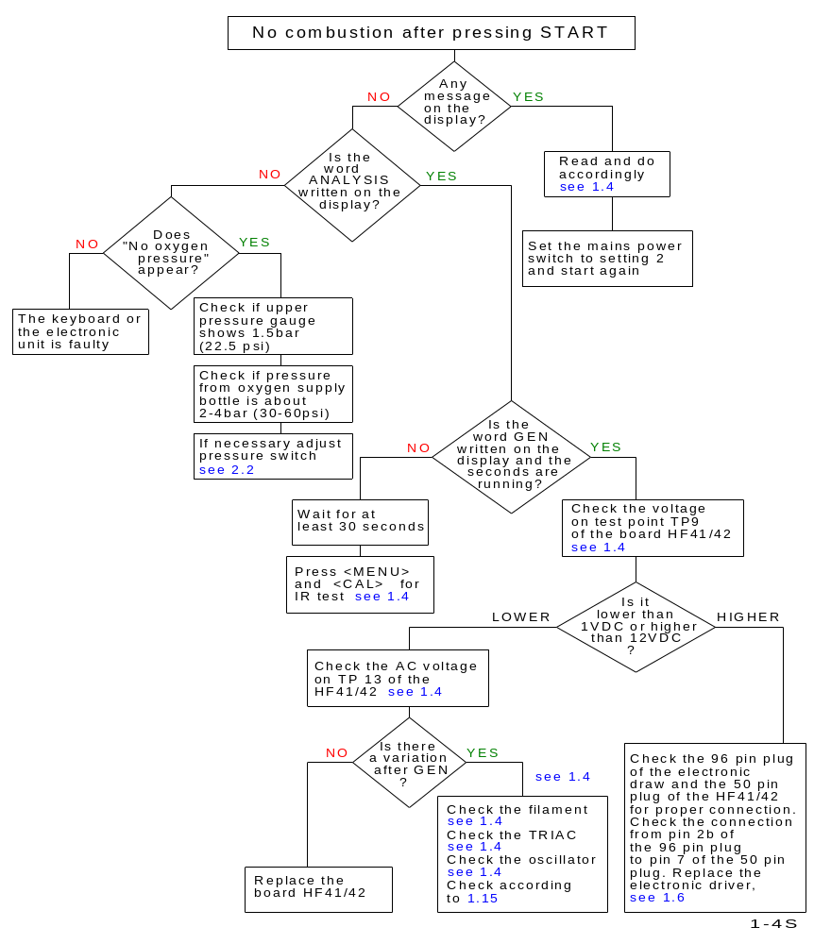
induction furnace operation

AFTER PRESSING < START >
"ANALYSIS" AND "GEN" APPEARS,BUT COMBUSTION DOESN’T TAKE PLACE.

- The command from the electronic unit to start the generator, is not received:
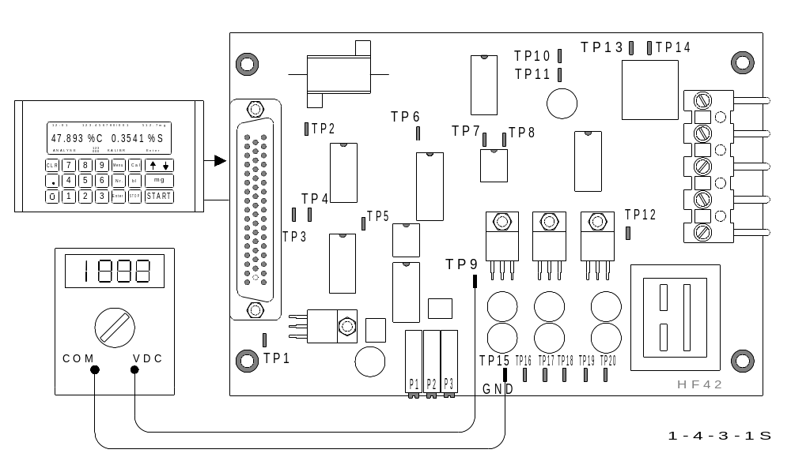

Measurements on TP9:
- a signal of about 0.5 V should turn the generator on,
- a signal of about 12 V should turn the generator off.
If 12 V are measured, despite "GEN" appearing on the display, then the electronic is
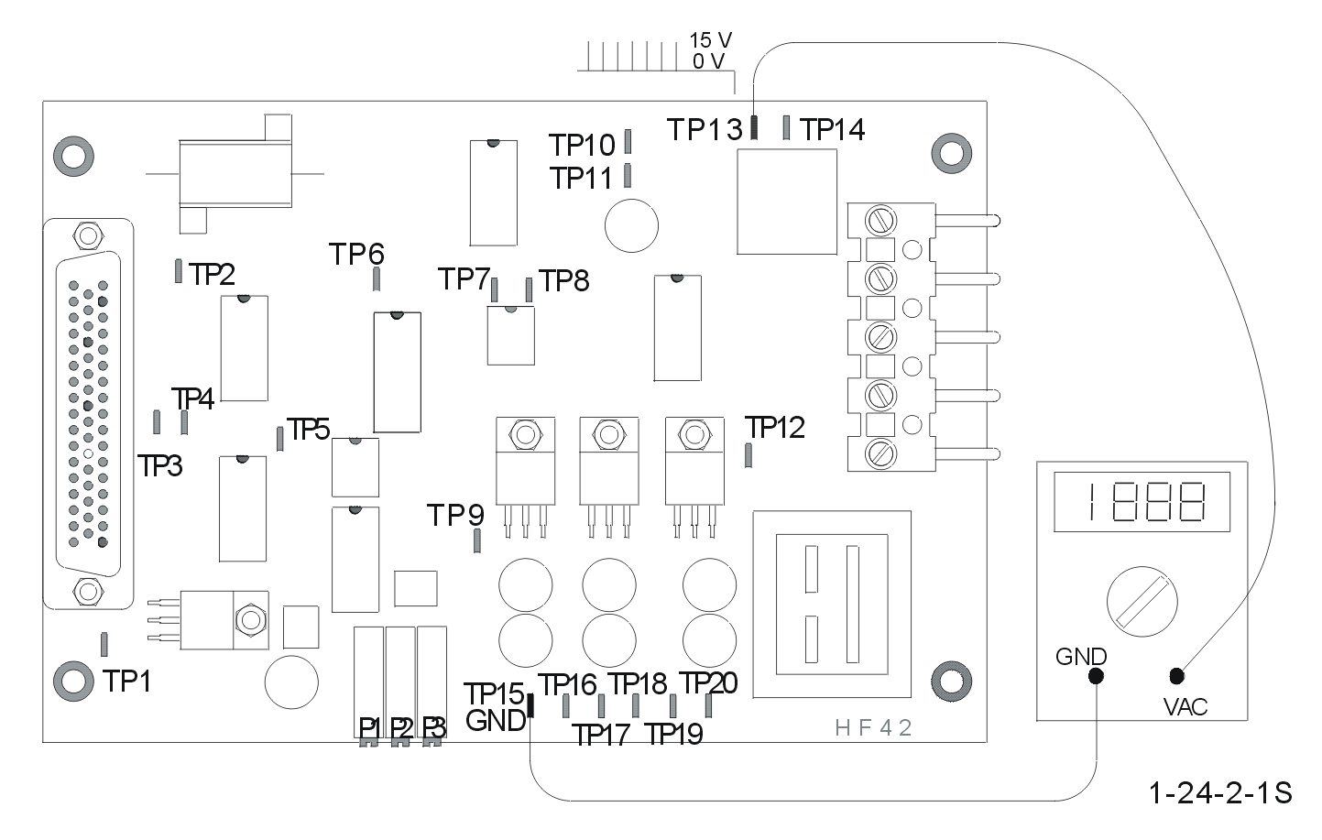
defective, see 1. 6; or the connection from the HF 42 circuit board, pin 7 is loose, see 4. 2.

When the command for
the generator is received
( 0.5 V DC ), the needle pulse must
appear on the TP13 test point. If
there is no oscilloscope available
you can test this with a digital
voltmeter.
The displayed value depends on
what type of digital voltmeter you
have. There must be a voltage
increase on TP13, once the word "GEN"
has appeared on the display, or once
0.5 V are present on TP9. When no voltage increase occurs on TP13, despite having
0.5 V on TP9; the HF 42 circuit board is defective.

CAUTION! After replacing the HF 42 board, make sure that the 50 pin plug is
properly inserted. It takes a lot of force to push in 50 pins at once.
50 pin plugs that haven’t been properly inserted are a frequent problem.
Tighten the screws of the plug properly, to ensure a proper connection to the board.
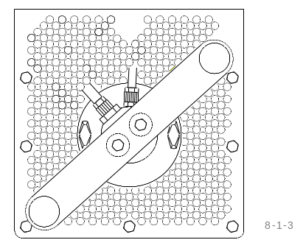
Checking the generator tube:
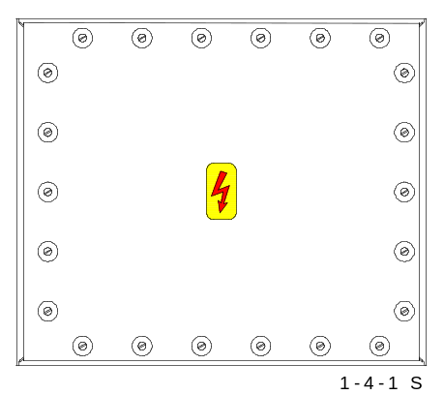
- Ensure that the power switch is at setting 2

- Check if the filament of the generator tube glows:
This can be easily checked:
through the air vent holes of the furnace,
the reflected light of the glowing filaments
( heater of the cathode ) should be visible.

If the light from the filament is not visible, then remove the
cover from the generator section, in order to see the tube.
WARNING ! HIGH VOLTAGE !

If the filament of the generator tube doesn’t glow:

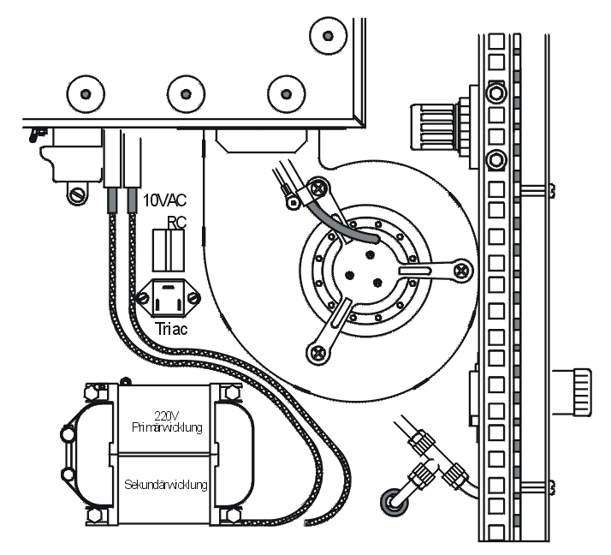
- Check the voltage for the heater,
on the transformer, there should be 10 V AC
on the secondary, and 220 V AC primary
voltage.

- Check whether the filament is faulty,
at the filament connections, only 1 Ohm
must be measured. A very high or
unmeasured resistance means that the
filament is burnt through and the tube needs
to be replaced.

CAUTION!
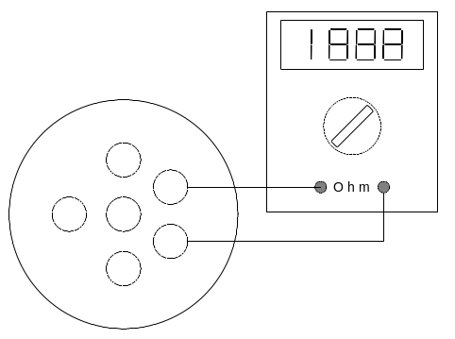
- Set the power switch to pos. 1 before removing
the tube, although it would be best
to completely turn off the device and unplug the power cord.

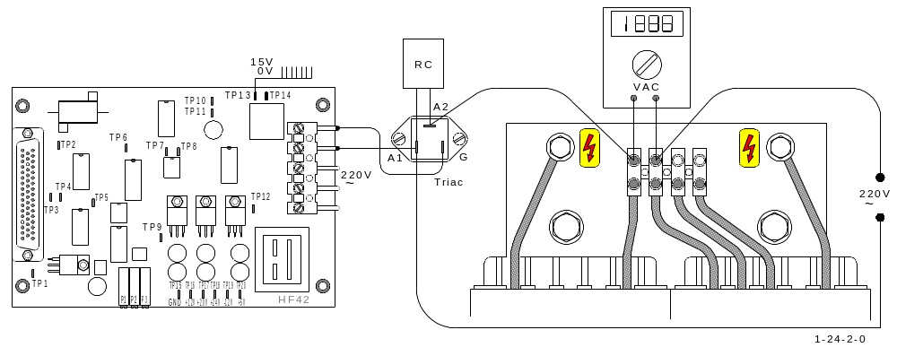

Checking the primary voltage on the high voltage transformer:
- On the primary side of the high voltage transformer, you should be able to measure
210 V AC; if not, the triac is defective. ( To locate the triac, see 4. 1 - 4 )
WARNING ! HIGH VOLTAGE !

High voltage transformer: windings check up:
- In case the transformer has 210 V AC on the primary coil and there is still no
combustion, check the windings of the transformer as follows:
- Switch off the analyser and disconnect the main power plug.
- Measure the resistance of the primary coil.
It must be extremely low, about 0.8 Ohms between the screws labelled 0 and 270.
- Measure the resistance of the secondary coil between the two screws on the ceramic
insulator where the wires of the rectifier are connected. The resistance is
approximately 322 Ohms.

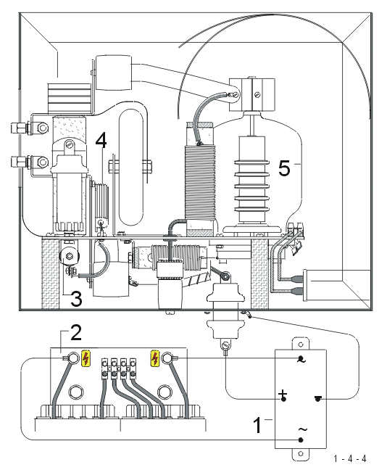
- The rectifier ( 1 ) could also be faulty!

CHECKING THE HIGH
FREQUENCY OSCILLATOR:
Warning ! HIGH VOLTAGE !

Never try to measure the voltage here !
As there is high voltage ( 5000 volts ) and
high frequency ( 19.2 MHz ) present, a
measurement would be very difficult and,
above all, very dangerous. Before the
generator cover plate is unscrewed, the
device should be turned off or, better, the
power plug pulled out.
- You should check the connections in the
oscillating circuit to ensure all screws are
turned tightly, especially all the screw caps
on the combustion coil.
- The electrical connections and resistors
should be checked with an ohmmeter.
- If the resistor 2.7 KΩ / 100 W ( 3 ) is
open circuit, then there is no oscillation.
- The parts e.g. tube and rectifier should be
replaced one by one, see also 1. 15

1.5 Bad combustion:

Insufficient flow: see 1. 3

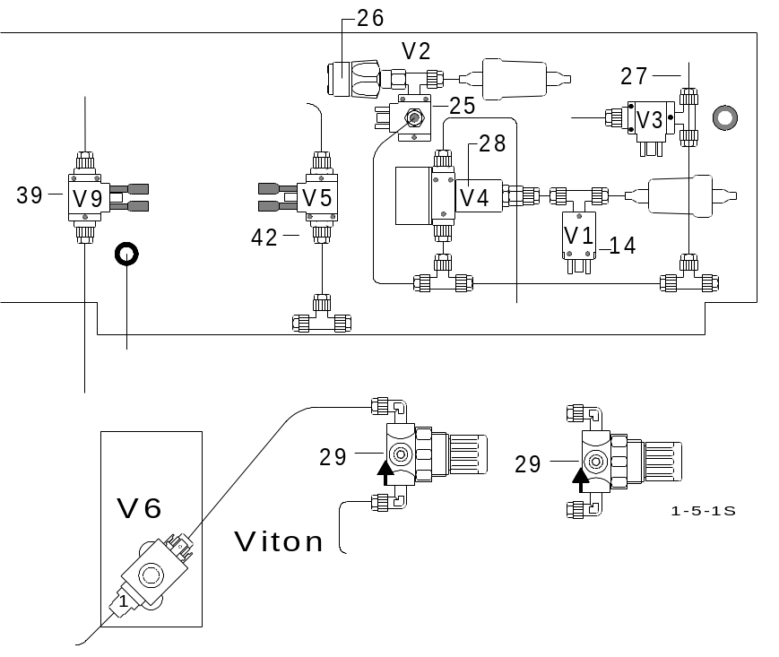

- The bypass valve ( 28 ) is either falsely activated during combustion, or it is sticking. In this case, the oxygen flows through the bypass valve into the IR-cell and not through the furnace. The furnace remains nonetheless under oxygen pressure.

- Measure the voltage to the bypass valve ( 28 )
24 Volts DC while the furnace is open is normal.
Zero volts when the furnace is closed is normal.
The measurements can also be made with a digital voltmeter, as well as with a glow light probe that shows 24 V / 20 mA.

Other false controls from the electronics :
Clear the memory;see 3. 9

Clean the valves; see 3.13

Generator tube is too old :
This normally does not occur suddenly, it is rather a long process.
- Replace the tube

Replace inadequate contact points in the oscillating circuit, see 1. 4

Replace worn power controls, see 1. 4

1.6 Electronic- drivers malfunctioning:

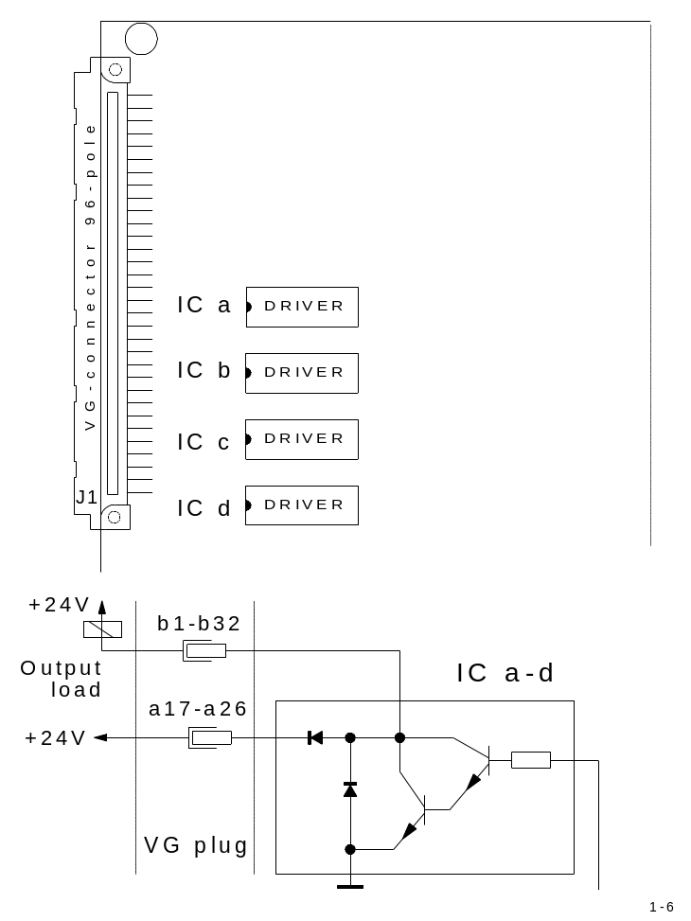

IC a, b, c and d are electronic driver
Integrated Circuits, found on the mother
board inside the electronic unit.
Their Type No. is ULN 2803 or
TD 62083.

These IC’s act as a power switch, in
order to energise solenoid valves inside
the analyser, see 2. 6, 3. 7 and 4. 2
or to send control signals, see 1. 2
1. 4 and 1.24

Operation range of IC’s a, b, c, d.
Depending on the fault location, the following driver IC’s need to be replaced:

IC a: Outflow valve V1, see 3. 7 and 4. 2

IC b: Shuttle valve V2, see 3. 7 and 4. 2 ; pneumatic valve for furnace, see 2. 6

IC c: Purging valve V3, see 3. 7and 4. 2

IC d: By-pass valve V4, see 4. 2
Generator „start“ signal, see 1. 4 and 1.24

1.7 The furnace does not close:

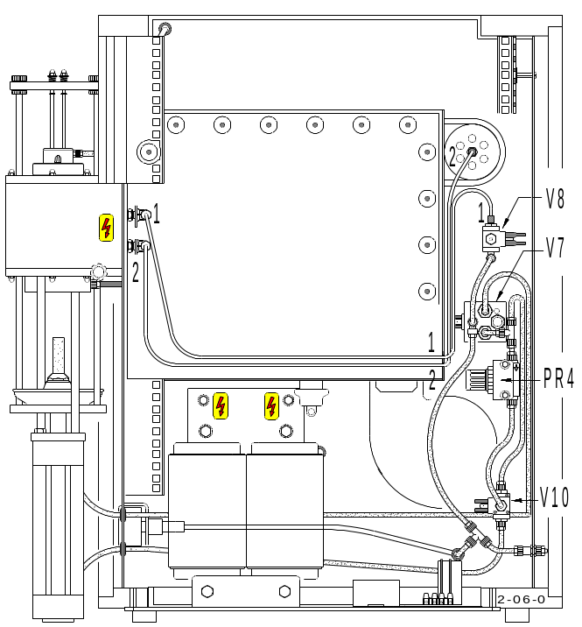
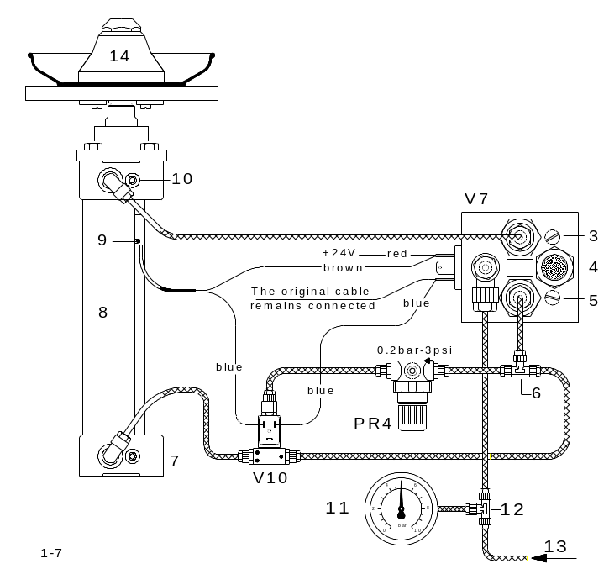

- Little or no compressed air pressure, the furnace cannot close.
This pressure is shown on gauge ( 11 ), on the front-side of the analyser.
It must be between 4 to 6 bar ( 60 to 90 psi ).

- The screws ( 10 ) and ( 3 ) must be turned counter-clockwise, as much as possible.

- Adjust regulator ( PR4 ), so that the furnace floor can rise completely, without shaking; while a person still can stop the moving furnace floor with only one hand.
This is a safety precaution.
Repeat above instruction, until the adjustment is completed. Now, the upward speed is fast enough, yet safe for the operator. The pressure regulator ( PR4 ) is found on the inside, on the right-side section of the analyser.

- The pneumatic valve ( V7 ) is malfunctioning.

- The magnetic coil of the pneumatic valve ( V7 ) receives no current.
The furnace floor goes up, when valve ( V7 ) receives 24 VDC.
The 24 V DC comes from the electronic unit; if not, replace the electronic drivers,
see 1. 6

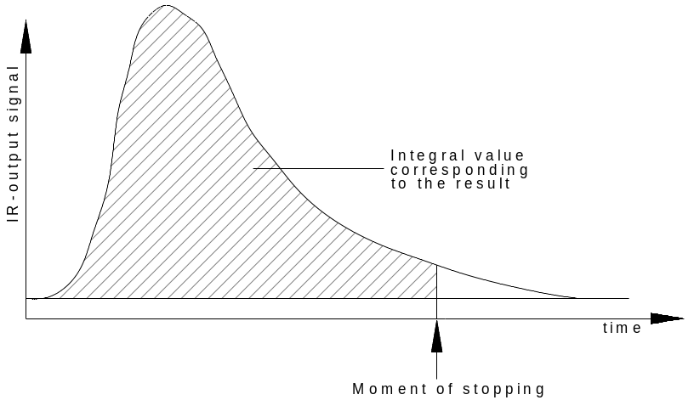
1.8 The analysis takes too long:

The analysis length lasts a maximum of up to 100 seconds, by virtue of a maximum time limit which the operator can select.
The minimum analysis time is automatically defined by the analyser and corresponds to half the maximum time.
Once the minimum time has expired, the analysis will stop automatically, if by that time no combustion has taken place.
If however the required combustion does take place, a signal from the infrared cell is then produced, causing the analysis time to be automatically lengthened.
The analysis is ended once the infrared signal has descended to the comparator threshold level, which is nearly zero volts.
The comparator threshold level is an artificial zero level.
When, however, as a result of unwanted hydrocarbons in the carrier gas, there is too much CO2, this threshold level won’t be reached.
In this case the analysis will stop only once the selected maximum time has expired.
The purpose of the maximum time is to protect the furnace from overheating.
It is important to ensure that the analysis is completed before the maximum time has expired.
This threshold level is not the same for every analysis, it is reset automatically during each analysis. The higher the maximum peaks, the higher the threshold level.
It can therefore happen that with higher peaks the analysis ends sooner than with lower peaks.
As long as the unwanted hydrocarbon concentration in the oxygen is not extremely high, the problem could only exist in the low carbon channel ( if present ).
You can confirm the source of this problem by deactivating the low carbon channel;
< Menu > < 5 > < 1 > .
If the analysis then ends before max. time, you can be fairly sure that the problem is with hydrocarbons.
In case that there is neither an oxygen purification furnace, nor some clean oxygen available, you can by-pass this problem by setting the threshold level higher. Press the keys;
< Menu > < 9 > < 1 > < k > < XXX > < ENTER >.
< k > can be the number 1, 2 or 3 for selecting the required IR- detector.
< XXX > is a three digit number for the set point of the threshold level, for example 250.
If the problem remains, this number can be increased stepwise until the problem is solved. The threshold level can only be set in the low carbon channel.

Additional reasons for excessive analysis duration could be:

- Dirty dust trap, see Operation Manual 7. 3
- Saturated chemicals, see Operation Manual 7. 2
- Cotton, glass or quartz wool is pressed too tightly, see Operation Manual 7. 2
- The oxygen is not pure, or the catalyst furnace is faulty or is cold, or the copper oxide is used up, see Operation Manual 7. 2
- The temperature of the infrared cell is not yet stable. Either it is not yet operational for at least 1 to 2 hours, or the oxygen flow has not yet been running for 10 to 15 minutes ( power switch on setting 2 ), see Operation Manual 3. 1 and 3. 2
- The thermostatic control of the infrared cell is defective, see 1.14 and 2. 5
- Excessive combustion temperature, causing the crucible to emit CO2.

One of the IR-sources is unstable:
- Small resistance changes of one or more IR-sources, can cause the
current to vary, thus affecting the intensity of the IR-radiation.
This problem will effect all the channels, due to the fact that the IR-sources are all
connected in series.
In order to establish whether this problem is present or not, an analysis cycle should be run without a sample or a crucible. The baseline of the IR-cells can then be monitored on the PC screen, see Operation Manual 5. 8 PLOTCS
The baselines should be quite stable and should run between 0.100 V and – 0.100 V
It would be very difficult, in case of a problem, to establish which IR-source is faulty and it is therefore easier to replace them all.

- A window of an IR-path is not airtight. The measuring gases pass through the leakage, either into the chopper housing or to the IR-detector.
Perform a leakage test of the IR-paths. Replace the faulty IR-path. see 3. 1

- The rectifier of the IR-source supply is faulty. The unstable voltage is too low, so that the voltage at the IR-sources cannot be regulated. see 2. 4
Check the base line on the PC screen, by starting analysis without sample. Zoom to get the scale of 10mV steps. see Operation Manual 5. 8
The base line should remain within 10mV, 50 seconds after START.
If the drift is larger and always positive, then check the IR-source voltage, see 2. 4

- The infrared power supply is defective, so that the voltage stabilisation does not function.
It is possible that the current to the IR-source is unstable, due to a faulty rectifier ( 4 ) causing only a half-wave to pass through. This can be checked rather easily, by measuring the DC-voltage across the outer legs of the rectifier ( DC-output ).
It should be at least 4 V DC higher than the supply voltage for the IR-source, measured between TP2 and TP1 ( GND ).

Voltage across DC-output At least 10 V DC for a 3 channel device
at rectifier At least 8 V DC for a 2 channel device
At least 6 V DC for a 1 channel device

Voltage across DC output of the rectifier:

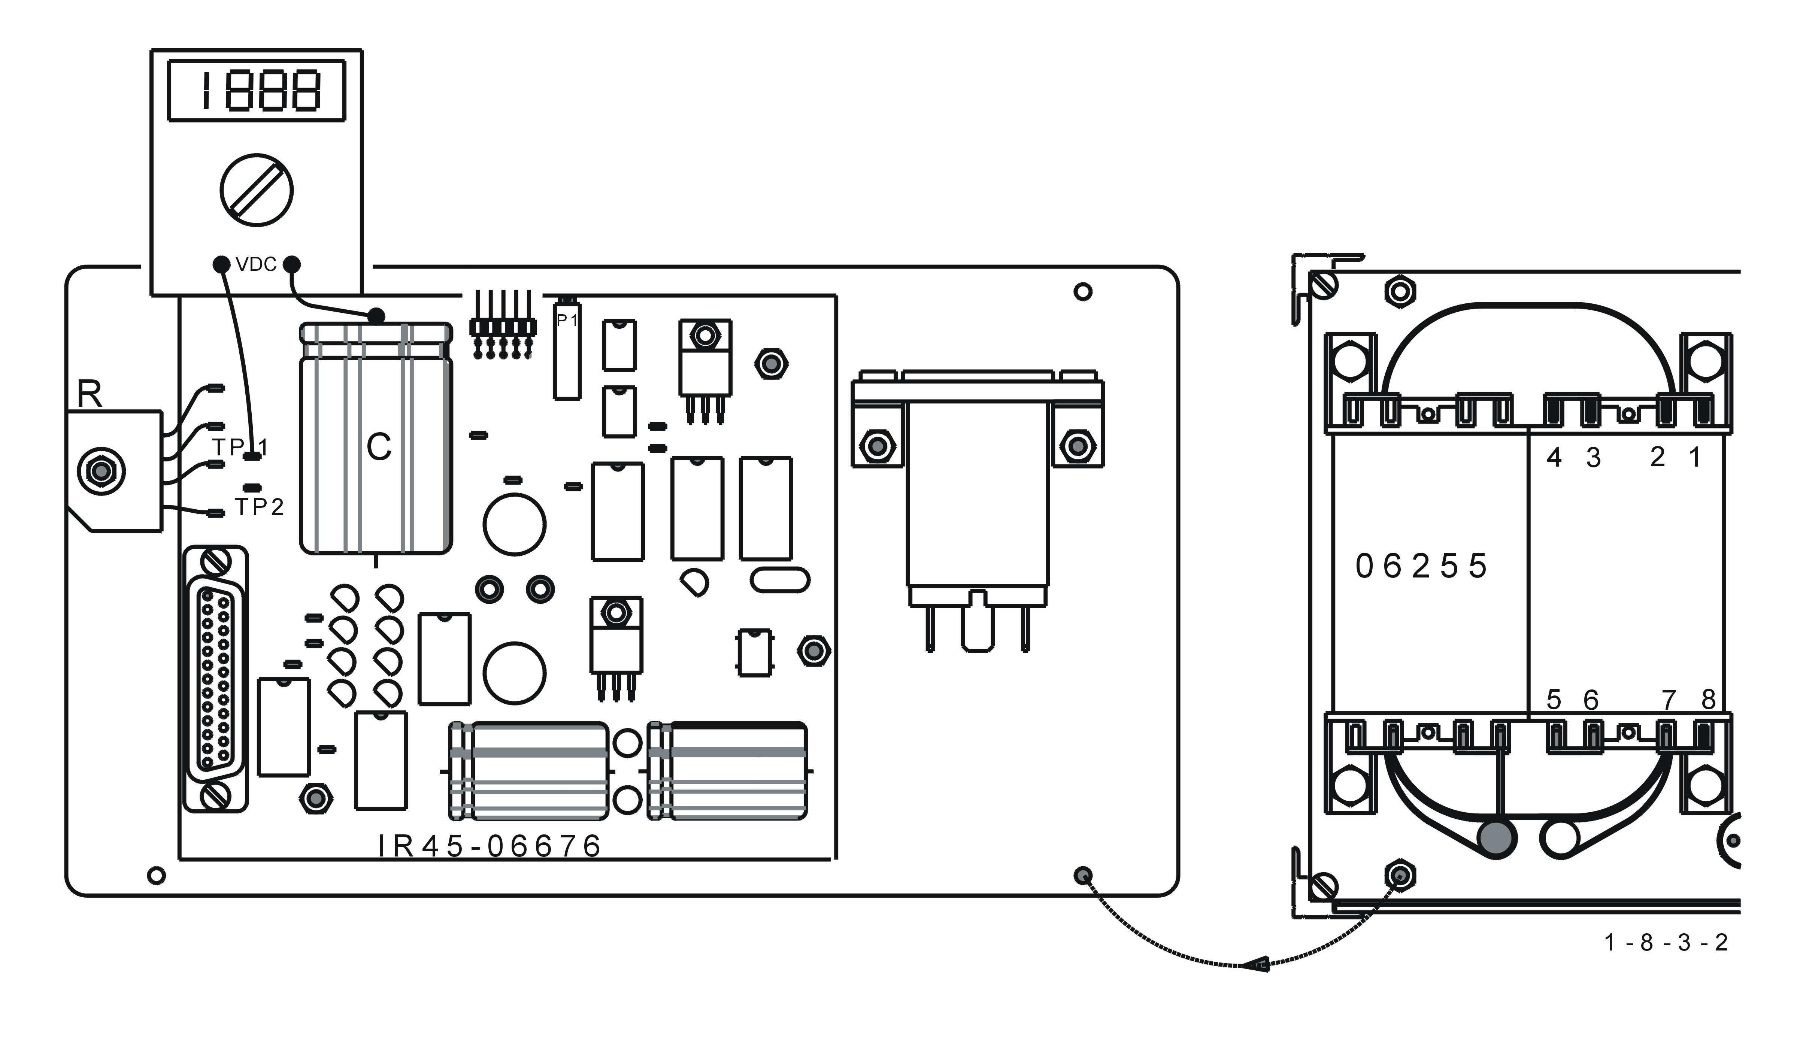

Voltage between TP1 ( GND ) and At least 6 V DC for 1 channel device
capacitor C: At least 7,5 V DC for 2 channel
( not stabilized voltage before stabilizer ) At least 9,5 V DC for 3 channel device
At least 11 V DC for 4 channel device
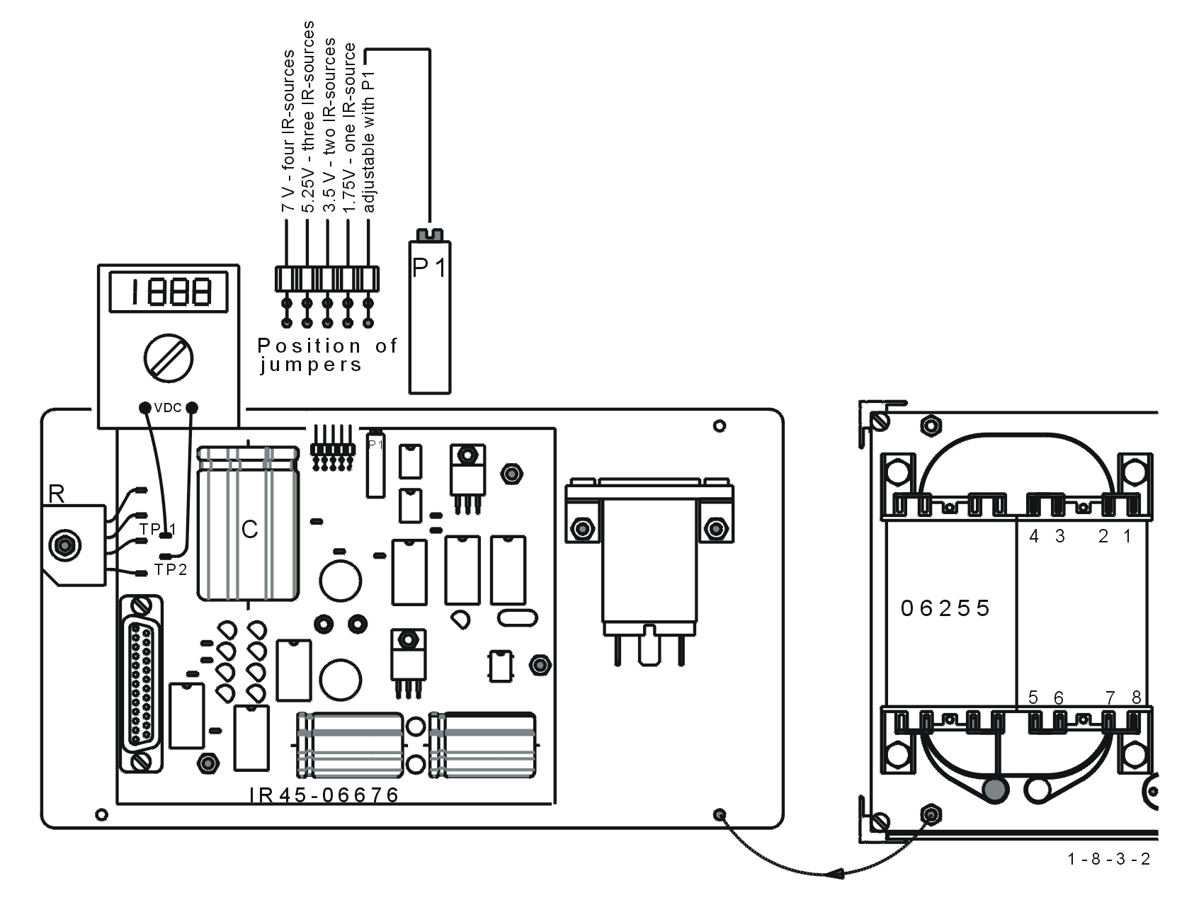

IR-source voltage, is to
be measured between TP1
and TP2 on IR 45 board. Transformer connections:
( stabilized voltage of IR – sources )
Blue cables
1,75 V DC for 1 channel device 1 Soldering location for 1 channel device
3,5 V DC for 2 channel device 2 Soldering location for 2 channel device
5,25 V DC for 3 channel device 3 Soldering location for 3 channel device
7 V DC for 4 channel device 4 Soldering location for 4 channel device
( 1,75 Volts DC for each IR source ) 8 Always connected ( common )
- RF-interference on the IR-cell, or on the electronic units:
If the generator's high frequency disrupts the electronic units or the infrared cell, then
the base line on the PC monitor appears jerky.
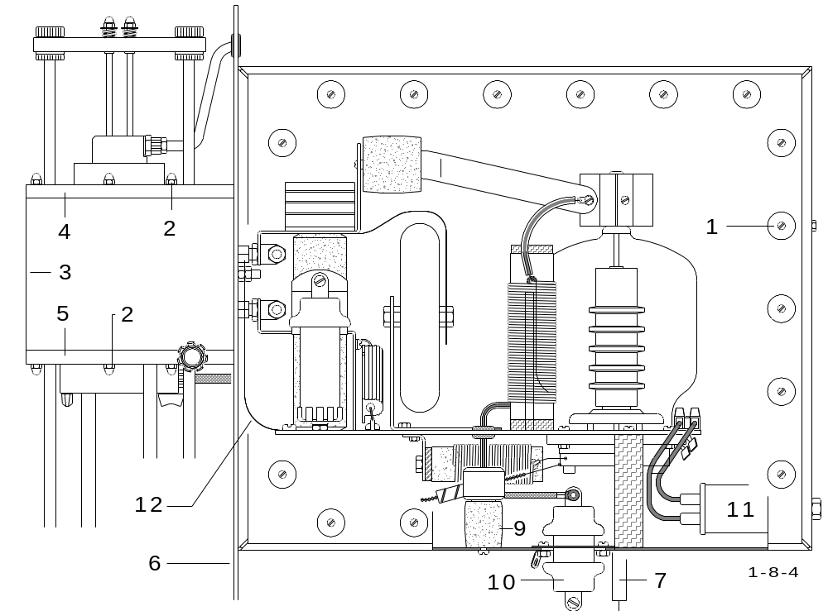

CAUTION ! HIGH VOLTAGE !

The causes:

- The screws ( 1 ) are not tightened properly, or not all 22 of them are screwed in.
- The acorn nuts ( 2 ) are not tightened properly or not all 14 are in place.
- The cover ( 3 ) does not seal tightly with the plates ( 4 ) and ( 5 ) or with
the front panel ( 6 )
- The capacitor ( 10 ) is out of order
- The capacitor ( 9 ) is out of order

One or both filters ( 7 ) are not OK:
- The filter ( 11 ) can also be damaged in this way.
When the ground strip ( 12 ) is not connected after removal or replacement of
the oscillator the filters ( 7 ) will defect.

The power voltage sinks below 180 VAC:
- Even a momentary drop in the in the voltage is enough to cause problems.
Use a voltage stabiliser. See 3.15

1.9 Development of dust when closing the furnace:
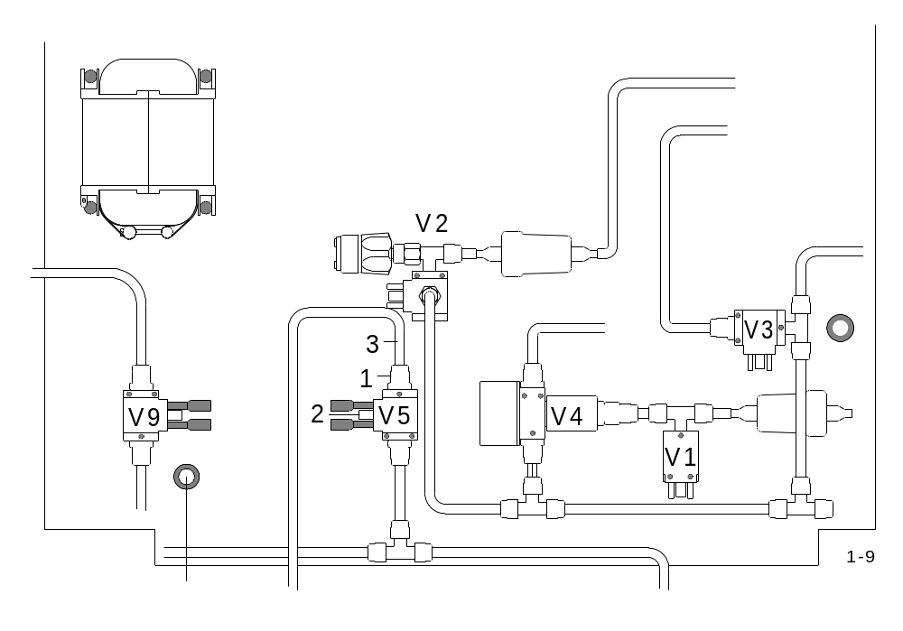

- The screw joint ( 1 ) from the valve ( 2 ) contains no nozzle, or the internal diameter of the nozzle is too large. This can easily be checked when removing the tube ( 3 ).
The nozzle should have an internal diameter of 1 mm.

1.10 Erratic results:

There are a lot of different reasons for this:

- Saturated chemicals or clogged dust filter -
see Operation Manual 7. 2 and 7. 3

- Heterogeneous samples

- Leakage, see 3. 7

- Flow problems, see 1. 2 , 1.3 and 1.18

- The electronic noise of the infrared signal, see 1.20

This can happen quite often that the combustion start is delayed and the analysis time is too long, see 1. 8.
You will see that the combustion start is delayed, when the word "GEN" appears later than the word "ANALYSIS".

- Incomplete or bad combustion, see 1. 5.

- Too high blank value for the crucible and tungsten. This will be especially noticeable,
mostly though, in the low carbon channel.

- Widely different weights of the sample and the accelerator ( tungsten ).

- Wrong data in the memory of the electronics: Clear memory, see 3. 9

- The base line of the detector is unstable, due through insufficient main voltage
( less than 200 V AC ).
Connect a stabiliser, see 3.15

1.11 The results are always 0.0000% or 00.0 ppm:

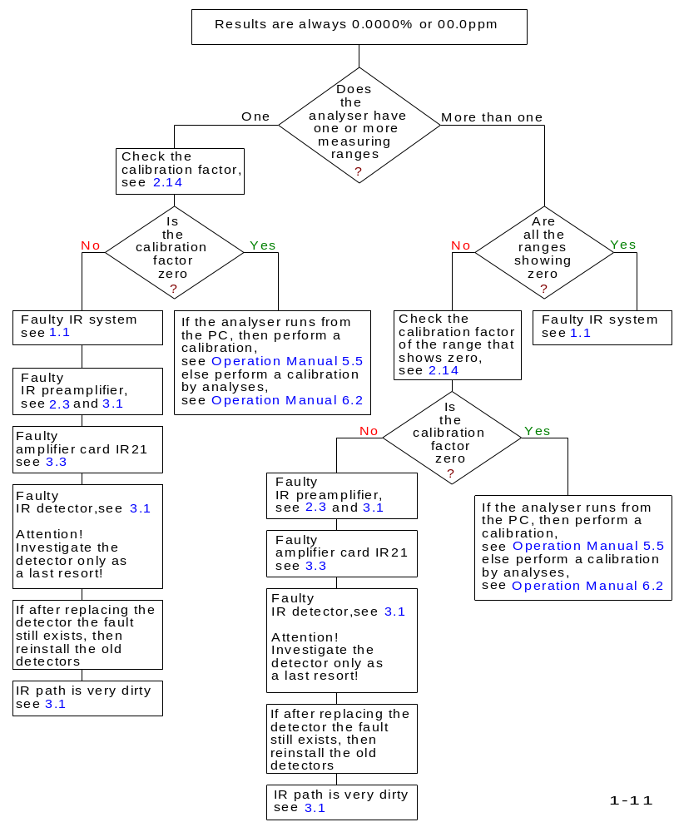

1.12 Beeper responding:

The built-in beeper of the analyser responds during the following reasons:

- When trying to analyse without entering the weight sample ( when the analyser operates without the PC )

- No oxygen input

- 24 V supply for the solenoid valves faulty

- No balance attached ( when analyser operating without PC )

At request, beeper can be made to respond every time when an analysis is
complete.

1.13 The life time of the combustion tubes is too short:

Possible reasons for that:

- The sample weight or the weight of the accelerator is too high.
See Operation Manual: “applications of”

2. Don’t use copper as accelerator.

3. The combustion tube is too long, i.e. longer than 145 mm. In this case, after fixing the four wing nuts ( 3 ) and ( 9 ), the combustion tube is pressed between the upper furnace closing part ( 17 ) and the lower part ( 10 )
In this case, when the combustion tube heats up during combustion, it may break.
Check the length of the combustion tubes to be not longer than 145 mm.
4. The upper furnace closing part ( 17 ) does not provide enough space for the combustion tube. To check this, install a combustion tube as usual but without the O-rings ( 11 ) and ( 12 ). After fixing the wing nuts ( 3 ) and ( 9 ), move the tube up and down. If the tube does not move at least 0,5 to 1 mm, replace the part ( 17 ) or make room for the combustion tube by machining the upper furnace closure on a lathe.

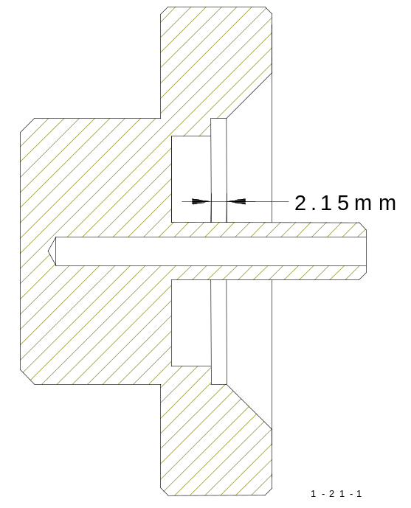

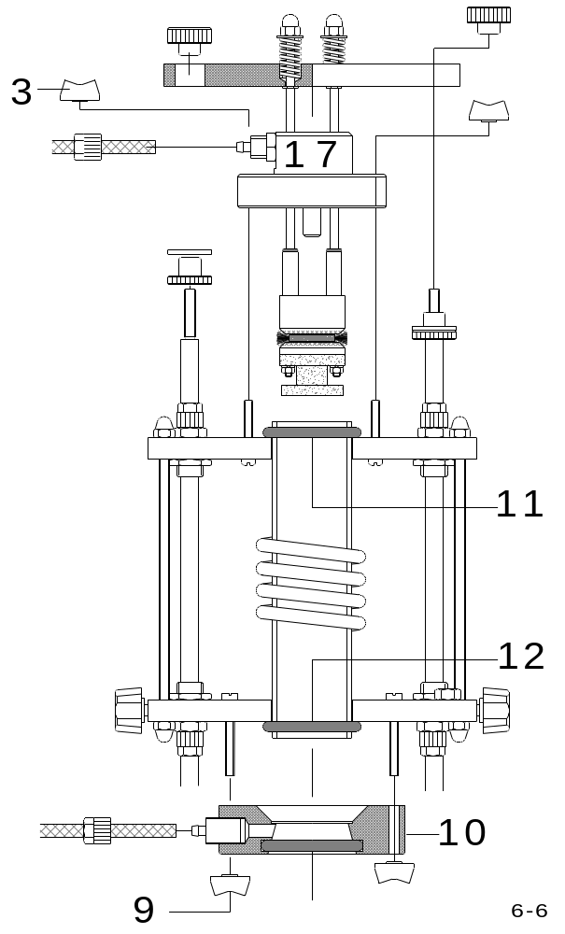

1.14 The LED for the IR-cell temperature regulation does not flash:

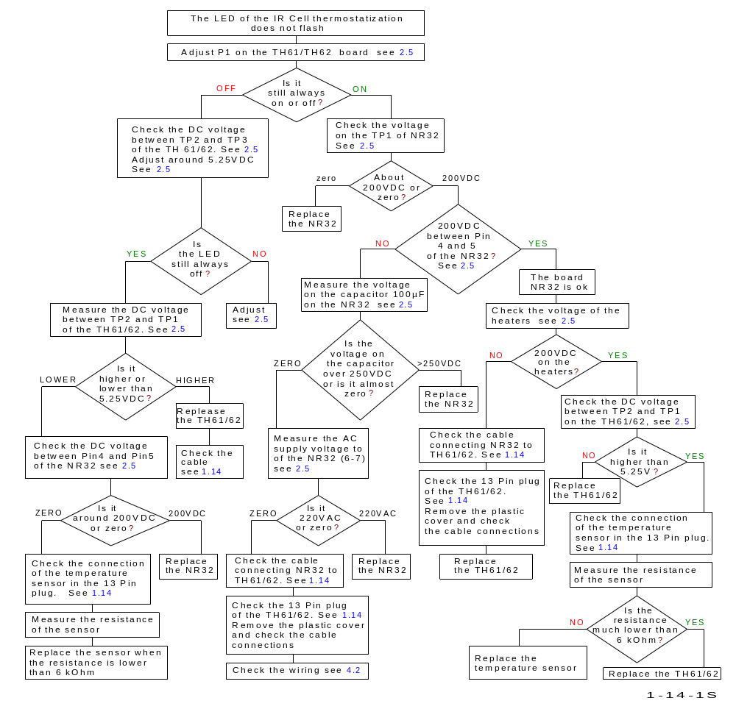

- Check that the cable is well connected to the plug, and that there are no short circuits between the contacts in the 13 pin plug.
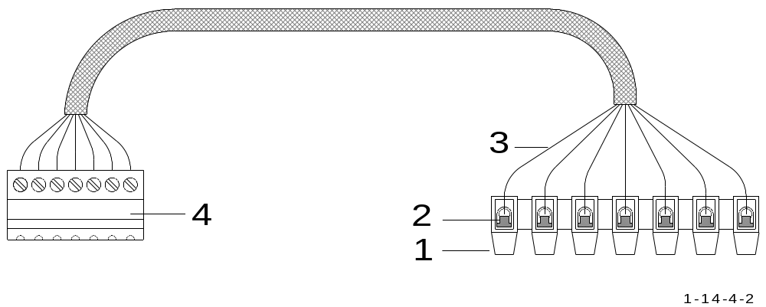

- Inspect the spring contact ( 2 ) on the connector ( 1 )

- One of the contact threads ( 2 ) could have failed, or one of the connections ( 3 )
could be disconnected.

- A look inside the plug ( 4 ) is recommended.

1.15 The fuse burns out at the beginning of combustion:

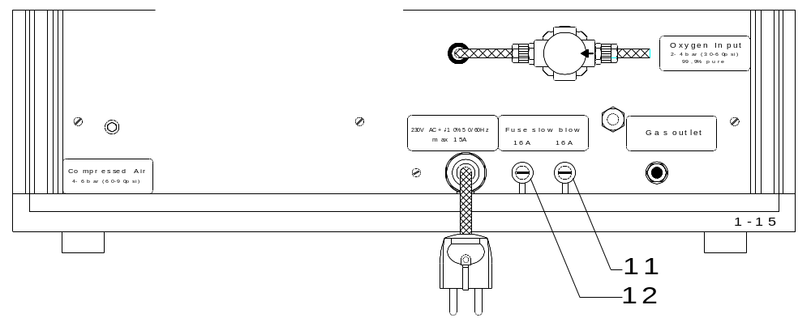

- If the fuses ( 11 ) or ( 12 ) blow, then Unplug the main power and replace them.
- Disconnect the cables ( 1 ) from the primary side of the transformer ( 2 ) and
connect the cables ( 1 ) to a 220 V light bulb ( 3 ) which is inserted to a socket.
An ordinary desk lamp can serve for this purpose. In case only 110 V light bulbs
are available, connect two of them in series.
BE CAREFUL that no short circuit occurs !

After the cables ( 1 ) have been connected plug the analyser to the main power again.
- Set the power switch to pos. 2
- Enter a weight manually, for example, 500 mg
- Press < START >
- When "GEN" appears on the display, the light bulb should glow; this does not happen suddenly, but gradually.
- Within a few seconds, the light bulb will change from dark to fully bright.
WARNING ! HIGH VOLTAGE!

SEE DRAWING NEXT PAGE:
- After pressing < START >, the message " ANALYSIS " appears, but "GEN" could appear later. The reason is, that after restarting the device and the oxygen flow, the infrared cell base-line could drift.
For the same reason, the analysis may stop longer than usual.
- You should wait until "GEN" appears.
- Quit by pressing < STOP >. If the light bulb turns dim, the triac ( 6 ) is OK.
- Unplug the main power and reconnect the power cables ( 1 ) to the transformer ( 2 )
WARNING ! HIGH VOLTAGE !
When reconnecting the power cables ( 1 ), do not let these wires approach the connectors for the cables ( 4 ) and ( 5 ). Otherwise the high voltage can create sparks.
- The cables ( 4 ) and ( 5 ) should be unscrewed from the transformer and placed
away from it.
- A new analysis should be started. When "GEN" appears and the fuse is not damaged, and the main current didn’t exceed 10 A ( RMS ), then the transformer is functioning properly.
- Otherwise, replace the transformer. The cables ( 4 ) and ( 5 ) are then reconnected.
The cable ( 7 ) is unscrewed and removed from the capacitor ( 8 )
WARNING ! HIGH VOLTAGE !
After the generator starts ( GEN ) the cable ( 7 ) carries a voltage of about 7000 Volts ! The cable ( 7 ) therefore should be laid so that its end is at least 10 cm away from the nearest object !
- If, after pressing < START > and GEN, the fuse is blown, then replace the rectifier ( 9 )

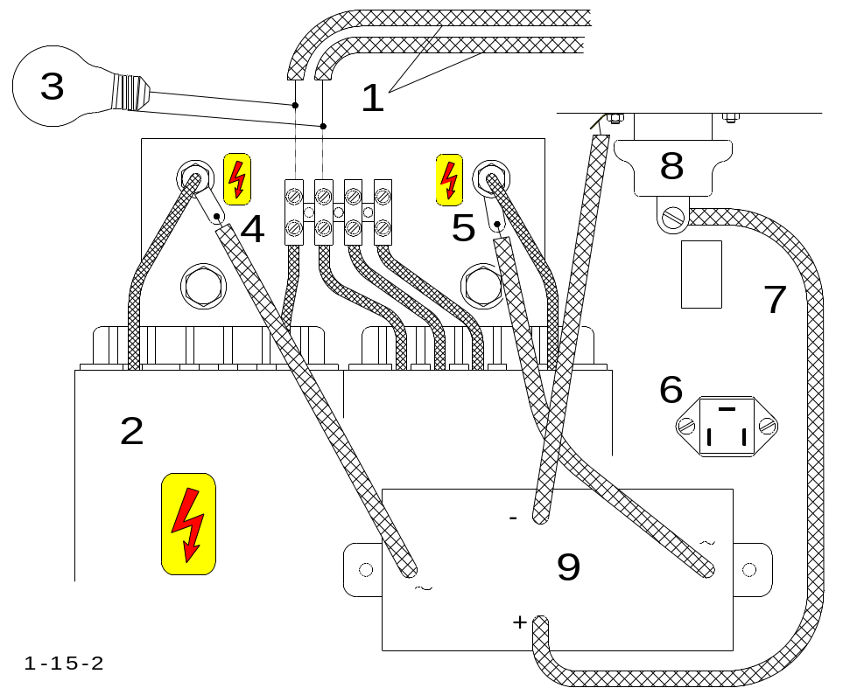

Further causes could be found in the oscillator circuit:

Because of the high voltage ( 7000 volts ) and the high frequency ( 19.5 MHz ), it is difficult to make measurements without any special measuring instruments.
Thus, the analyser needs to be turned off, and the power plug disconnected.
WARNING ! HIGH VOLTAGE !
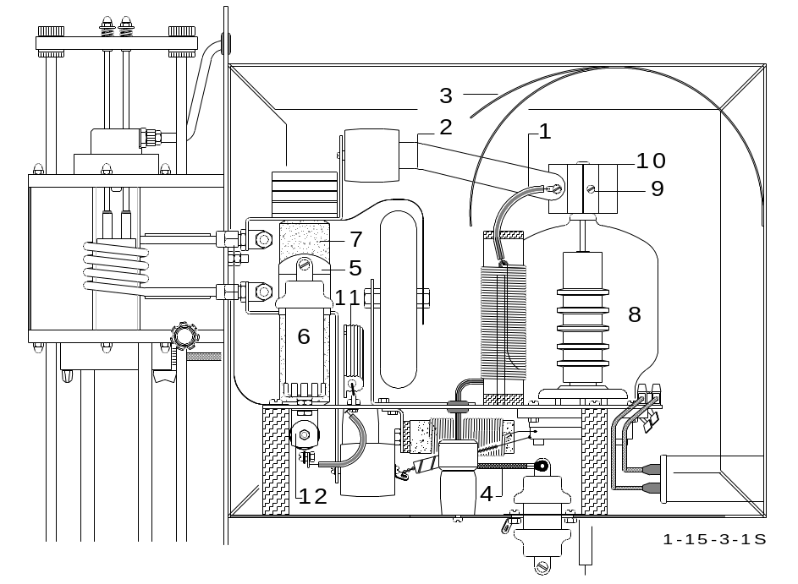

- Check that all the screws and soldering connections
have a good contact.

If the resistor 100 KΩ / 50W ( 11 ) is a short circuit,
then the fuse will blow when starting the
combustion.
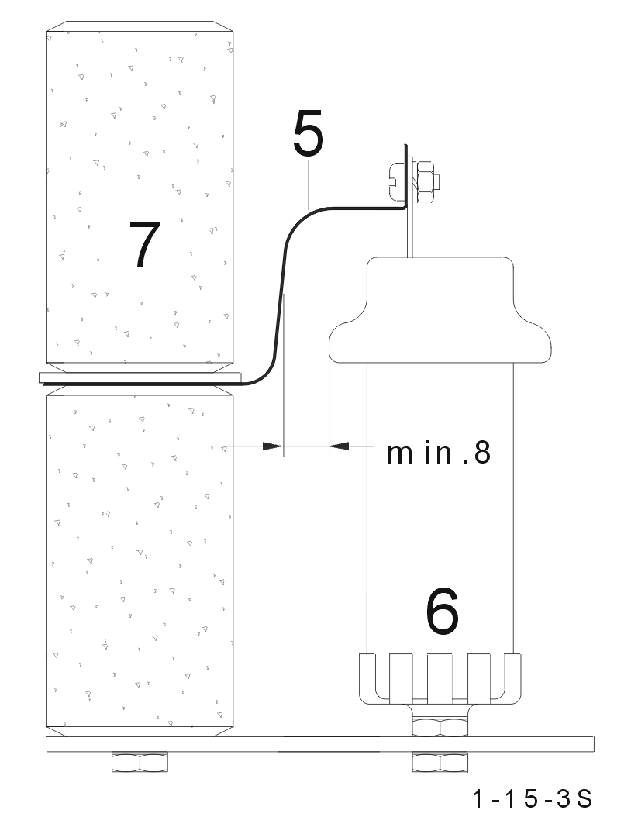
- Check that all power conductors and copper bands are
placed far enough away, from any nearby objects! The
wire ( 1 ) and the copper band ( 2 ), for example,
should be placed far away from the plate ( 3 ).

- The power cable ( 4 ) should have a maximum distance
from any surrounding object.

- The copper band ( 5 ) should be placed as far as
possible away, from the capacitor ( 6 ) !
This is why the copper band ( 5 ) should always
be bent around the insulator ( 7 ) !

If the tube needs to be replaced ( 8 )
- Loosen the screw ( 9 ), pull out the heat sink
( 10 ) upwards ! Pull out the tube ( 8 ) upwards!

1.16 The fuse blows at the end of the analysis:

Causes :
- The triac is malfunctioning.

The so-called Latch-up effect causes the undesired conduction during one halfway
of the triac, once the trigger pulses to the triac have subsided. The transformer is then
acting as a short circuit because it is fed with a DC voltage!

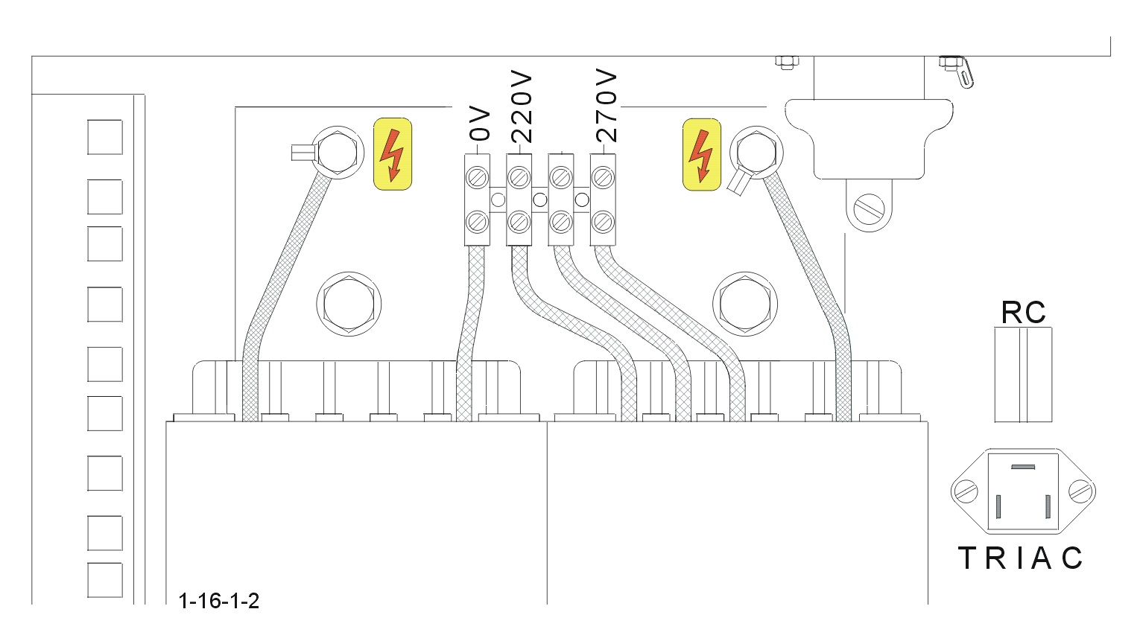

Replace the TRIAC!
( To locate the triac, see 4. 1 - 4 )

1.17 Large collection of dust when opening the furnace:
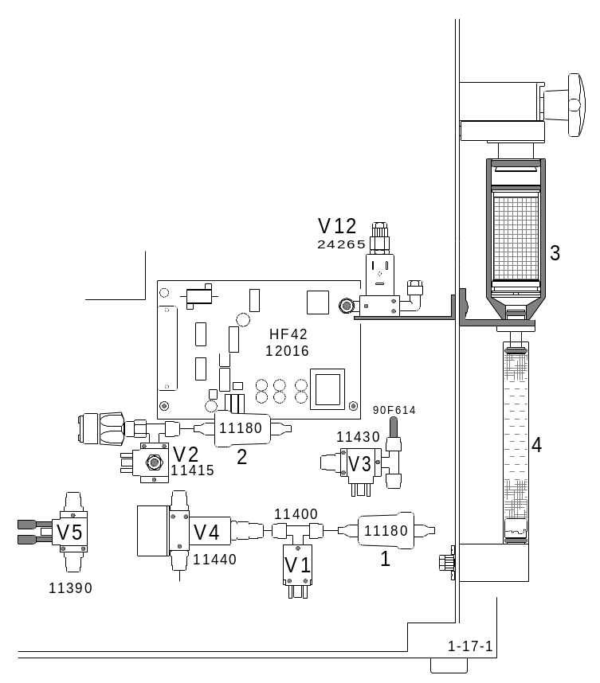

After pressing the key to open
the furnace, the valves ( V1 )
and ( V2 ) a re-activated,
this means that on the coils, 24 volts
DC coming from the electronic unit
are present.
Valve ( V2 ) closes the oxygen
supply to the furnace.
Valve ( V1 ) opens,
releasing the pressure from the furnace
through the dust trap ( 3 ),
through the moisture trap ( 4 )
and through the filter cartridge ( 1 )
into the open air
( in the direction of the arrow ).
Following this, the pneumatic valve shuts
and the furnace opens
( lift downwards ).
When dust comes out of the furnace after
this process this will cause, that the pressure
in the furnace is not sufficiently eliminated.

The causes:
- Too much dust in the dust trap ( 3 ), ( a few hundred analyses without cleaning )
- Saturated moisture trap ( 4 )
- Clogged paper filter in the moisture trap ( 4 ), see Operation Manual 6.1
- Clogged filter cartridge ( 1 and 2 ) ( this would be unlikely though)
- One of the valves ( V1 ) or ( V2 ) receives no power ( 24 V DC )

CAUTION !
- The valve ( V1 ) will only be supplied with voltage ( 24 V DC) until the lift has reached the bottom position, then it will be switched off.
- The 24V on the coil of this valve can be measured with a digital voltmeter, or with a light bulb of 24 V / 20 mA.
- One of the valves ( V1 ) or ( V2 ) is sticking, preferable valve ( V1 )
- Clean the valves, see 3.13

1.18 No or low oxygen pressure:

SYMPTOM: After pressing the START button, the following message appears: " no oxygen pressure "

POSSIBLE FAULTS: on the front panel of the analyser:
- Is the power switch ( 1 ) set on pos. 2 ?
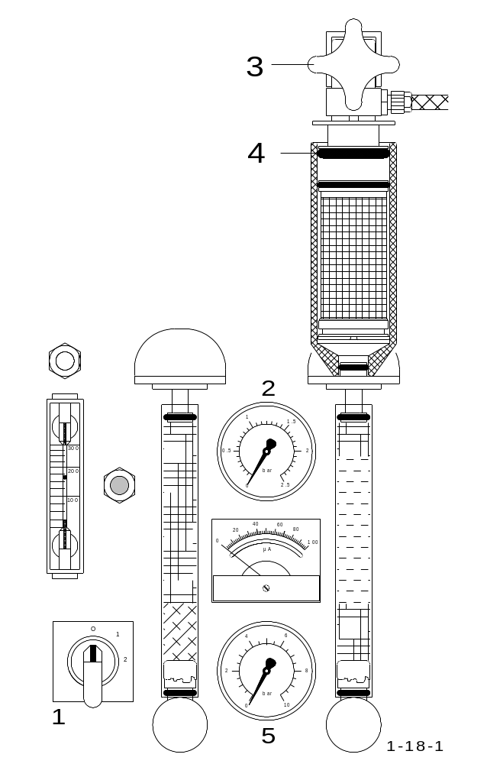
- The pressure on the oxygen gauge ( 2 )
may be too low.
1.5 bar is normal ( 22 psi ).
The pressure remains constant when
the furnace is closed, and it sinks
during the upward movement
of the furnace floor.

- Check the oxygen pressure
in the supply line or tank.
4 to 6 bar ( 60 to 90 psi ) showing on
the pressure gauge is normal.

- Check if the pressure gauge for
compressed air ( 5 ) shows 4 to 6 bar
( 60 to 90 psi ).

- Check if the cock ( 3 ) is properly shut,
or else the O-ring ( 4 ) will not seal.
Check if the O-ring ( 4 ) is in a good condition.

- Check if the combustion tube is broken
or cracked.

- Check for gas leakage, see 3.7

- Check if the chemicals are saturated
and have become hard.

- The paper filter could also be the cause.
For changing the paper filter,
see Operation Manual 7. 2.

On the rear-side of the analyser:

- The contents of the gas cleaning furnace could be worn out and clogged.
See Operation Manual 7. 2

Inside the analyser:

The oxygen solenoid valve ( V5 ) may be defect.
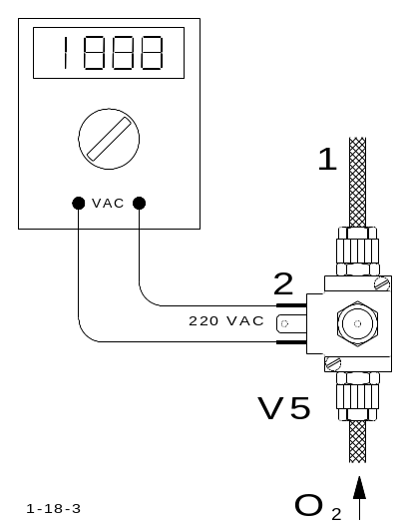
- Open the left-side panel of the analyser.
Unscrew the upper tube ( 1 ). The oxygen should
rush out when the power switch is set to pos. 2.
If not :
- There may be no oxygen supplied.
- 220 V AC is not measured on the terminal ( 2 )
of the solenoid coil.
- The solenoid valve is clogged.
Clean the solenoid valve, see 3.13.
If the fault is still present, then:
- Switch off the power, ( set the power switch to position 0 )
Pull out the socket ( 2 ) from the coil and measure the
coil resistance. 3.3 KΩ is normal.

The outflow valve does not close:
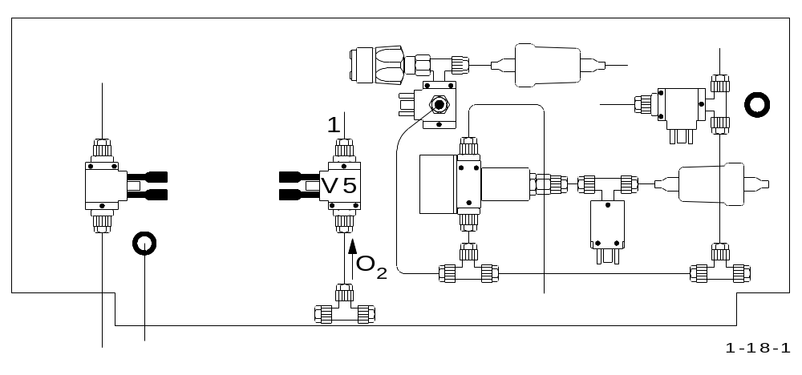

Open the left-side panel of the analyser. When the furnace is closed ( the lift is up ),
no oxygen should be flowing out of the lower ( free ) opening of the valve ( 1 ) ( in the
direction of the arrow ). This can be checked by putting your finger under the lower
opening of the valve. If the valve does not close correctly, you will feel a strong
oxygen pressure. The power supply to the valve ( 1 ) should be 0 Volt. If this is the
case then the outflow valve ( 1 ) should be cleaned, see 3.13 or replaced.

If the voltage on the outflow valve is constantly at 24 V, then:
- Erase the memory, see 3. 9 .
- Replace the electronic driver, see 1.6.

OTHER FAULTS:
The screw for the upper furnace cushioning is too tight, see 2. 6
The pressure switch does not close, see 2. 2
The furnace closes too slowly, adjust according to 2. 6
The furnace does not close, see 1. 7

1.19 Saved data are lost:
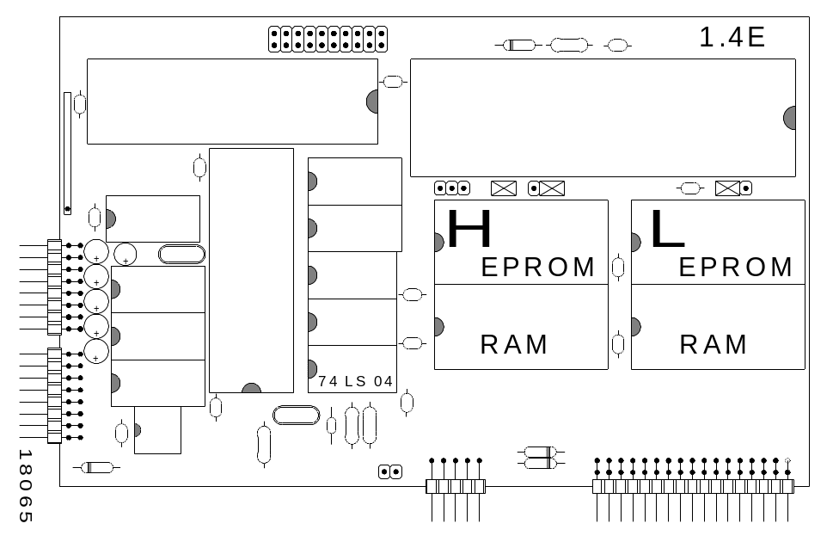

- Make sure that a 74LS 04 is present.
- In this location only an LS-Type has to be installed.
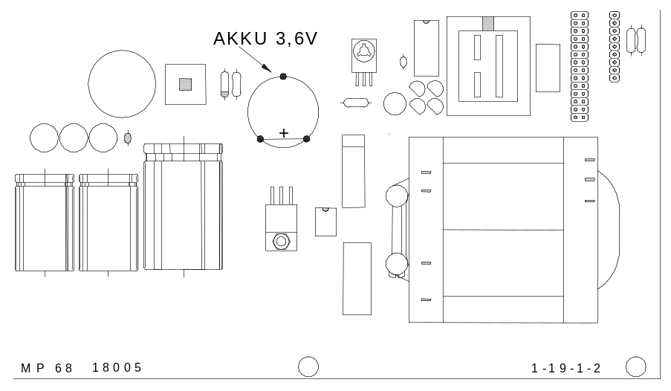

- Replace the accumulator ( accu in diagram ), when the accumulator will not charge
after the power had been switched on, and after installing the 74 LS 04
Once the analyser is switched off and the accu didn’t charge data will be lost !!!

The data that is meant here is the data that is saved in the accumulator-buffered RAM area. It consists mainly of the calibration factors, the blank values, and the linearity factors, which are entered through the keyboard. See 2. 9
The linearity factors, which were programmed in our company when the device was manufactured, were saved in the EPROM, they don’t get lost.
After turning on the power again ( with an empty accumulator ), those default linearity factors that are saved in the EPROM’s are the current values. Therefore, you should note down any linearity factors that you enter through the keyboard, in case the accumulator becomes empty.

1.20 Noise or drift of the infrared baseline:

The symptoms are noticeable on the display and especially on the monitor
attached to the PC, when either rhythmic or sporadic jumps of the zero line are
present.

- The cause for a swinging rhythmic is the chopper motor.
Replace the chopper motor, see 3. 5

Causes for noise are:

- The pre-amplifier,
replace, see 3. 1 and 2. 3

- The infrared detector,
replace, see 3. 1 and 2. 3

- A fault on the circuit board IR 21,
replace, see 3. 3

- The power supply fluctuates,
see 3. 3 and 3. 4

- The IR source is defective,
see 3. 2 and 1. 8.

1.21 Dust in the oxygen carrying tube when the furnace opens:

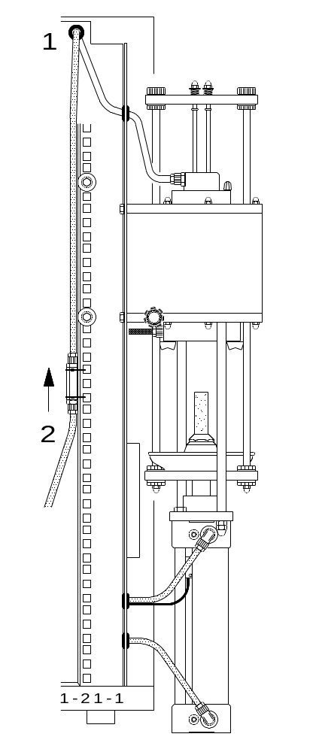

When dust can be seen inside the
transparent tube ( 1 ) leading into
the furnace, then the one-way
valve ( 2 ) is defect.

- Replace the valve ( 2 ).
Attention: install the valve, so that
the arrow points upwards. Because.
the gas has to flow upwards.
This is a one-way valve.

- Before mounting the valve,
you should simply push air
( e.g. by blowing )
through the valve in order
to ensure that it is properly connected.
When the valve is incorrectly
mounted, the oxygen flow will be blocked.

1.22 The word Eltra appears on the display:

This only happens when the power supply to the electronic is turned on.
The electronic unit can function down to a minimum main voltage of only 160 V.
If, during the operation the word "ELTRA" appears on the display, then the
voltage has sunken below 160 V.

- Monitor the main voltage during an analysis.
Should there be a short interruption detected, then the cause could lie with a poor contact.
- If the voltage drops when the generator is running, then the generator power can be reduced:
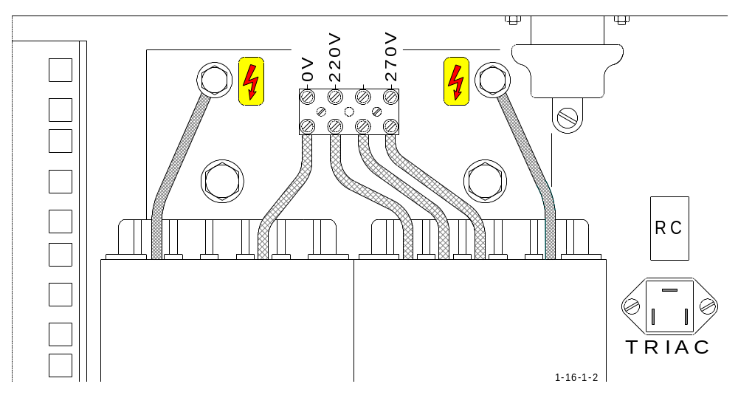

The cable that is connected on the high voltage transformer to the 220 V terminal,
should be then connected to the 270 V terminal. This way, the generator draws
less energy.

- Use a voltage stabiliser, see 3.15

1.23 The oxygen pressure falls when the furnace opens

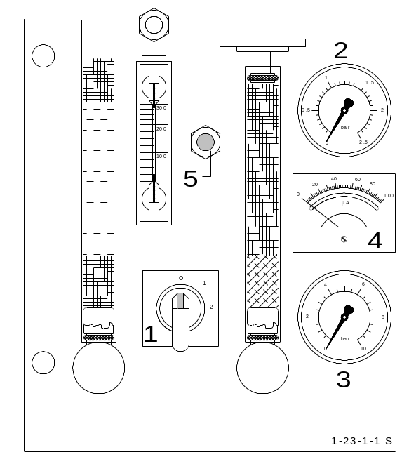

Regardless of whether the furnace is
opened or closed,
the oxygen pressure shown on the pressure
gauge ( 2 ), must remain 1.5 bar ( 22.5 psi )
constant.
If, however, the oxygen pressure falls
when the furnace is open, then:

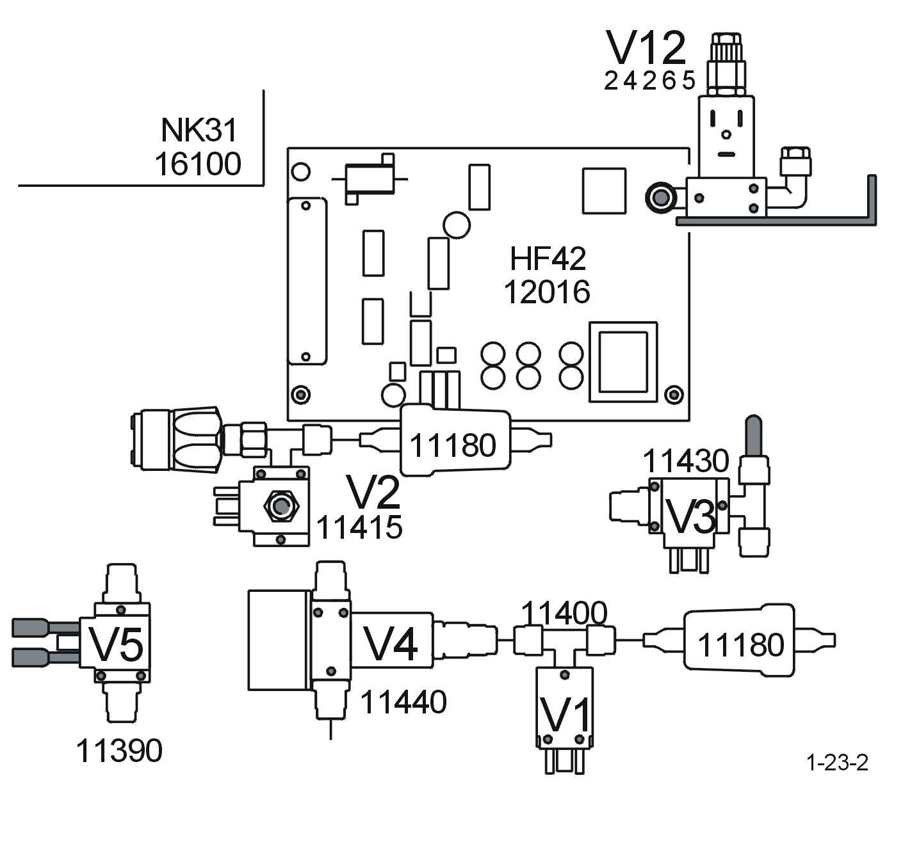

either the valve ( V2 ) is defective or its control is incorrect.
When the furnace is open, the valve ( V2 ) should have 23 V DC on its magnetic coil.
When the furnace is closed, the voltage should be at zero volts.

- If the voltage on the valve ( V2 ) remains at 23 V DC, no matter whether the furnace is opened or closed, then the electronic unit is defect, see 1. 6.
- If the valve voltage always stays at zero, then either the wiring to the electronic unit is broken, see 4. 2 , or the electronic unit is defect, see 1. 6.
- If the voltage on the valve ( V2 ) is correct, then the valve itself is defect, see 3.13.

1.24 Combustion without pressing " START "

In this case, the combustion of the sample begins immediately after the sample enters the furnace, and before having pressed the "START" button.
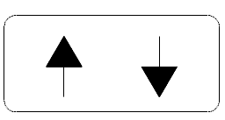
Should the combustion start just,
after closing the furnace, and by pressing
then there is a serious fault !

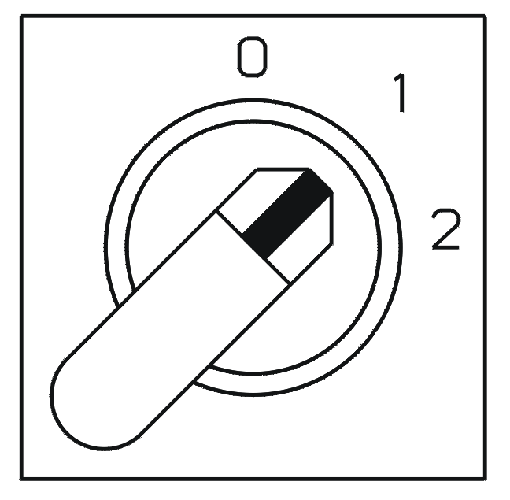

The power switch should be set immediately
to pos. 1, in order to avoid any overheating
of the generator.

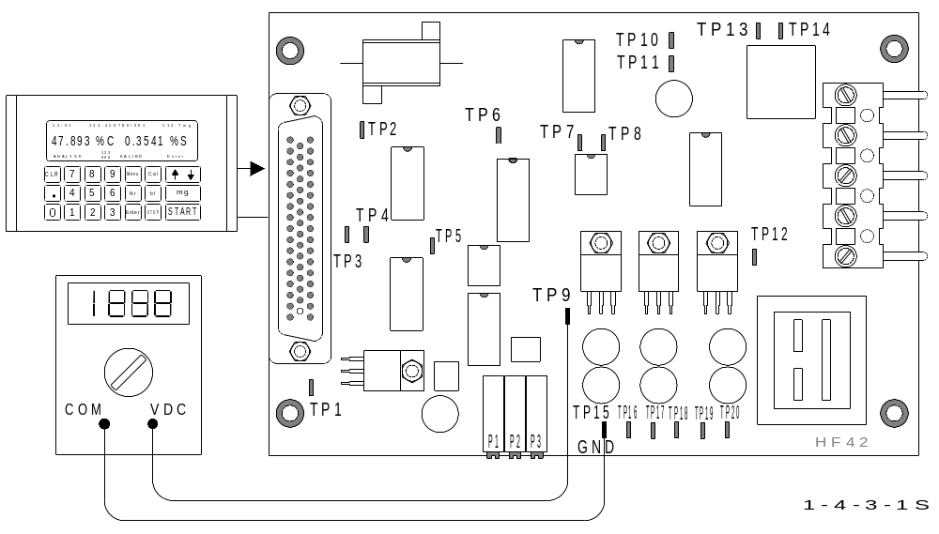

- The electronic unit ( rack ) is out of order, when the combustion starts without pressing "START" and without "GEN" on the display, there is only 0,5 V DC on TP9 ( instead of 1 2V DC ). Replace the electronic drivers, see 1. 6.

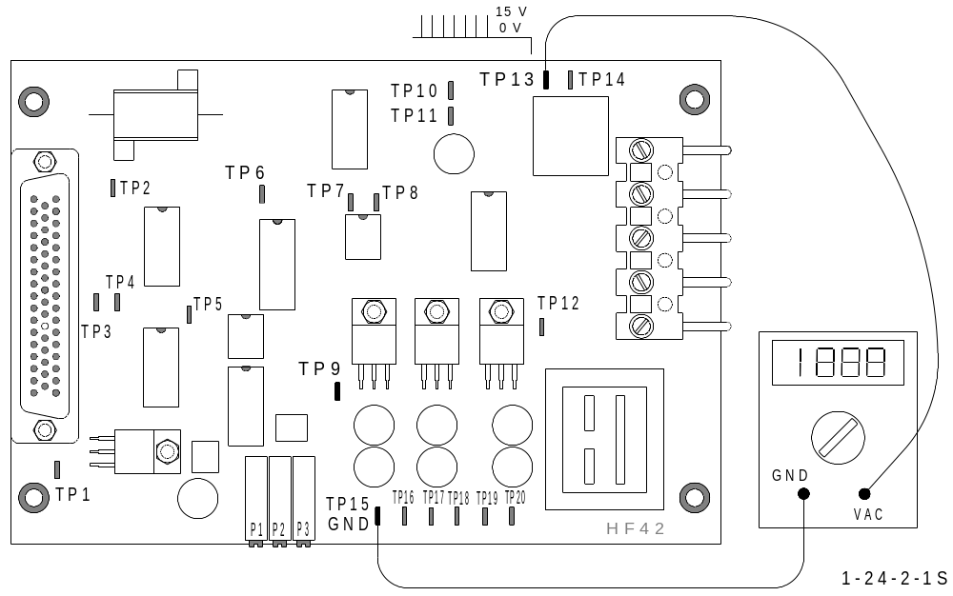

When the pulses at TP13 are present without pressing "START"
and with 15 V DC at TP9, then the circuit board HF 42 is out of order.
If no scope is available, the pulses can be detected by using a voltmeter.
Normal values are about 0 V AC without pulses, and about 1 V AC with pulses.
This indicated value can be different, depending on the type of the voltmeter used.

Possible reason :

- The triac is faulty ( short circuit ), and has to be replaced.
( To locate the triac, see 4.1- 4 )
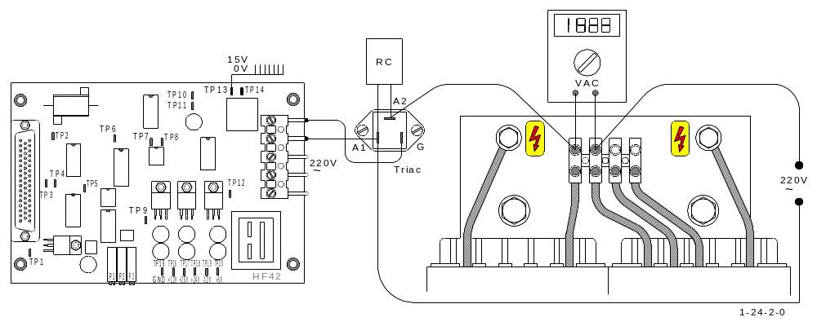

1.25 The crucible cracks or melts:

One reason could be that:
The quality of the crucible is bad, use a better quality.

Another reason could be that:
The furnace temperature is too high, due through:

- Excessive main voltage.

- Excessive sample and / or accelerator weight.

- The use of a “sample or accelerator” that requires lower generation power.
In this case reduce the generator power, see 2.12

1.26 The analysis doesn’t start :

There are two reasons for the above fault:

- Insufficient oxygen pressure ( below 1 bar ), see 1.18

- The infrared zero- baseline deviates too much from zero, see 2.3

1.27 Vibrations on setting 2:

The reason is dust accumulation on the blades of the oscillator’s blower. The oscillation result due through distribution of dust on the blades causes an unequal rotation.
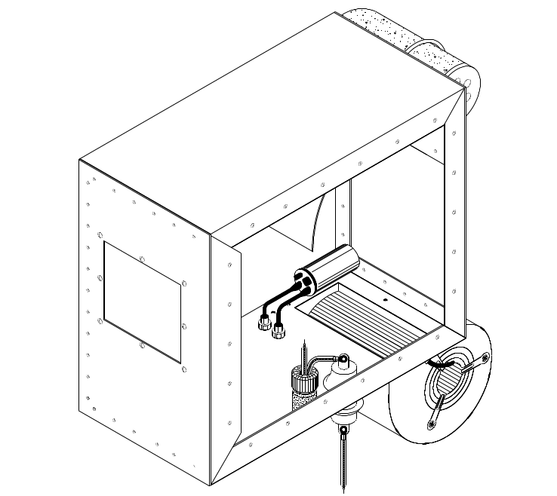

Caution:
Disconnect the power before
removing the oscillators lid.

Blow the dust away with compressed air. Blow from the inside to the outside, otherwise the dust will be blown into the oscillator. Take care of the rotary speed of the blower to remain within the operation limits. When blowing compressed air, the rotary speed of the blower can exceed the limit of operation causing damage to the bearings and the shaft.

The analysis cycle stops only 25 seconds after start:

Information.
When 50 seconds as maximum analysis time is entered, this means that 50 seconds after start, the analysis, resp. the combustion will definitely stop in any case. But if there is no signal ( peak ) coming from the infrared cell, the analysis cycle will take at least 25 seconds i.e. half the maximum analysis time.

The problem.
It seams that there is no signal coming from the infrared detector. If the peak comes, the minimum analysis time of 25 seconds will be automatically prolonged until the signal comes bask to zero or the maximum analysis time of 50 seconds has been reached.
There are two possibilities for not having a signal:
- There is no combustion. See 1. 4 and 1. 5.
- The infrared cell is damaged. Do the IR-test. See 1. 1, 2. 3 and 2. 4.
Make sure that you take a sample with relatively high carbon to provide a clear visible high peak to about 3 to 8 volts.

The chopper motor doesn`t rotate:

Mostly, the reason is that the grease of the bearings becomes dry.
You can feel a resistance when you try to turn the shaft by hand.
In this case the problem can be solved by lubricating using silicon oil.
Dip a piece of wire in to a flask of silicon oil and apply as shown below.
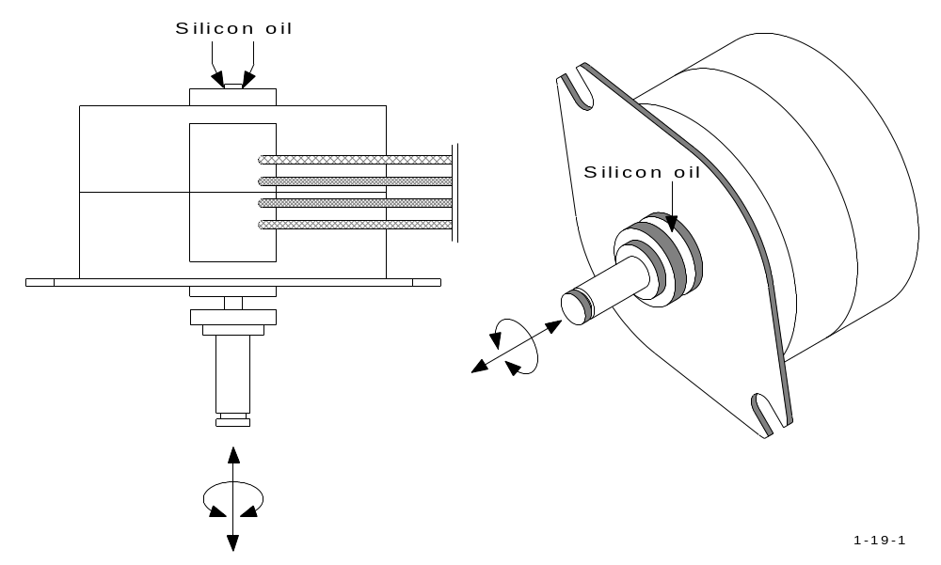

In order to spread the oil in to the space between shaft and bearings, turn the shaft and move it in axial direction at the same time. The use of mineral oil is not suggested, because mineral oils become dry and hard after long time of operation. If no silicon oil available, use silicon spray. Silicon grease is also good for this purpose and it is also available in laboratories, however it could be very difficult for grease to penetrate the space between shaft and bearings.

High carbon results are erratic:

If only high carbon results are erratic, while low carbon and sulfur results are repeatable, most likely the metal dust filter is blocked.
Even if the filter may be brushed and cleaned in ultrasonic cleaner, some day will not be able to be cleaned any more. The filter don’t last for ever.
Check by removing the filter with the dust filter housing.
Don’t remove the filter from its housing.
Turn the filter housing upside down and try to blow air through the small hole (about 16mm diameter) of the filter housing.
If you feel a remarkable restriction, replace it by a new one. With a new filter the air should pass practically free without any restriction.
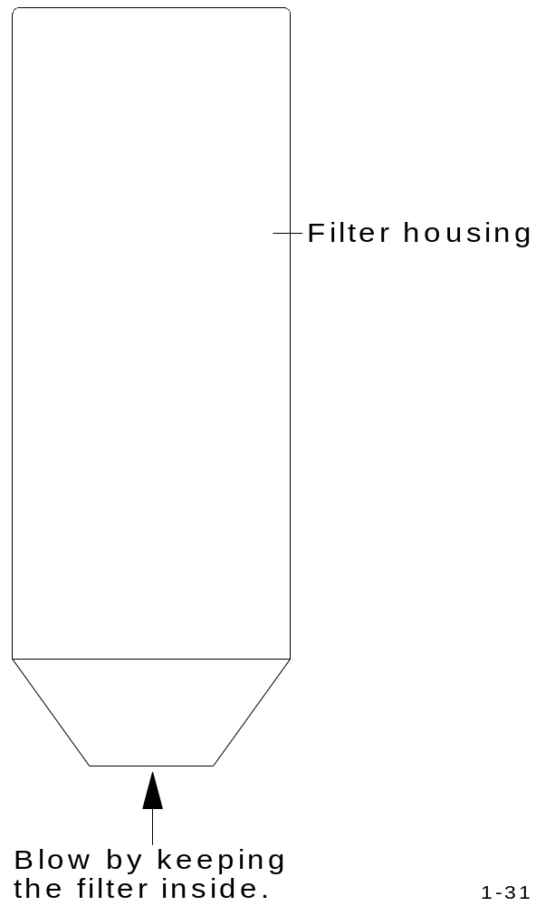

2 ADJUSTMENTS, TEST AND FUNCTION EXPLANATION

2.1 Gas flow controller adjustment and jumper settings:
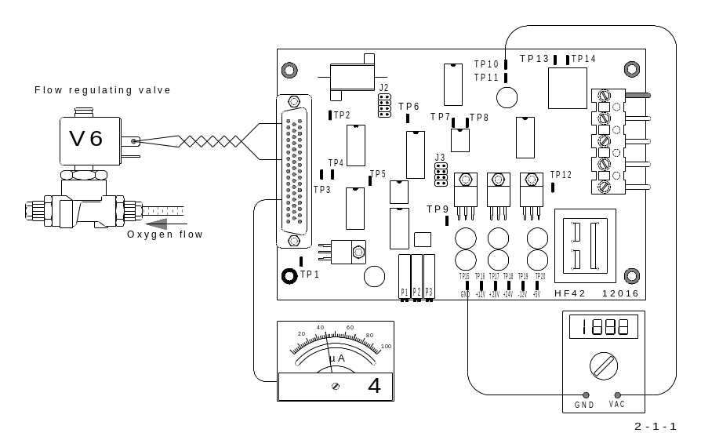

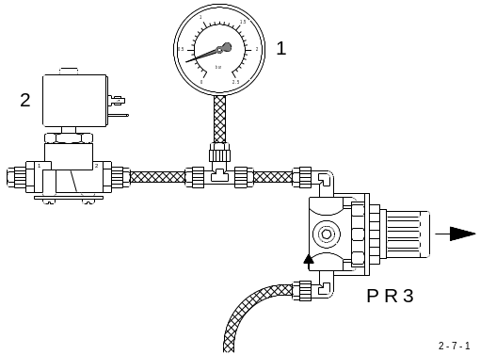

- Make sure that the pressure regulators are at least pre-adjusted. See 2.7 this is mainly important for the pressure regulator ( PR3 ) in front of the gas flow regulating valve.
- Set the flow rate with P1 of the HF 42, to about 180 l/h. Observe the flow rate on the lower flow meter of the analyser, wait until the value has settled.
- The output of the flow sensor is found on TP10 of the HF 42 board; TP15 is GND.
With a flow of 180 l/h, the voltage is about 2.5 – 3 V.
Please note: without flow, the output voltage of the sensor is not 0 V, but about 0.6 V.
- Adjust with P3 until the voltage on TP7 is 5 V.
- On TP8, the activity of the pulse width modulator can be checked.
- The output voltage to the gas flow regulation valve can be measured on TP3.
With a constant flow of about 180 l/h, it should be between 5 and 15 volts.
The panel meter ( 4 ) must indicate between 30 and 70 µA.
- Check and if necessary readjust the pressure regulator ( PR3 ) in front of the flow regulating valve. See 2.7

- Jumper settings:
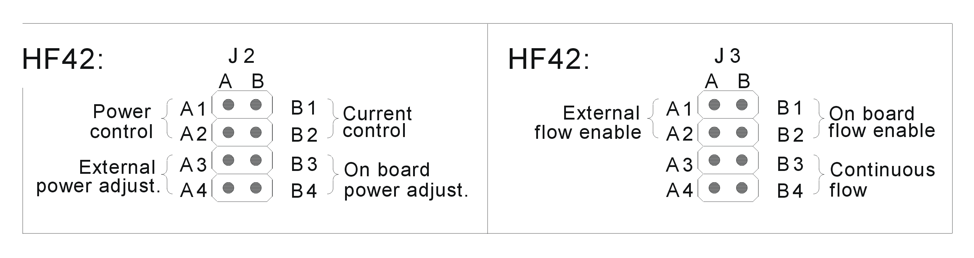

Detailed explanation of the gas flow regulation:

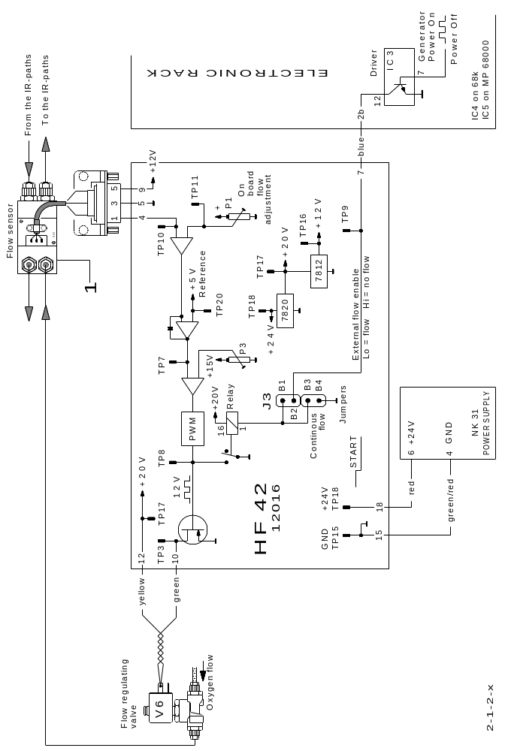

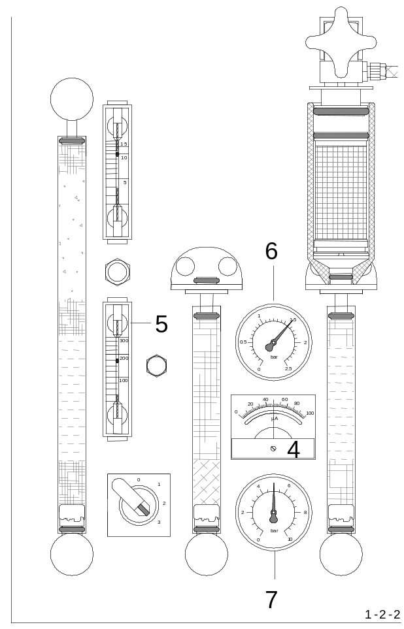

The flow controller mainly consists of the following components:

- The flow sensor ( 1 )
- The flow regulating valve ( V6 )
- The flow control board HF 42

The flow sensor detects the gas flow, and converts its amount into an electrical voltage.
This voltage is then sent, as a feedback signal, to the HF 42 board.
The HF 42 board compares this feedback value, to the flow set point value.
The signal resulting from the comparator, runs a pulse width modulator.
Its output can be seen on TP 8.
The pulse width modulated signal runs a power transistor, which in turn, supplies the output signal to the flow regulating valve.
The duty cycle of the output signal determines its DC voltage, which, with a flow of about 180 l/h and with clean chemicals, measures around 9 V ( on TP 3 ).
The HF 42 board drives the flow regulating valve ( V6 ) in such way, to provide a constant and accurate gas flow. The µA meter ( 4 ) shows the rate, at which the flow valve ( V6 ) is driven „open“.
Remark:
Due to a few failures of the flow sensors, almost exclusively on the CS-800 at customers who regularly treat their samples with acid, we concluded that the reason of the failures should be of chemical nature i.e. acids and Schutze`s Reagent damage the sensor.
The solution is to prevent the analysis gases to get in contact with the sensors. Therefore the sensor ports are connected with long tubes to the gas flow system. There is no gas flow through the sensor tubes but only the pressure is sensed by the sensor.
In case of failure of a previous version sensor, it is advisable to replace it by the new version. In this case the part numbers of the complete assemblies should be used for ordering. In case the analyzer has already the new version sensor, the order should include the spare part number. See attached drawings.
The new flow sensor can not be used as a replacement for the older flow sensor consisting of a rotameter and a optical element.
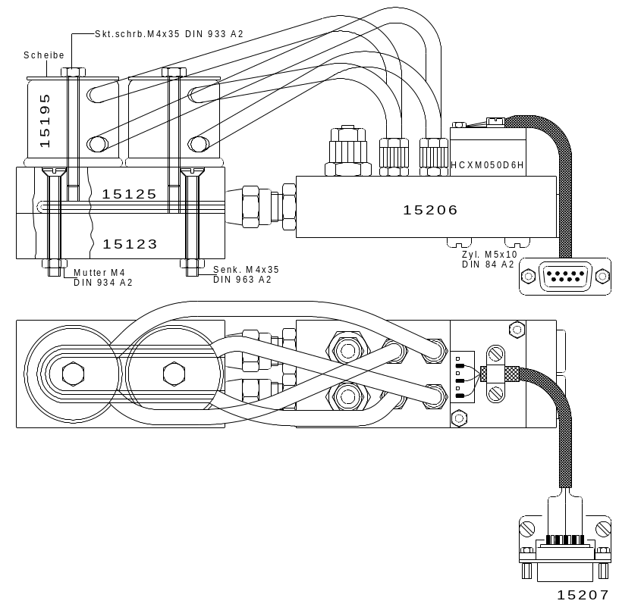

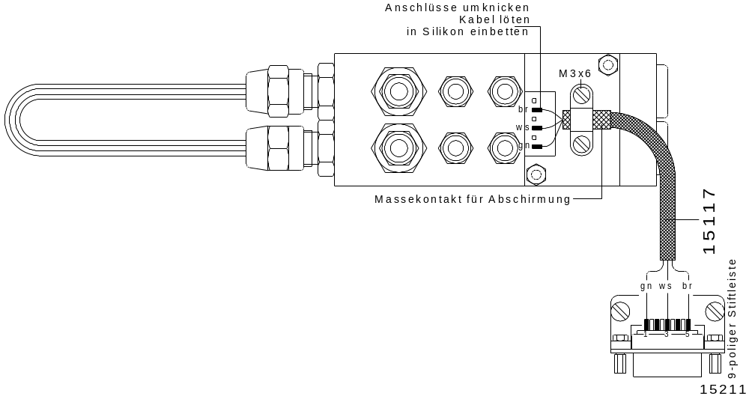

2.2 Pressure switch:

- Close the furnace.
The pressure switch should be adjusted, to about 1 bar ( 15 psi ); this means that under
1 bar ( 15 psi ), the contact is open ( no contact ), and over 1 bar ( 15 psi ), the contact
is closed ( turned on ).
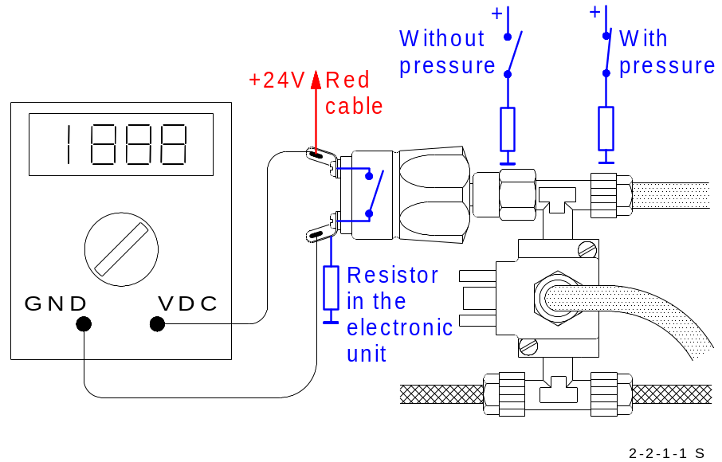

- In installed condition and with the analyser turned on ( Power switch set to pos. 2 ), there should be a voltage of 24 V DC when the pressure is under 1 bar ( 15 psi ).
If the pressure is over 1 bar ( 15 psi ), then the voltage should be zero.

ATTENTION ! Measure this with a high-impedance digital voltmeter!
Do not cause a short circuit while measuring, or else the
electronic drivers will blow!

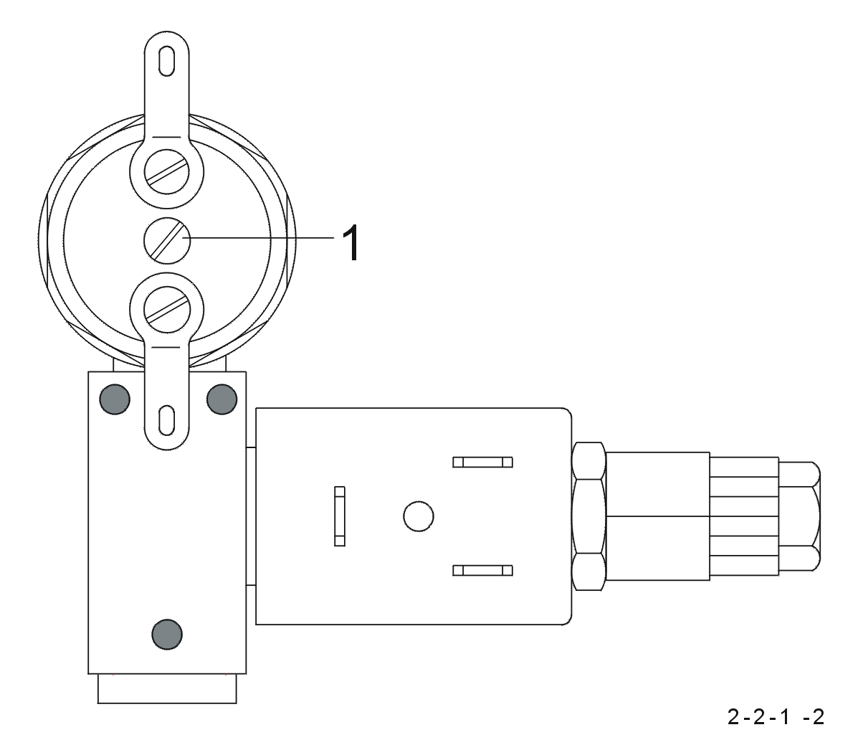
- If necessary, the oxygen pressure can be adjusted to 1 bar ( 15 psi ). This can be read off the upper pressure gauge of the analyser.

- The switch point can be set by turning the screw ( 1 )

- If the switch is turned off ( 24 V ) when the pressure is at 1 bar ( 15 psi ), then the screw ( 1 ) should be turned counter clockwise until the switch turns on, measuring the power until it reaches zero volt.

- If zero volts are measured when the pressure is at 1 bar ( 15 psi ), the screw ( 1 ) should be turned clockwise until the voltage goes to 24 V.

2.3 Infrared zero- baseline, control and adjustment:

The infrared cell zero-baseline is normally controlled by the electronic and automatically set to zero.
The auto – zero control should be disabled In order to control and adjust the infrared cell zero-baseline manually, this way the electronics will have no influence. This can be done by pressing the < Menu > and < Cal > keys.
The voltage exiting the infrared channel should be shown as in the following example:
- 0.13
- 0.21
- 0.18
- 0,17
The displayed numbers refer to the IR-cell output voltage:

The upper number refers to the voltage of channel 1
The next number refers to the voltage of channel 2
The next number refers to the voltage of channel 3
The lower number refers to the voltage of channel 4

The channel numbers can be shown on the display by pressing: < Menu > < 5 >
Return by pressing < CLR >.
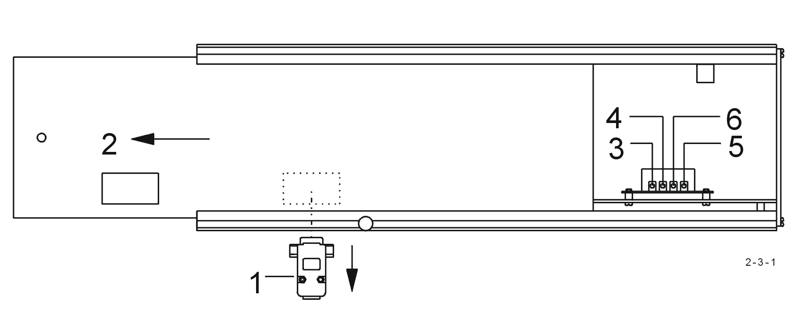
If at least one voltage exceeds +3.0 volts, then the zero-signal needs to be adjusted.

- To adjust the zero signal, push the left cover plate ( 2 ) of the infrared cell about 10 cm towards the back.
With a small screwdriver, adjust the trimmers ( 3 / 4 / 5 / 6 ) in the infrared rack, so that the numbers shown on the display are between + 0.20 and - 0.20.
The adjustment should preferably be carried out while the carrier gas is flowing.

If the zero level ( between + 0.20 and - 0.20 volts ) cannot be reached, and if more
than two adjustments were recently carried out, then the problem could be:
- Contamination of the IR-paths, see 3. 1
- bending of the IR-source, after rough shipment of the device, see 3. 2
- insufficient supply voltage for the Infrared, see 2. 4

The stability of the displayed numbers should be better than ±0.01.
Normally, the second digit after the decimal comma does not change, or it may
fluctuate up and down by only 1, since this could be actually on the rounding point.
If the fluctuations are larger, then there is a major degree of noise, see 1.20
The drift should also be very small. Within 10 minutes the second digit after the
decimal point should not change more than 1.
The drift should first be checked when the analyser has been switched on
( power switch on setting 1 ) for at least one hour, better would be two hours, and
the oxygen flowed for about 10 to 15 minutes ( Power switch on setting 2 ).
In case the drift is too large :

- Check the temperature regulation, see 2. 5
- Unstable power supply, see 2. 4
- Defective IR-source, see 3. 2
- By pressing the < CLR > key, you can end the test.

- Notice :
If the infrared cell's output voltage is over 10 volts,
++++ is shown on the display, ++++ then there is a serious defect.

Adjusting the infrared cell:
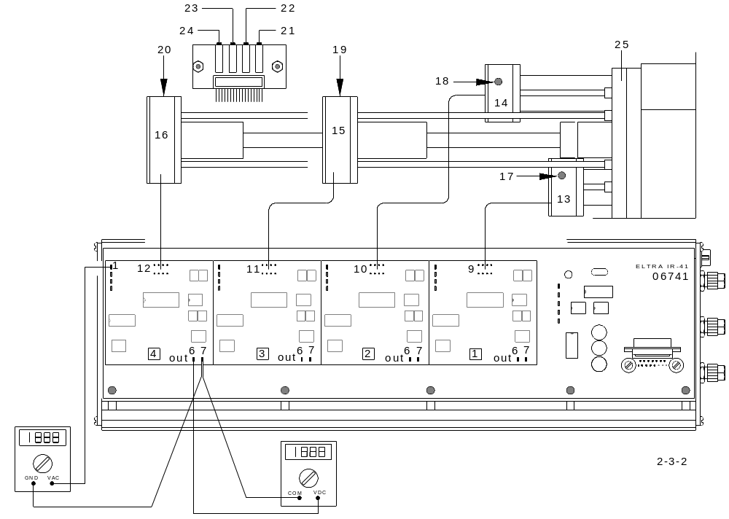

The connection sockets of the measurement channels ( 9 / 10 / 11 / 12 ) are predetermined on the circuit board IR 41.
The position of the IR-paths on the path plate ( 25 ) is irrelevant. Each IR-path can be changed, according to the required measuring ranges.
The connections to the IR 41 board, however, is very important:
9 Connection for section ( 1 )
10 Connection for section ( 2 )
11 Connection for section ( 3 )
12 Connection for section ( 4 )
( C or S, depending on the layout of the Analyser, see 3.11 )
13 / 14 / 15 / 16 Pre-amplifiers
17 / 18 / 19 / 20 Adjusters
21 / 22 / 23 / 24 Zero fine adjustment
- Each channel is adjusted separately.
- Set the trimmers ( 19 / 20 / 21 / 22 ) in the middle of their range.
- Connect a digital voltmeter on the outlet 6 and the ground 7
( measuring range 200 V DC )
- Adjust 0 volts DC by adjusting the preamplifiers (13 / 14 / 15 / 16 )
- Turn the trimmer clockwise for lower voltage, counter clockwise for higher voltage.
After the zero adjustment, the voltage on test point 1 should be about 1 to 1.5 volts
AC( measuring range 2 V AC )
- Install the infrared cell in the Analyser.
- Restore the oxygen flow.
- After 30 to 60 minutes, adjust the zero by turning the trimmers ( 19 / 20 / 21 /22 ).
- To adjust zero, the < Menu > and < Cal > keys are pressed,
- Press the < Cal > key again to return to the analysis.
- On the temperature regulation card, check if the LED is blinking, see 2. 5

ATTENTION !
When the test signal fails on test point 1, this can be due to the 8-pin connector
( 9 / 10 / 11 / 12 ) that connects the pre-amplifier to the IR 41 board not being correctly connected.

- remove, turn 180°, and replace, the 8-pinn connector and measure again.

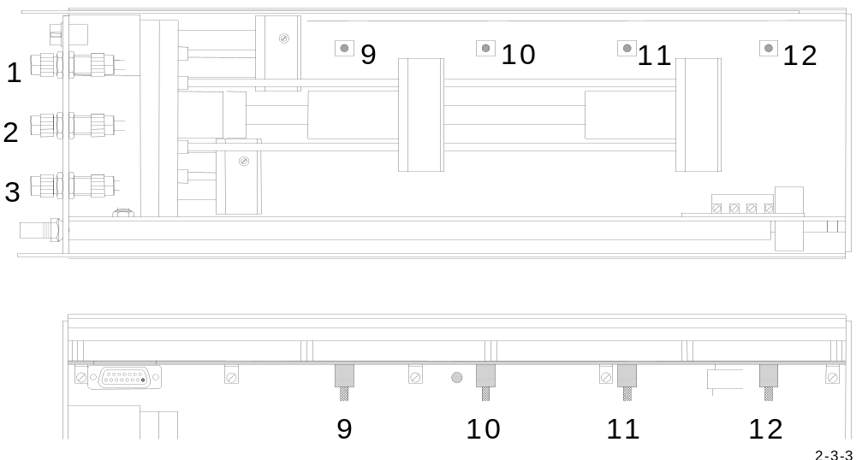

1 black marked tube connection
2 yellow marked tube connection
3 red marked tube connection

- When reinstalling the infrared cell into the analyser, you must pay attention to the colour markings of the tubes and their connections.

2.4 IR-source voltage setting:

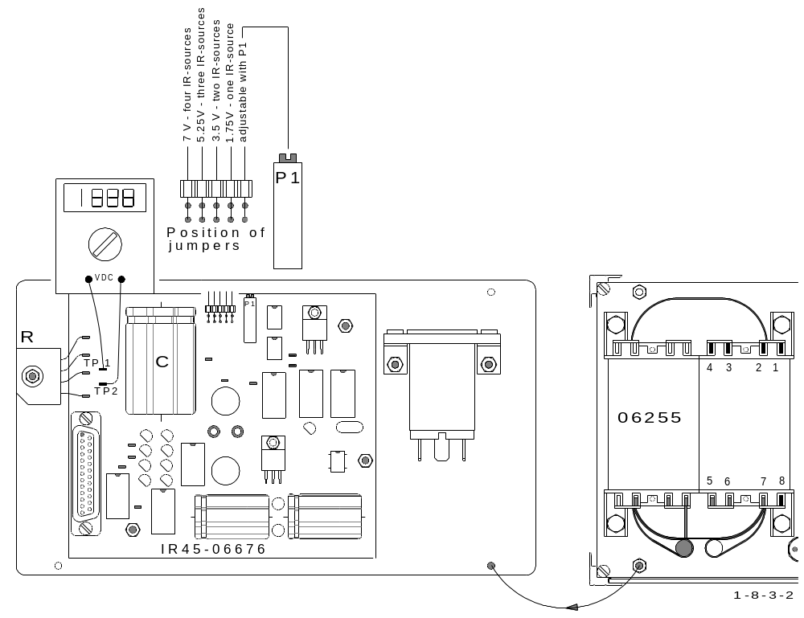

IR-source voltage, is to
be measured between TP1
and TP2 on IR 45 board. Transformer connections:

Blue cables
1,75 V DC for 1 channel device 1 Soldering Location for 1 channel device
3,5 V DC for 2 channel device 2 Soldering Location for 2 channel device
5,25 V DC for 3 channel device 3 Soldering Location for 3 channel device
7 V DC for 4 channel device 4 Soldering Location for 4 channel device
( 1,75 Volts DC for each IR source ) 8 Always connected ( common )

- Set above voltages through Jumpers

- The voltage of the capacitor C must be about 5 to 6V higher than the voltage of the IR-source measured on the a.m. test point.

- If the voltage of C is too low, either the transformer is not correctly connected, or the rectifier R is out of order.

2.5 Temperature regulation of the IR-cell:
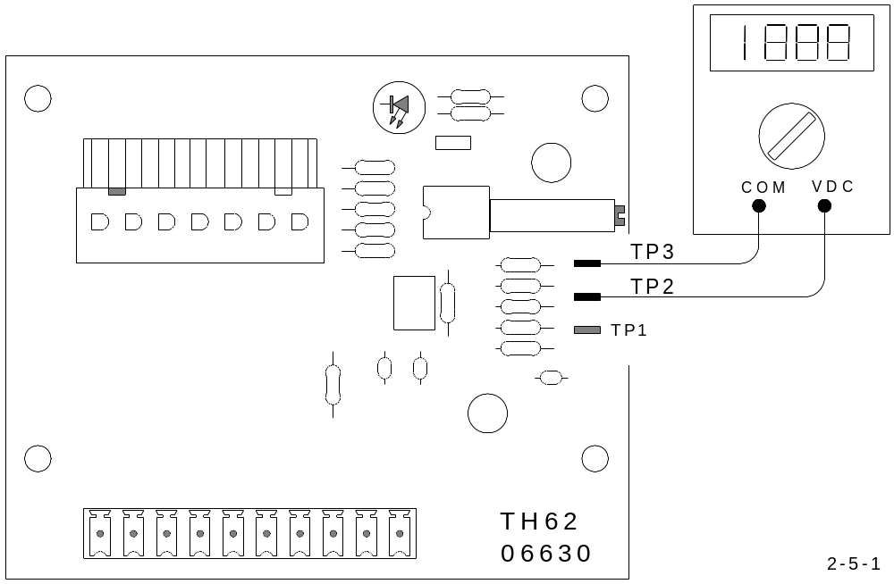

The adjustment should preferably be done only when the analyser, and the
infrared cell, has been in operation for at least one hour.

- If the LED is always off, adjust P1 on the TH 62 board clockwise for higher
temperature set point.

- If the LED is always on, adjust P1 counter clockwise for lower temperature
set point.

In case the LED is already blinking, adjust the flash rate of the LED to 50%
duty circle.

ATTENTION!
- The effect of the readjustment will appear in a few minutes, as soon as the temperature has changed to the new setting.

- The voltage on TP1 ( TP2 = GND ) does not correspond to the actual temperature of
the IR-cell, but it corresponds to the power needed to keep the IR-cell at a constant
temperature.

- When the environmental temperature goes down, the heaters of the IR-cell need
higher power to keep the temperature of the IR-cell constant. In this case the
voltage will go higher.

- The opposite happens when the temperature in the laboratory goes higher. The IR-cell heaters need less power to keep the temperature constant, so that the voltage will become lower.
- The adjustment of the IR-cell should be done, if possible, when the laboratory has the average temperature of a year. The set point of the IR-temperature should then be adjusted with P1 so that the voltage in stable condition measures 6 volts.

- For readjusting, turn P1 when the voltage to is too low clockwise, when the voltage is to high turn counter clockwise.

- Caution: After you have turned P1, several times the voltage will be out of range. This is normal. When turning P1 you enter a new set point of the IR-cell temperature which is at that moment different to the actual temperature of the cell.

- The temperature control circuit will give full power to the heaters ( in case you have set a higher temperature ) or the circuit will completely shut down the power to the heaters, if you have adjusted a lower temperature set point than the actual temperature.

- After about 10 minutes the temperature will reach the new adjusted level, and the voltage will come back to remain stable at the new level.

- This is the voltage level which corresponds to the power to keep the
IR-temperature stable at the new level.

- If the LED still doesn’t start blinking , adjust P1 on the TH 62, until there is about
5.35 V DC present between TP2 an TP3.

- If the fault still remains, despite adjusting the TH 62, then check the board NR 32,
according to the following instructions.

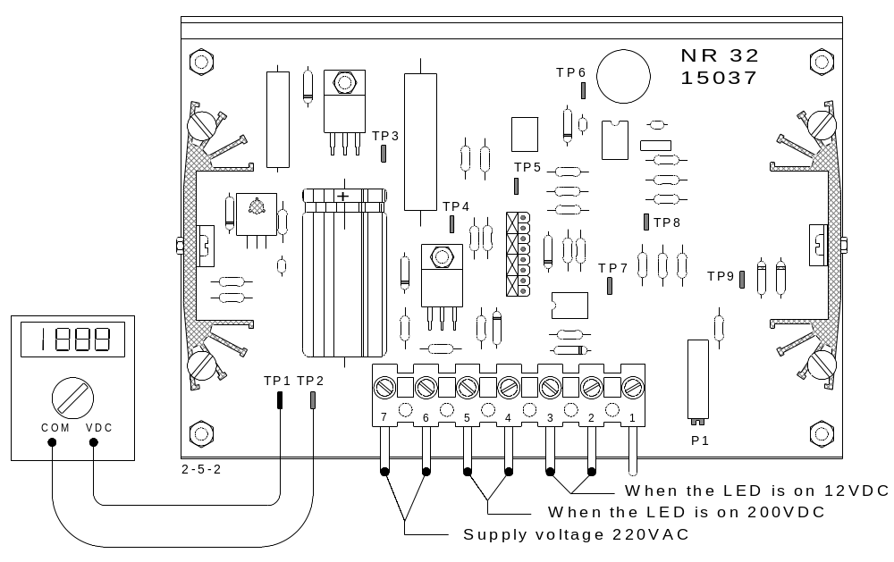

- CAUTION! ELECTRICIAL HAZARD !

- You should be able to measure 200 V DC between TP1 and TP2 ( GND ) of the NR 32 board; otherwise the board is faulty.

- This requires that 220 V AC comes through the connectors 6 and 7

- If there is no 220 V AC, then there could be a bad contact in the plug.

- The voltage for the infrared cell heating elements, comes from the connections 4 and 5 of the 7 pin plug, measure the voltage on the screws, without disconnecting the plug.

- As long as the LED is on, there is 200 V DC between 4 and 5.

- As long as the LED is off, there is no voltage between 4 and 5.

If there is no voltage between 4 and 5, then the NR 32 is faulty. Replace it, according to 3. 6.

- The above sentences, extend to the board TH 62. From there they feed the heating
elements.

General description of the infrared cell temperature regulation:

For more details see 4.2

Simplified diagram with TH-62

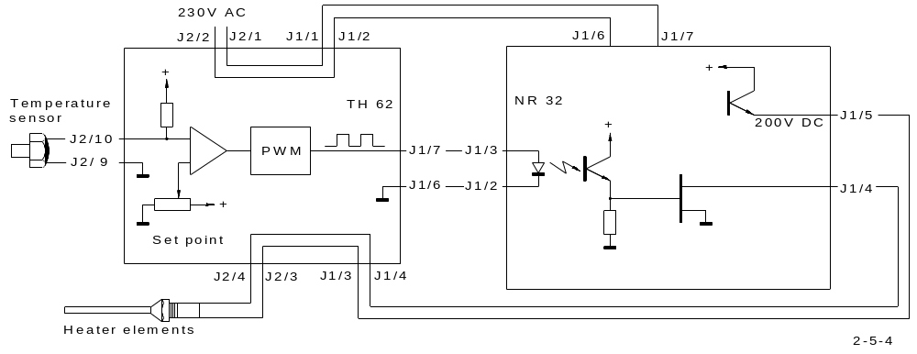

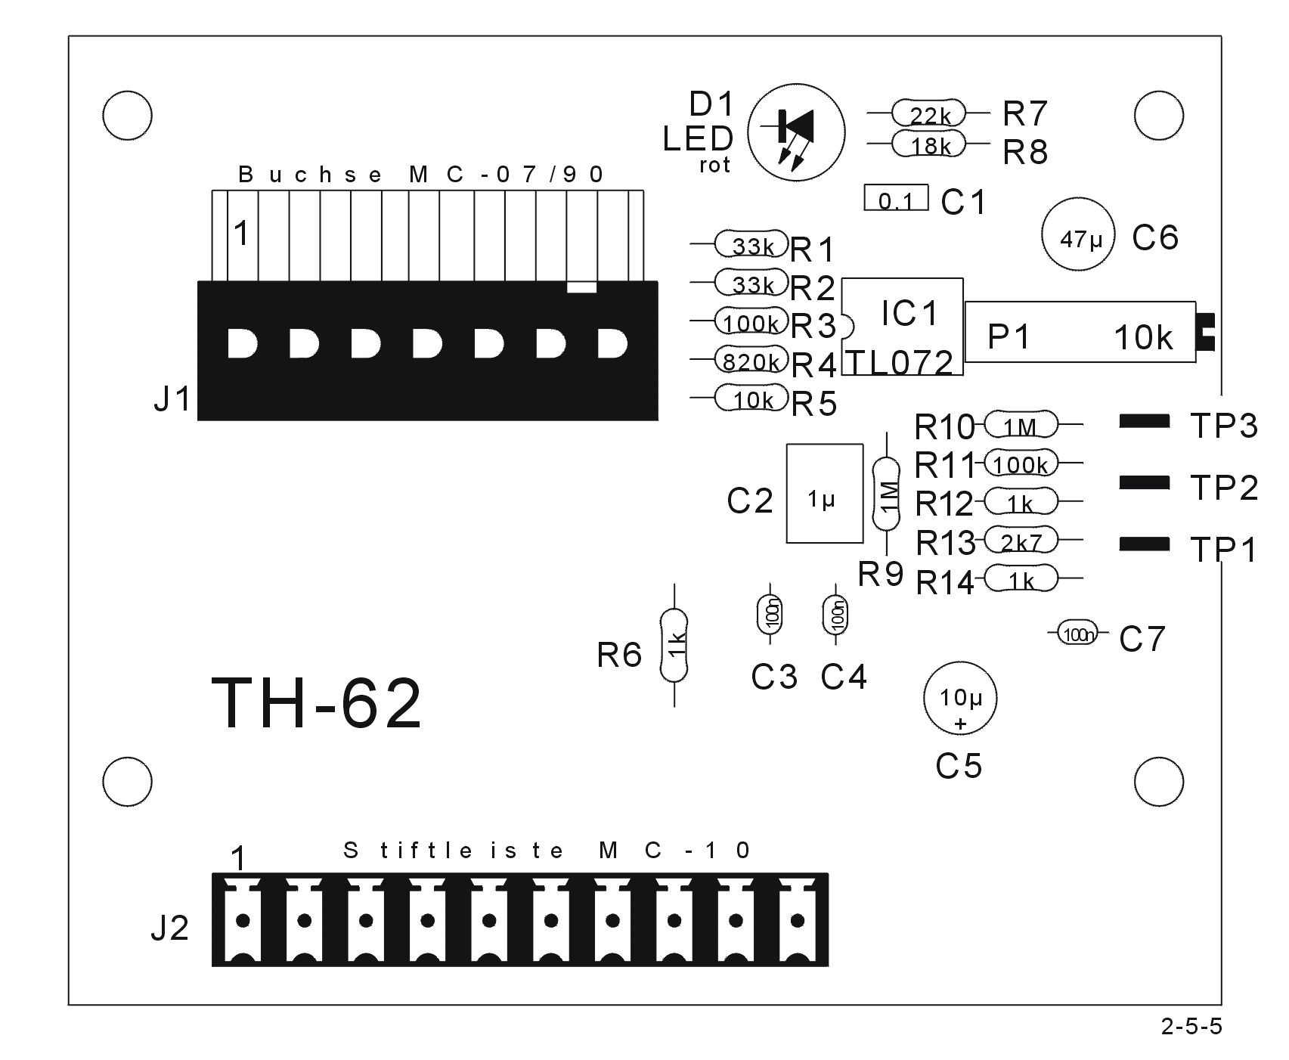
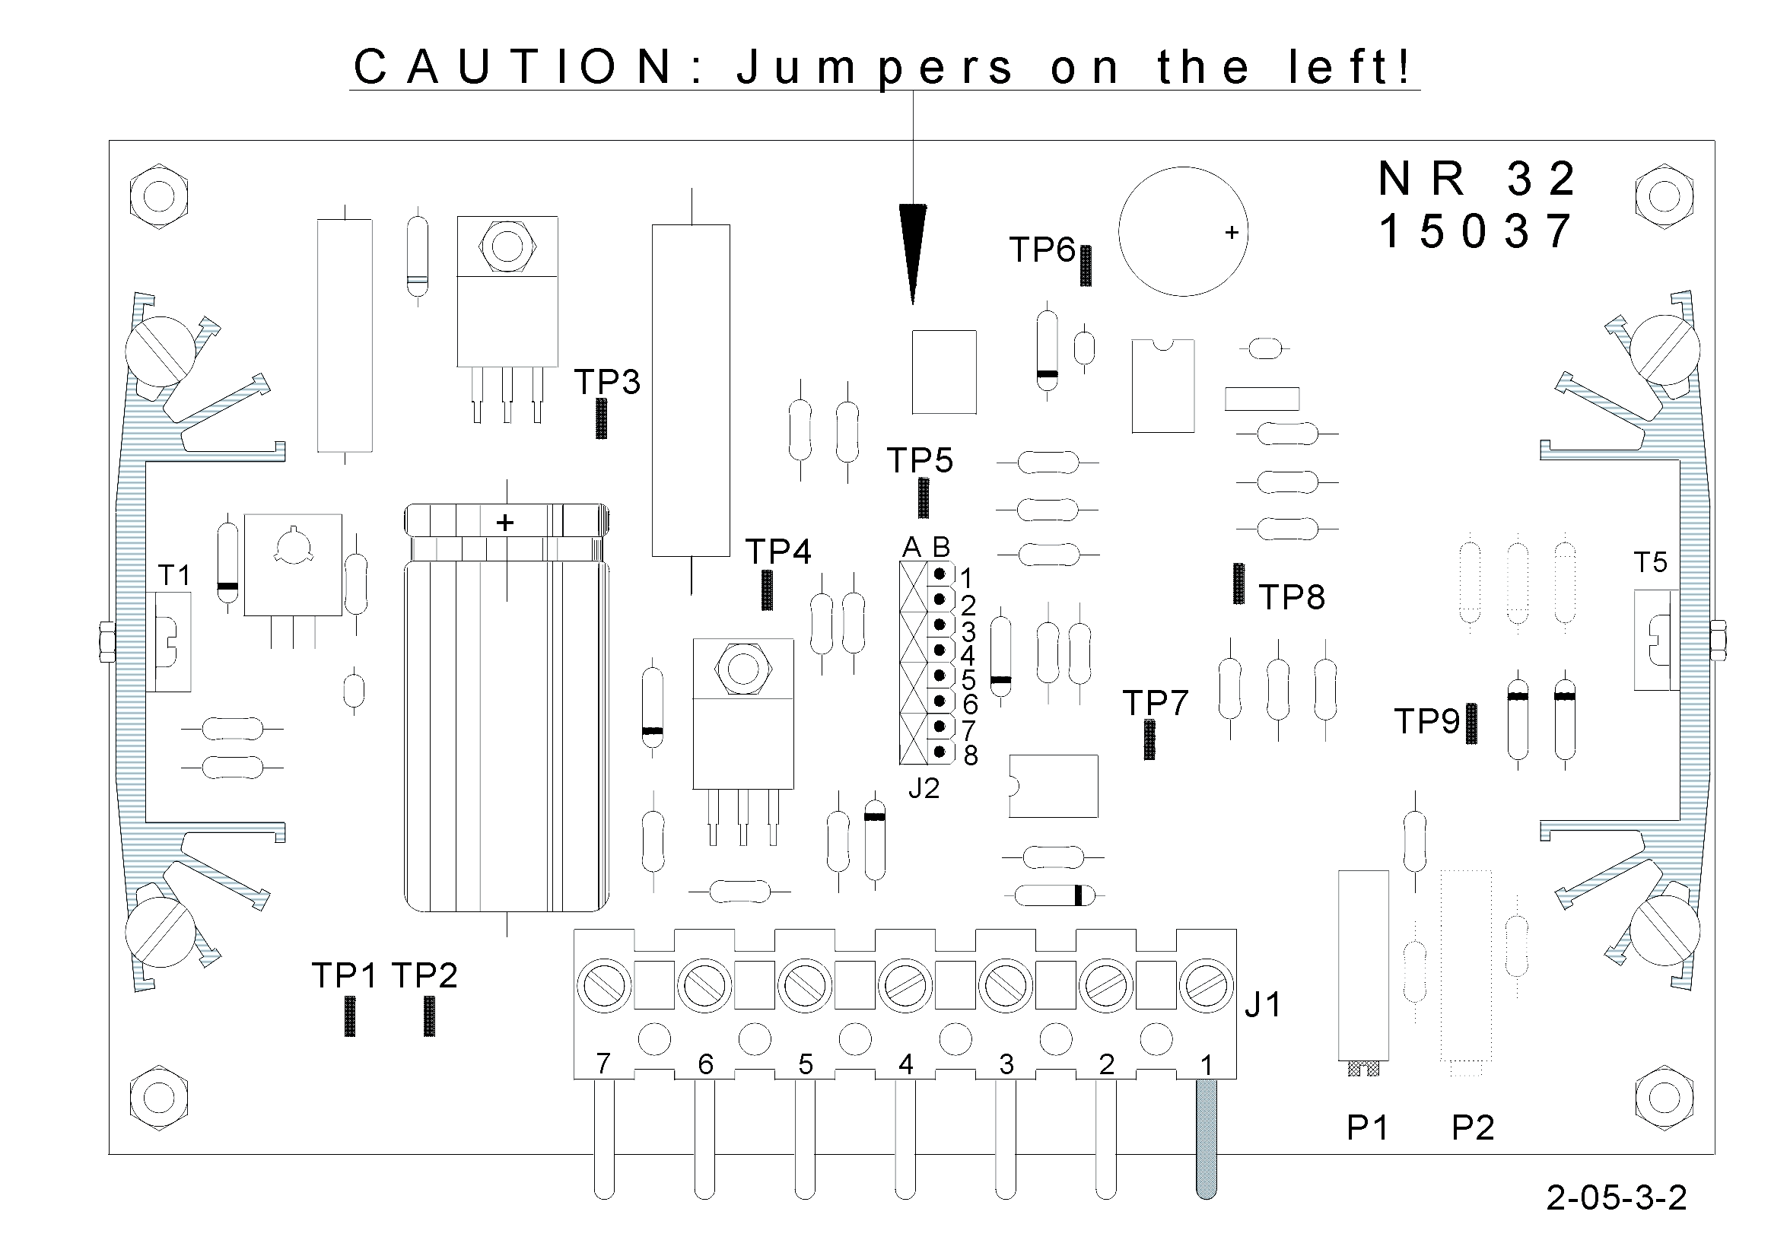

This system consists mainly of the following components:

- The temperature sensor
- The temperature control board TH 62
- The power stage board NR 32
- The heater elements

The temperature sensor feels the temperature of the infrared system, and sends the signal to the temperature control board TH 62.

The TH 62 compares this signal with a set point value. The resultant value drives a pulse width modulator. The LED of this board shows the function of the modulator.

The modulated signal further drives and power stage of the NR 32 board; the power signal returns to the TH 62 board, from there it finally goes to the heater elements.

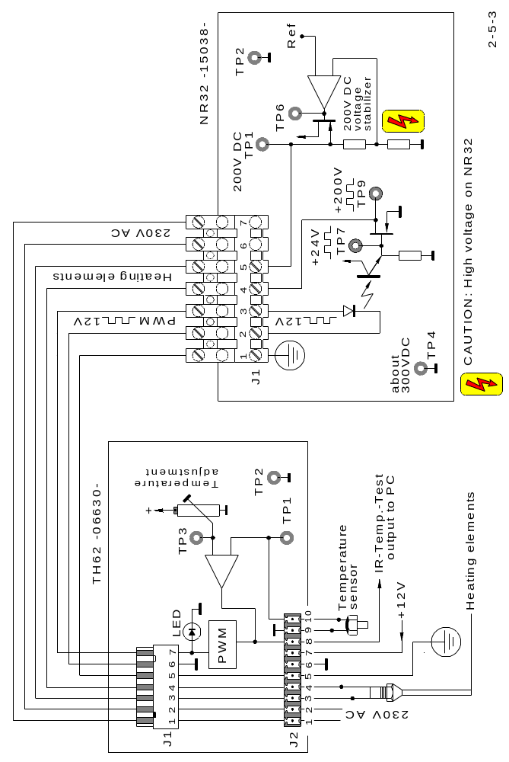

2.6 Pneumatics:
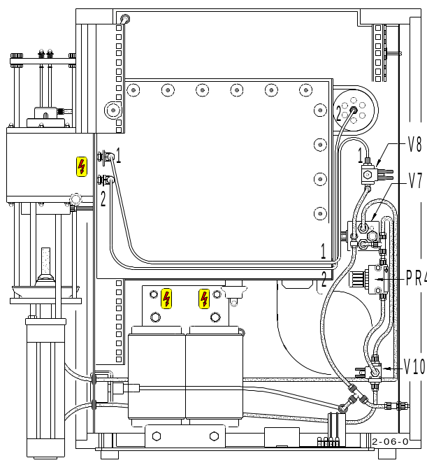
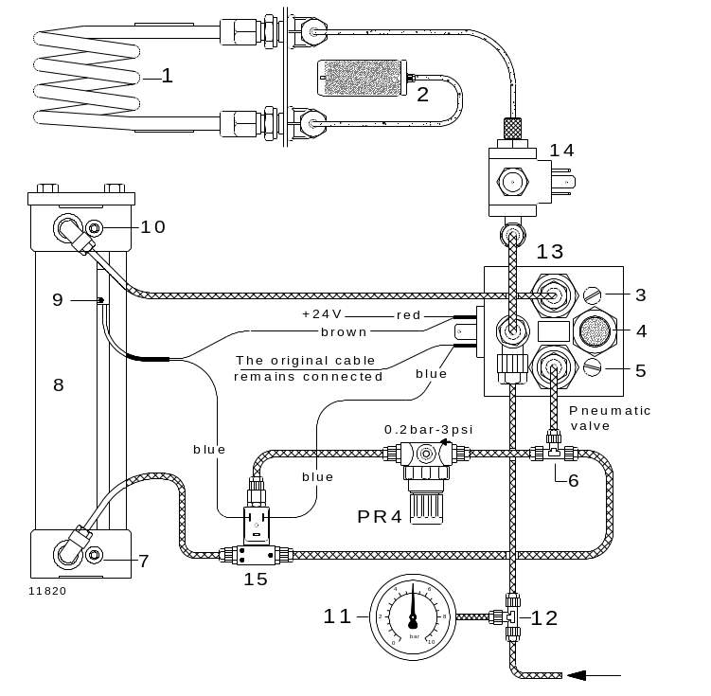

1 Combustion coil 6 T-piece 11 Pressure gauge
2 Muffler 7 Lower cushioning 12 T-piece
3 Upward speed regulator 8 Pneumatic cylinder 13 Pneumatic valve
4 Muffler 9 Magnetic switch 14 Coil cooling valve
5 Downward speed regulator 10 Upper cushioning 15 Pressure reduction valve
PR4 Pressure regulator

Adjusting the pneumatics for correct furnace movement:
- Check if the air pressure on gauge ( 11 ) is between 4-6 bar.
- Press the button ↓ ↑ to open the furnace.
- Open the right-side panel of the analyser, to find the pressure regulator PR4 and the pneumatic valve ( 13 )
- Turn the screw ( 5 ) counter clockwise, for minimum air restriction. Leave it in that position.
- Rotate the knob of the pressure regulator PR4 fully counter clockwise.
- Turn the screw ( 3 ) clockwise, for maximum air restriction. Leave it in that position.
- Shift the magnetic switch ( 9 ) fully upwards.
- Press the button ↓ ↑ to close the furnace ( furnace floor won’t yet move ).
- Adjust regulator PR4, until the furnace floor can rise completely, without shaking,
- For safety precaution, a person still can stop moving the furnace floor with only one hand.
- When the furnace is closed, shift the magnetic switch downwards until it switches on;
Now shift down another 5 mm.
- Open the furnace and then close it, to check if the adjustments are still correct.
- Adjust the furnace upwards speed with screw ( 3 ), it must be within a reasonable limit.
- Adjust the furnace downwards speed with screw ( 5 ), it must be within a reasonable limit.
- Adjust lower cushioning ( 7 ), so that the furnace opens without banging at the bottom.
Magnetic switch of the pneumatic cylinder:

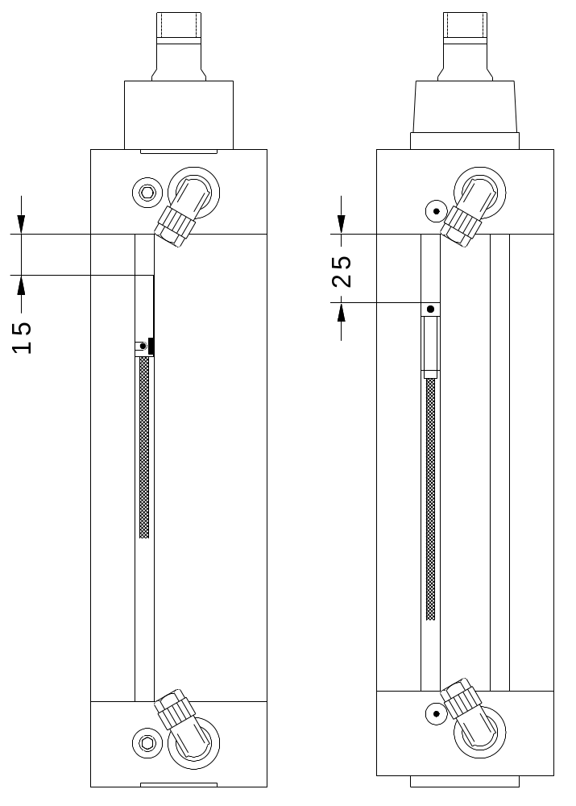

Cylinder model with one Cylinder model with two
slot pre-adjust 15 mm as above. slots pre-adjust 25 mm as above.

Check the following :

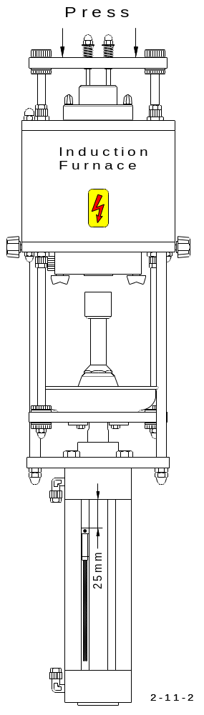
- Open the furnace ( piston down ).

- Hold the piston down by pressing on the horizontal
bar of the furnace. ( with the fingers )

- Press the key to close the furnace.

- Allow the piston to go up very slowly by controlling
the force of your fingers.
If not possible do the pneumatics adjustment.
see pages before.

- About 5 mm before the piston reaches it’s highest
position the force will increase.

- With your fingers press down firmly to make
sure that the piston can not be pushed down.

- If the piston starts vibrating by moving up and
down with full force, then adjust the switch higher.

- If the piston goes down, then adjust the switch lower.

2.7 Pressure regulation:

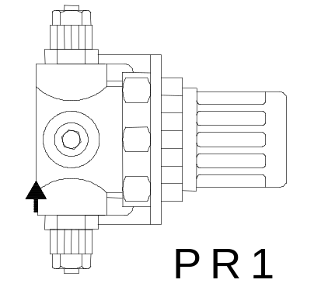

PR1 is the inlet oxygen regulator, and is situated inside the analyser, on the rear panel.
The outlet pressure needs to be set to 1.5 bar ( 22.5 psi ).

- Pull and rotate the knob of the regulator, until the pressure gauge ( 6 ) shows the correct value.
- Ensure that the flow shown on the flow meter ( 5 ) shows between 180 and 200 l/h; if not, adjust according to 2. 1.

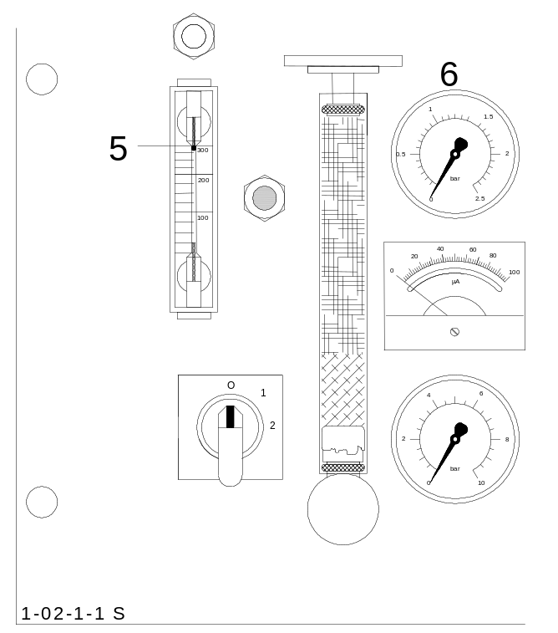

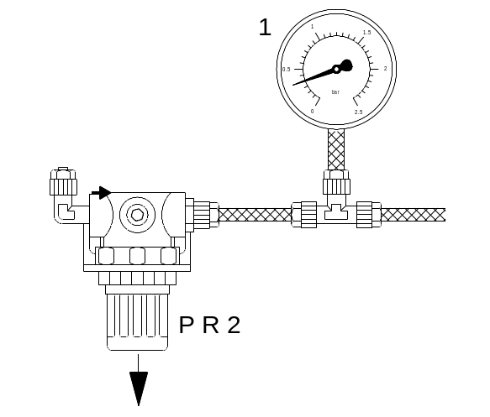

PR2 is the pressure regulator for the purging system of the IR-cell and it is situated
inside the analyser, just behind the left-side of the panel. It is positioned horizontally.
The oxygen pressure at the outlet of the PR2 should be 0.35 bar ( 5 psi ).

- The pressure can be checked by applying a T-piece on the outlet of the pressure regulator, and connecting a pressure gauge ( 1 ), as indicated above.

- Pull and rotate the knob of the pressure regulator ( PR2 ), until the correct pressure is shown on the gauge.
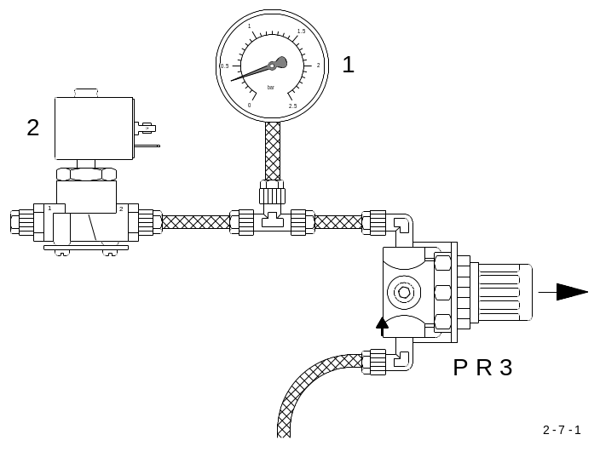

Using induction furnace operation:

PR3 regulates the pressure of the carrier gas that circulates through the IR-cell and
then finally out of the analyser. This pressure regulator is situated inside the analyser,
just before the flow regulation valve ( 2 ). The gas pressure at the outlet should be
0.7 bar ( 10 psi ).

- The pressure can be checked, by applying a T-piece on the outlet of the pressure regulator, and connecting a pressure gauge ( 1 ), as indicated above.

- Pull and rotate the knob of the pressure regulator ( PR3 ), until the correct pressure is shown on the gauge.
- Ensure that the flow shown on flow meter ( 5 ), see drawing on previous page, shows between 180 and 200 l/h; if not, adjust according to 2. 1.

For more accurate adjustment do this:

Increase the pressure slowly by turning clockwise and observe the upper pressure gauge ( 6 ) on the front panel. It may start vibrating. It may not vibrate even if you adjust the maximum possible pressure with ( PR3 ). The maximum possible pressure is slightly lower than 1,5 bar ( 22 psi ), because the incoming oxygen pressure is adjusted to 1,5 bar ( 22 psi ). After reaching the maximum pressure or when any vibrations should start, slowly reduce the pressure by turning PR3 counter clockwise.
Read the pressure on the gauge ( 1 ) when the vibration on ( 6 ) stops.
( In case of no vibrations read the maximum pressure you obtained ). Then go on reducing the pressure with ( PR3 ) and observe the volt meter ( 4 ). When it starts moving towards its maximum scale ( 100 µA ) stop reducing the pressure, and read it on the gauge ( 1 ).
Now adjust the pressure with ( PR3 ) at a level on the gauge ( 1 ) wich is about in the middle between the lowest pressure you read and the pressure you noted after the vibrations stopped.

For example:
The vibration stopped at the level of 1 bar. The volt meter ( 4 ) started moving to ist maximum at 0,3 bar.

Therefore: 1 bar + 0,3 bar = 0.65 bar on the gauge ( 1 ) with PR3
2

2.8 Closing cone, adjustment:

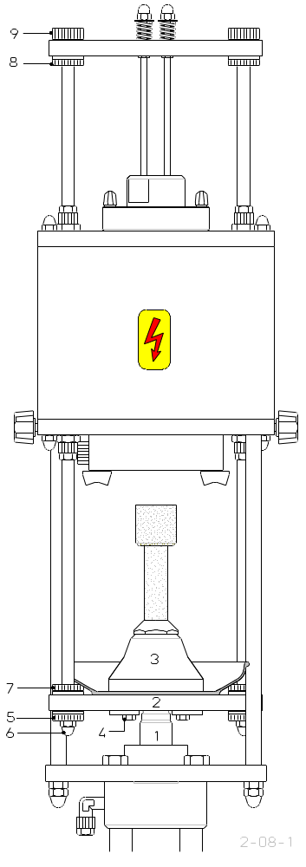
- You should ensure that the shaft ( 1 )
is securely fastened to the base ( 2 )
If not, hold the base ( 2 ) securely
and tighten the shaft ( 1 )
( engineers wrench size 17 )

- In order to adjust the cone,
the screws ( 4 ) should be loosened
so that the cone ( 3 ) moves horizontally
on the base ( 2 )

- Close the furnace ( with the lift upwards )

- Tighten the screws ( 4 )

- The cone is now positioned correctly

- The screws ( 7 ), ( 5 ), ( 6 ), must
now be well tightened in this order

- The screws ( 8 ) should be properly fastened
( with a wrench )

- The screws ( 9 ) should only be tightened
by hand

2.9 Linearisation:

The linearisation of the Analyser is done in our company and does not need to be repeated by the customer.
Therefore it is fatal to experiment with the linearity.
The following description applies only in case the number of channels are increased
see 3. 12 , or if the range of a channel has changed, ( for example, by installing a longer or shorter IR-path ).
The infrared cell is basically non-linear; meaning that its output voltage, is not proportional to the CO2 or SO2 concentration. In order to obtain the correct measurements, this non-linearity must be corrected electronically through the software. Once the „linearity factor“ has been entered, see description below.
For each measurement channel, the exact characteristic curve must be individually determined and programmed into memory.
After programming in a ( new ) factor, analyse a high and a low standard sample, to check the accuracy.
If, the measurement results after the test of the low standard sample are not correct, a new factor must be programmed and the test repeated.

Procedure:
1 ) Analyse the high standard ( 7 Volts to 8 Volts peak )
2 ) Note the result
3 ) < Cal > < 1 > < Channel Number >
4 ) < Standard Value > < Enter >
5 ) < Result > < Enter >
6 ) Analyse the low standard ( 2 Volts to 3 Volts peak )
7 ) If the result ( from 6 ) is too low, then the factor should be higher.
8 ) If the result ( from 6 ) is too high, then the factor should be lower.
9 ) < Menu > < . > < Channel Number >
10 ) < New Factor > < Enter >
11 ) < Nr > < New Factor > < Enter >
12 ) Repeat from # 1

Approximate standard samples for linearisation and calibration:
of the usual standard ranges for metal analysis.

Channel 1 : Carbon ( low ) linearisation factor Approximate value 23000:

0.197%C 400 mg
0.151%C 500 mg
0.100%C 500 mg
0.067%C 500 mg
0.023%C 500 mg

The standard for successive calibration is 0.151%C

Channel 2 : Carbon Linearisation factor Approximate value 23500

3.920%C 500 mg
3.200%C 500 mg
2.080%C 500 mg
1.050%C 500 mg
0.452%C 500 mg
0.243%C 500 mg

The standard for successive calibration is, 2.080%C

Channel 3 : Sulphur Linearisation factor Approximate value 50000

0.230%S 500 mg
0.167%S 500 mg
0.103%S 500 mg
0.050%S 500 mg
0.022%S 500 mg

The standard for successive calibration, is 0.103%S

When the true factor is closely approached after using the above methods, an exact determination can be derived in the following way:
Rather than only one analysis, three separate analyses are conducted.
The arithmetic average is then taken.

1 ) Analyse the high standard three times.
2 ) Note the arithmetic average.
3 ) < Cal > < 1 > < Channel Number >
4 ) < Set Value > < Enter >
5 ) < Result > < Enter >
6 ) Analyse the low standard three times.
7 ) If the arithmetic average ( from 6 ) is too low, then the factor should be higher.
8 ) If the arithmetic average ( from 6 ) is too high, then the factor should be lower.
9 ) < Menu > < . > < Channel Number >
10 ) < New Factor > < Enter >
11 ) < Nr > < New Factor > < Enter >
12 ) Repeat from # 1 )

2.10 Programming the balance:

Basic settings for all types of balances:
2400 Baud
No parity
Send continuously

Please note:
We are not responsible for balances that have not been delivered through our company.

The below setting is only a general guideline. Some balance may have a different data or cable configuration and may therefore fail to communicate with the analyser. The balance
supplied by Eltra is a Sartorius, model CP 64. The balance is programmed ( always
with 3 Digits ) in our company, in order to establish a good communication with the analyser.

Should any problems arise, then please follow the next instructions:
At first switch the balance off by pressing and follow the steps below.

1) Switch the balance on, by pressing the TARE button by holding it down. Then
press the on/off button. Release first the and then TARE.

2) Selecting the first programming mode, 113 ( to stabilise the vibration ) by pressing
the first digit No. will appear on the display. Change the digit No. by pressing
Repeat step 2 until the No. 113 has been inserted then,
Store with a short press on the TARE button.

3) Selecting the 2nd programming mode 515 ( 2400 Baud )
Same usage as in step 2) and don’t forget to store with TARE (short press)

4) Selecting the 3rd programming mode 614 ( continuous data sending )
Same usage as in step 2) store again with TARE (short press)

5) After the programming has been done it is IMPORTANT to hold the TARE button again
until the display shows a row of 88888888 and then release the TARE button and the
balance is ready for operation.

The correct settings:

113 to stabilise the vibration
515 2400 baud
614 continuous data sending

CAUTION:
The balance model CP 64 has is a switch to enable / disable the programming mode.
The switch, when shifted to the left, disables the programming mode.

2.12 Induction generator control

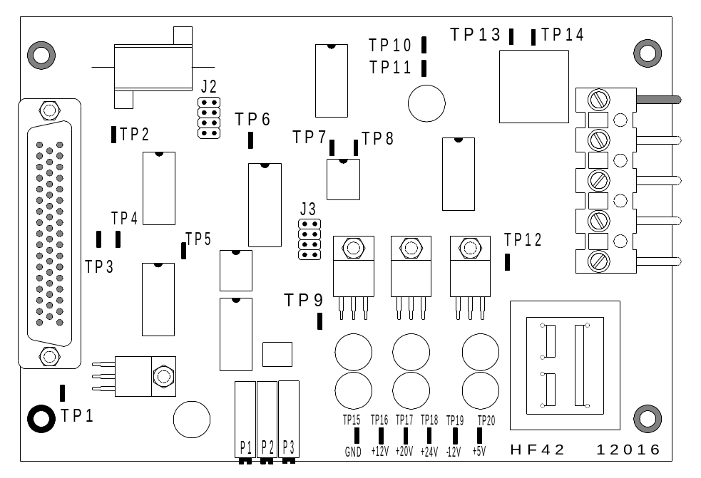

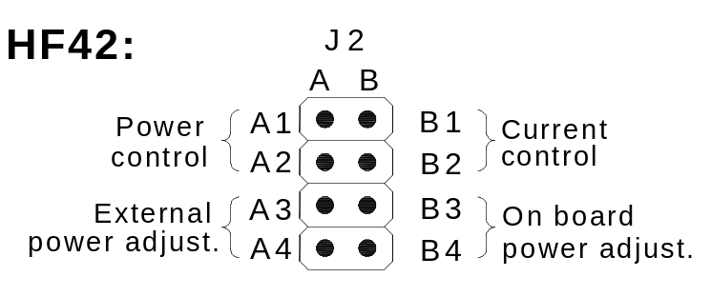

Current control:

The current control provides a safer and more accurate control of the furnace
intensity.

- Set the jumper J2 to B1-B2

- Connect a digital multi meter on TP1 ( TP15 is GND )

- Start the analysis, adjusting P2 until 6.3 volts DC are on TP1 (for copper analysis adjust 1.2 volts DC).
Adjust only, while the furnace is active.
The following diagrams show the relationship between the set value ( adjustment with P2 on the HF 42 board ) and the generator parameters.
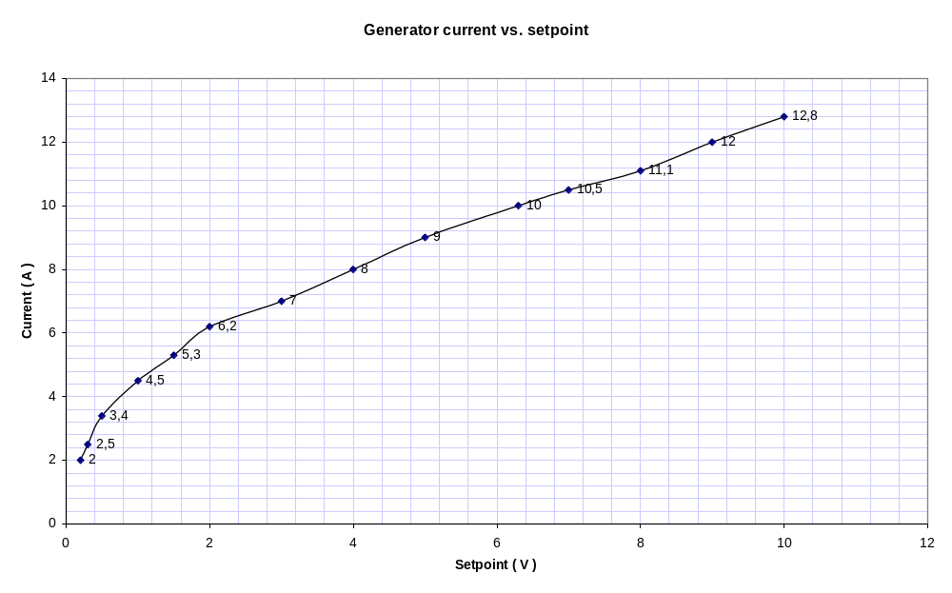
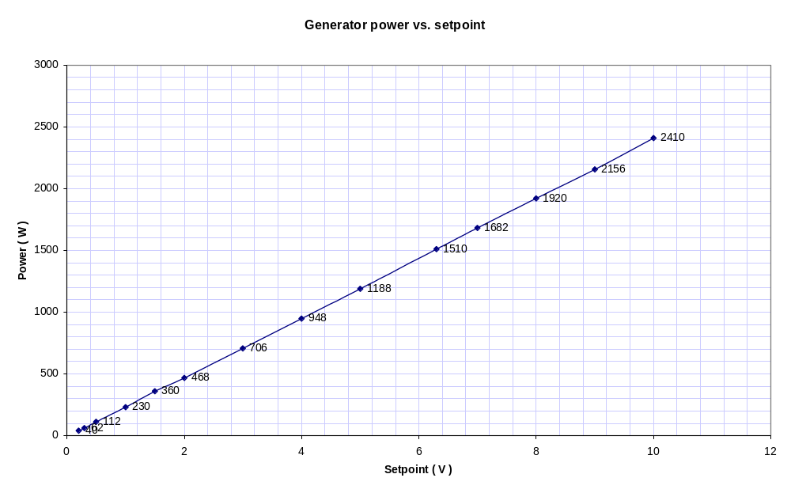

2.13 Diagnostic printouts:

By pressing the:

< Menu > < . > < 0 >

keys, a diagnostic report will be printed out on the printer.

Attention !

The printer port must be activated, with :

< Menu > < 3 > < 1 > < Enter >

This report should be faxed to ELTRA if interpretation or further instructions are needed.

2.14 Setting check up:

CAUTION!
If the analyser is currently being controlled by the PC, disable the latter by clicking on
the disconnect button of the main window.

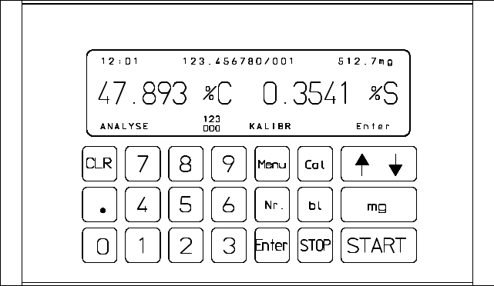




- Press , then

- Ignore the error message

- Press the number of the measuring range to be examined, e.g.

Low carbon

0.000035

24300

0

Now the display shows the setting as above. Starting from the top, the following
information appears:

- The measuring range
- The calibration factor
- The linearisation factor

- The blank value

- Conclude this section, by pressing

CAUTION!
Do not press any other key instead of Enter, otherwise the linearisation factor will
be affected and the analyser will be totally inaccurate.
Setting print out:

When a printer is connected to the analyser, all the settings, regarding all the measuring ranges can be printed out.



- Press , then , then , in order to activate the printer.



- Press , then , then , in order to print out the settings.

The following information is printed out:

- The serial No. of the analyser

- The internal software version

- The calibration factors for each measuring range

- The linearity factor

- The blank value

- The comparator level

3 SERVICE

3.1 IR-paths, cleaning and replacing:

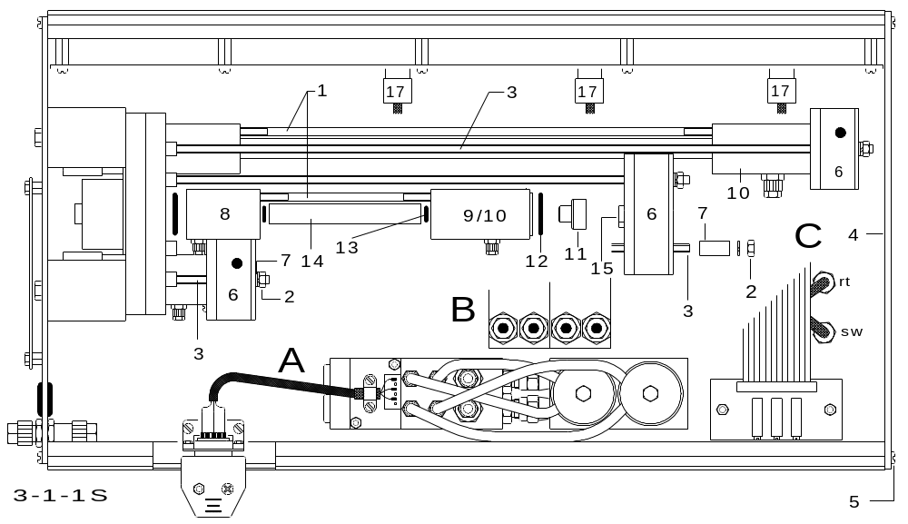

- Unscrew and remove the tubes from the IR-paths.
- Remove the nuts ( 2 ) ( Size 7 ); in doing this, the threaded rods ( 3 ) should be held
tight to prevent them from turning with the nut.
To be able to remove the nut ( 2 ) from the maximum length IR-path (10),
remove the plate ( 4 ) by unscrewing the four screws ( 5 ).
Take out the pre-amplifiers ( 6 ) together with the spacers ( 7 ).
- Clean the paths with a cleaning solvent, e.g., ethanol.
- With a three part path, such as ( B ) and ( C ), the windows can be cleaned on the inside using a cotton swab.
- In case of a single part path, such as ( A ), the path is filled with ethanol and, after a few minutes, oxygen is blown in, to clean and dry out the path.

Soiling, which can accumulate from the analysis of materials that contains a lot of sulphur and moisture or hydrogen, can be very difficult to clean. In such cases, the paths should be replaced.

- Before reassembling the paths, the threaded rods ( 3 ) should be screwed in by hand, in order to ensure that they are firmly installed.

- Assembly of the paths follows in the reverse order.
- Reconnect the plugs ( 17 ) of the preamplifiers ( 6 ), in case they were removed.
- After reinstallation, adjustments according to 2. 3 are highly recommended.

How CO₂ detectors can be recognized: How SO₂ detectors can be recognized:

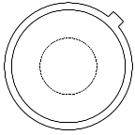
Square window Round window
Initial option: without any Initial option: without any
type number. type number.

Round window Round window
Later option: with type No.: Later option: with type No.:
407M36-611 407M36-118

- In case the infrared detectors ( 15 ) are to be replaced, you can recognize them as described above.

ATTENTION!:
After replacing a specific IR-detector, it is compulsory to zero-adjust:

- see 2.3 under „ Adjusting the IR cell “
- linearise, see Operation Manual 5.5 when operated by PC, see 2.9

and calibrate the corresponding measuring range:
- see Operation Manual 5.5 when operated by PC see Operation Manual chapter 6.
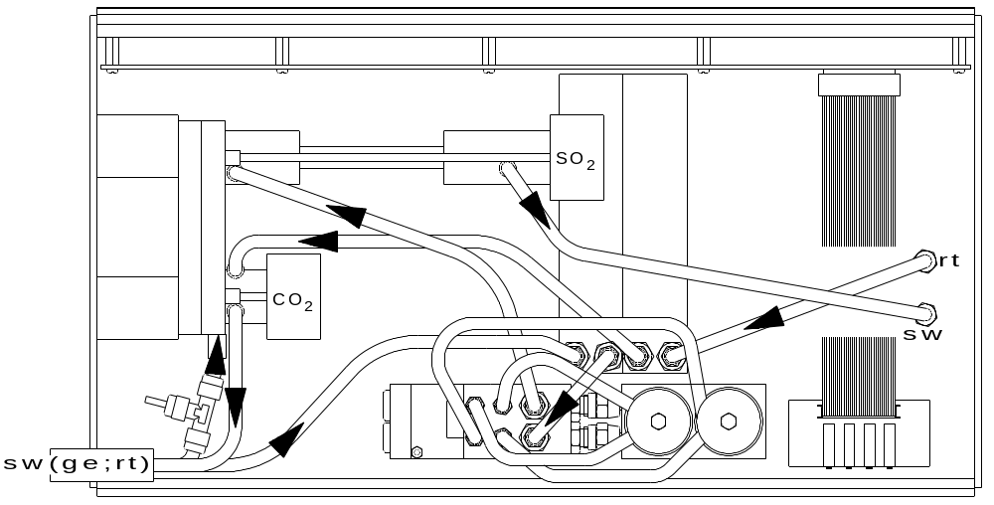

- black marked tube connection
- yellow marked tube connection
- red marked tube connection

- by reinstalling the infrared cell unit in the analyser, you must pay attention to the colour markings of the tubes and their connections.

Available infrared paths for the CS-800:

Path length | % C | Material/ Sample weight | % S | Material/ Sample weight
1 mm
3 mm | 6 | Metals / 500 mg
mm
6 mm | 5 | Metals / 500 mg
10 mm |  |  | 40 | Non Metals / 200 mg
20 mm |  |  | 20 | Non Metals / 200 mg
30 mm
40 mm
50 mm
100 mm |  |  | 4 | Non Metals / 200 mg
120 mm | 0,2 | Metals / 500 mg
140 mm
170 mm
200 mm | 0,1 | Metals / 500 mg
275 mm
300 mm |  |  | 0,3 | Metals / 500 mg

Comments:

1,5 g Tungsten accelerator are needed when analysing Metals.
Above sample weights for Metals and Alloys are just guidelines. For more accurate information please turn to Operation Manual 3.3 „Applications“
The following materials are used as Non Metals: cement, stone, soils, etc.

3.2 IR-source:
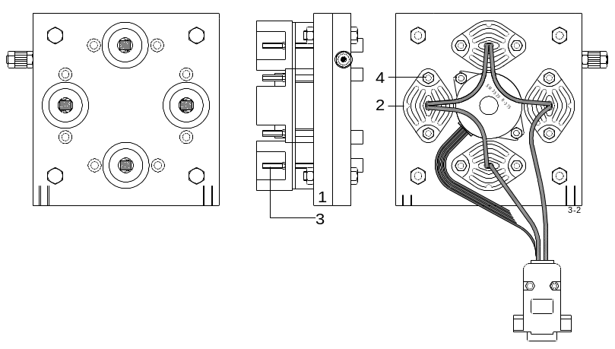
- The IR sources ( 2 ) are fastened
with the screws ( 3 )
- To install or removing the IR-source
( 2 ), the complete chopper
motor assembly ( 1 ), together with
the mounted paths and pre-amplifier,
should be removed from the infrared
unit, see 3. 5
The chopper motor housing ( 1 ) does
not need to be unscrewed. Either by
removing or installing the IR-source.

- In order to remove the IR-source,
unscrew the nuts ( 4 ) with a
( 5.5 mm wrench )
and counter the screws ( 3 ) at the
same time.

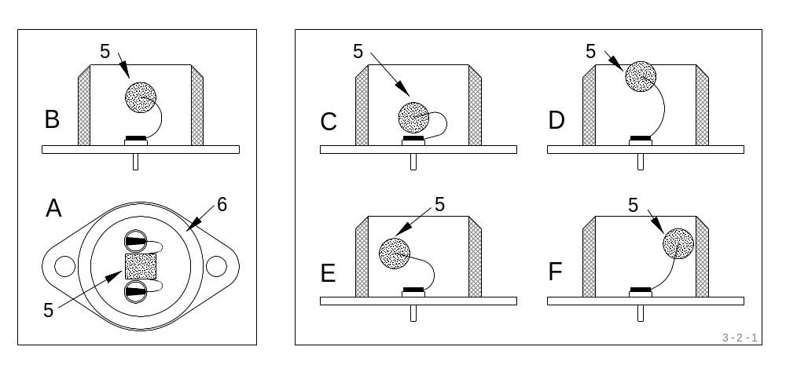
CORRECT WRONG!

CAUTION !
The IR source ( 5 ) itself should be in the middle of the ring ( 6 )
( this is without considering the location of the soldered connections,
which are not centered ).
See above drawing: A and B are correct, C, D, E and F are wrong.
Avoid moving the IR-source back and forth, try placing it correctly the first time.

- After re-assembling the infrared cell, adjust according to 2. 3

3.3 Infrared electronics:

The complete signal processing for all channels is handled through the circuit board IR 41. In the event of a failure, the entire circuit board should be exchanged.

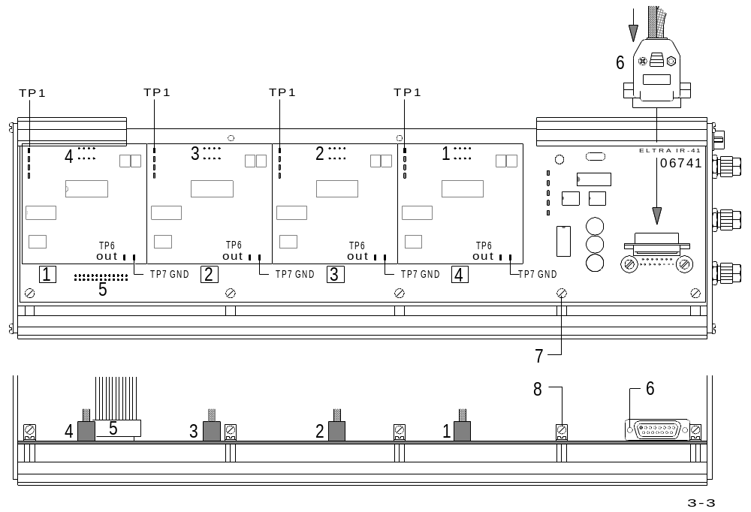

- The plugs ( 1 / 2 / 3 / 4 / 5 / 6 ) should be unplugged.

- The 10 screws ( 7 and 8 ) should be removed.

- No adjustment is needed on the IR 41-circuit board, You should, however, check the adjustments on the infrared cell, see 2. 3.
The IR 41-circuit board is malfunctioning, when the correct signal can be measured at test point 1; while the signal at test point 6 cannot be adjusted to zero, see 2. 3.

3.4 Infrared power supply:

- The power supply ( 1 ) is a complete unit, which is regarded as a single spare part.
- If there is a failure, the entire module ( 1 ) is replaced.
- In order to keep costs down, are exchange of modules is offered.

Replacement:

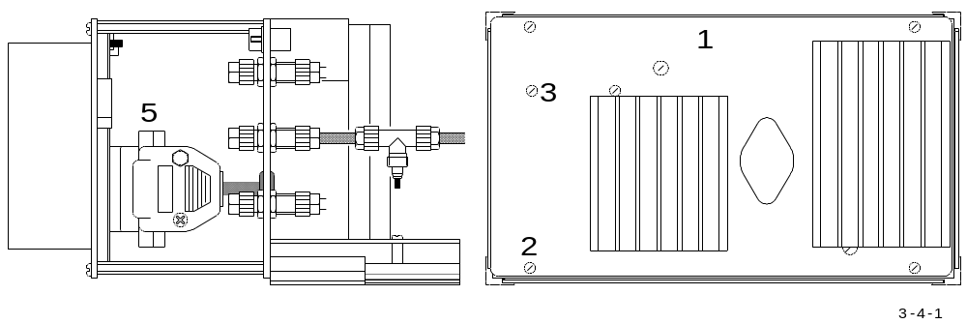

- Remove the four screws ( 2 ) from the front panel ( 1 ).
- Remove the two screws ( 3 ) from the front panel ( 1 ), to loosen the internal plug ( 4 )
- Unplug the 2nd internal plug ( 5 )
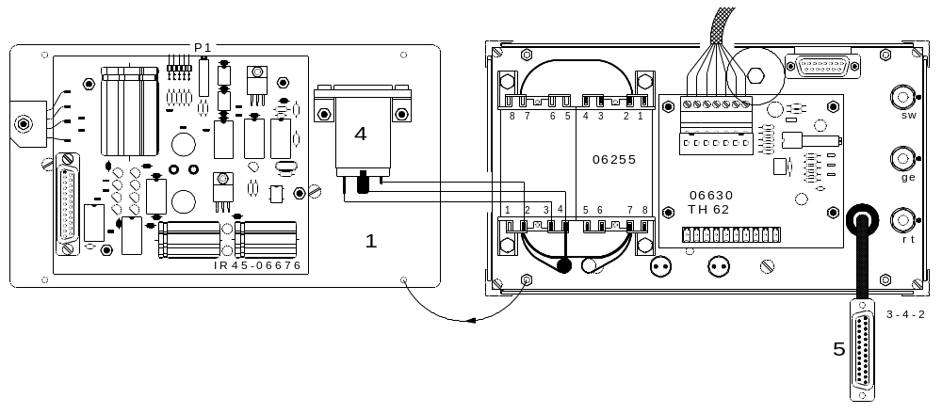

- The front panel is now completely loose and can be exchanged.
- The new power supply unit ( 1 ) is installed in the reverse order.
- It is suggested that the adjustments now be made according to 2. 4.

3.5 Chopper:

see 3. 1

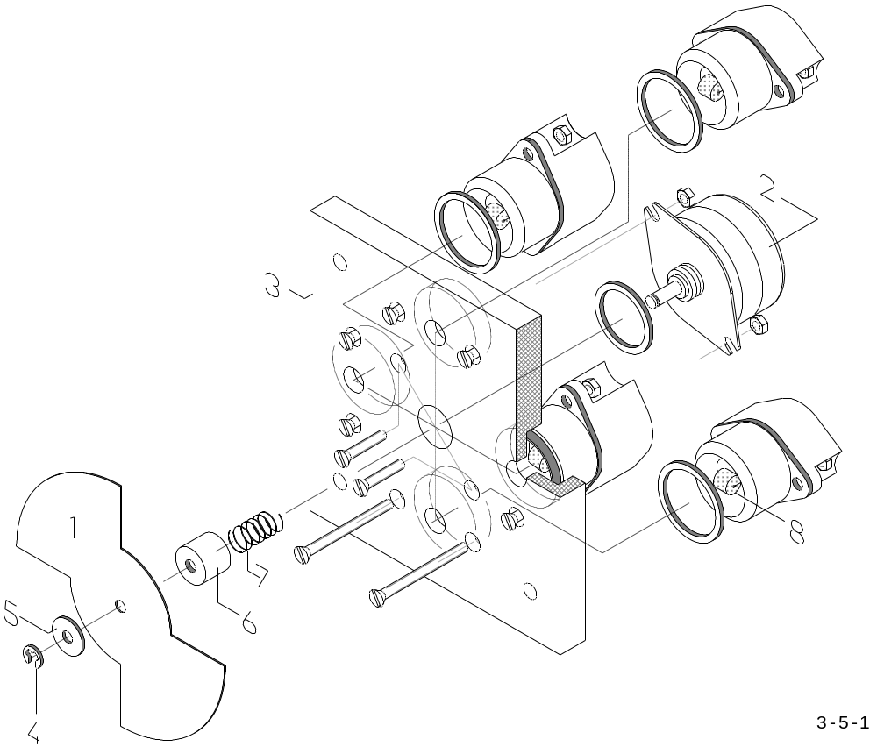

The chopper blade ( 1 ) is fastened to the motor ( 2 )
the chopper blade must be removed first to dismount
the motor ( 2 ) from the mounting plate ( 3 )

In this numeral sequence disassemble the pieces as follows:
- safety ring ( 4 )
the washer(s) ( 5 ) ( there could be two )
the chopper blade ( 1 )
the cylinder ( 6 ) and the
spring ( 7 )
- Reassemble in the reverse order.

CAUTION !
Before re-assembling, check the position of the IR-source ( 8 ) and, if necessary,
centre its position see 3. 2. The heating wire is not very elastic, therefore do not
move it back and forth, rather, you should correctly position it the first time
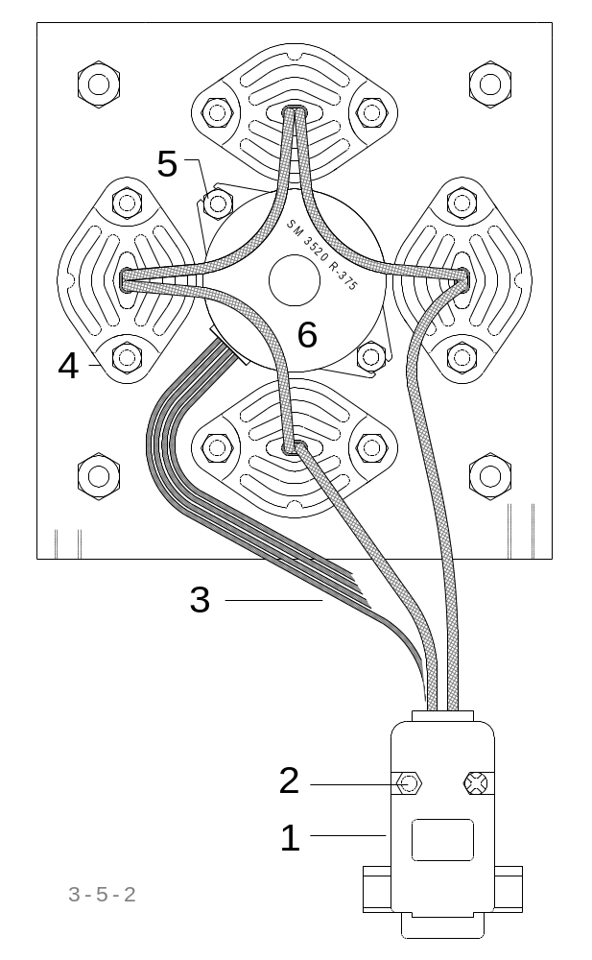

- Disassemble the plug ( 1 ) by removing the screws ( 2 ).
- The cables ( 3 ) of the IR source ( 4 ) are then unsoldered from plug ( 1 )
- Unscrew the nuts ( 5 )
- Install the new motor ( 6 )
- The IR source cables ( 3 ) are then soldered to the plug ( 1 )

CAUTION !
Due to the high current for the infrared cell;
it is important that the soldering here is done accurately, because two pins inside the
plug ( 1 ) will be soldered together to form one group. There are two such groups
in one plug.
Each end of the IR-source cables ( 3 ) will then be soldered to each one of these groups. Polarity is irrelevant.

- Afterwards, the chopper blade is refastened.
- Reassemble in the reverse order.
- After installing, the infrared cell should be adjusted, see 2. 3

3.6 Infrared temperature regulation:
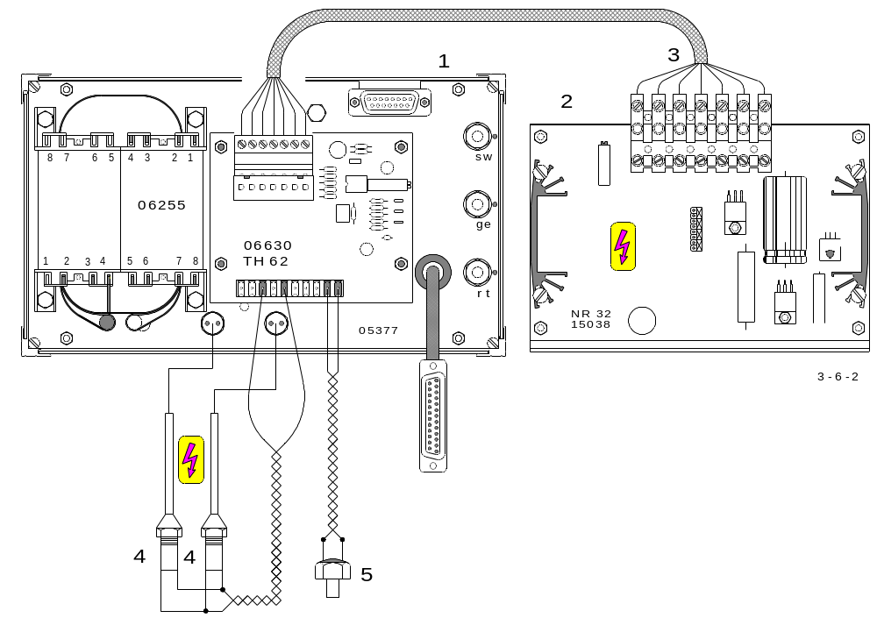

- The temperature regulation of the infrared cell are made up of;
the circuit boards TH 62 ( 1 ) and NR 32 ( 2 )
the connecting wires ( 3 )
the temperature sensor ( 5 ) and the
heaters ( 4 ).

Replacing the TH 62:
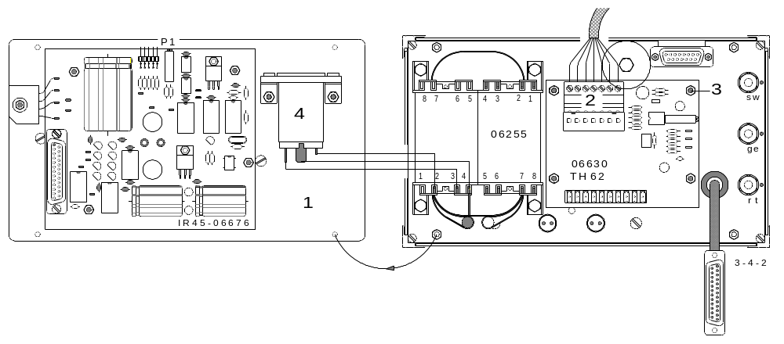

- The plug ( 4 ) should already have been disconnected during the removal of the infrared cell from the analyser.
- Unscrew and remove the power supply module ( 1 ) see 3. 4
- Disconnect plug ( 2 )
- Remove the four nuts ( 3 ) Re-assemble in reverse order.
- Make adjusts to the unit, according to 2. 5
Replacing the heaters:

- Unsolder the cables ( 2 )
- Cut the silicon seal away from the heaters ( 1 ) and then pull them carefully out
- Insert the new heaters with smearing thermal conducting paste ( in case there is none available, silicon grease can be used ).
- Solder the cables.
- Secure the heaters against falling out with silicon sealant.
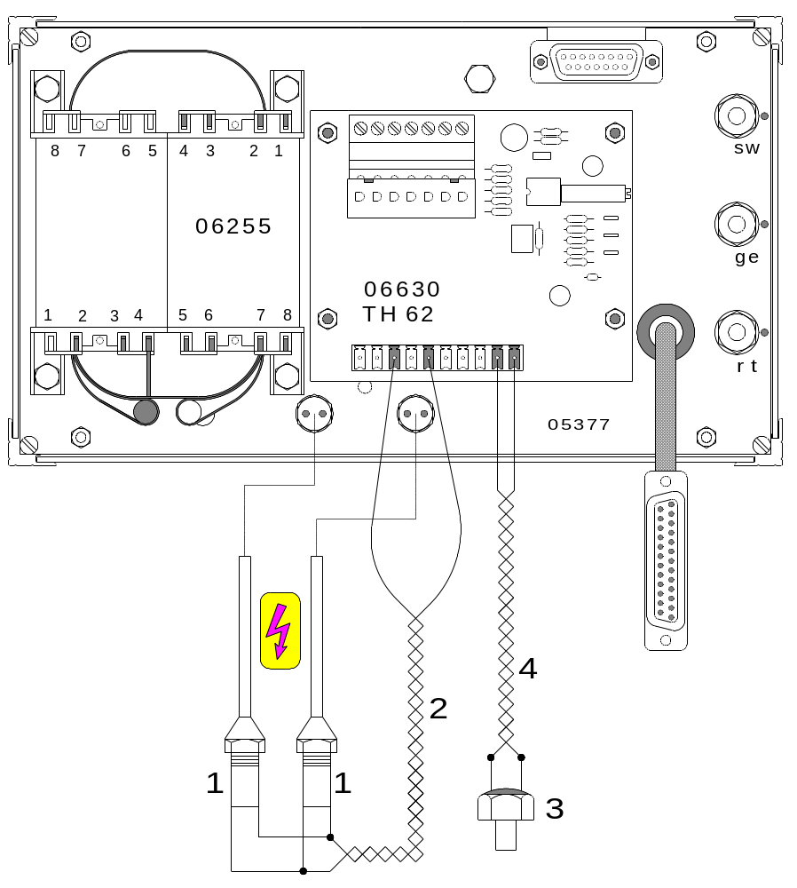

Replacing the temperature sensor:

- Unsolder the cables ( 4 )
- Cut the silicon sealant away from the temperature sensor ( 3 )
- Screw the new temperature probes in
- Solder the cables ( 4 )

CAUTION !
screw the probes in very gently, the threads are of aluminium.

- After replacing the temperature sensor, adjust according to 2. 5

3.7 Leak checking:
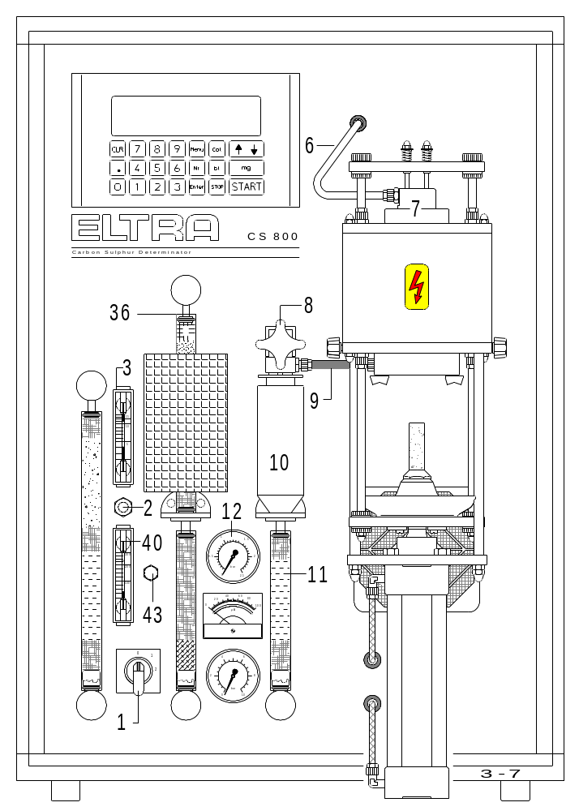

- Set the power switch ( 1 ) to pos. 2
- Close the furnace
- Press and hold the button ( 43 )
The entire system will be checked for leaks.
- The leakage test is completed when the initial pressure drops (about 5 seconds)
on gauge ( 12 ) and then remains constant, the gas system is ok.

- Should there be a continuous pressure drop, then release the button ( 43 ),
open the furnace, press and hold the button ( 43 ) again. If the pressure is
stable then the leakage will found in the furnace.
- If the pressure still decreases, then the leakage is to found inside the analyser.
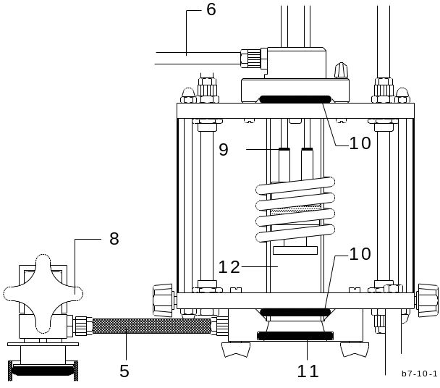

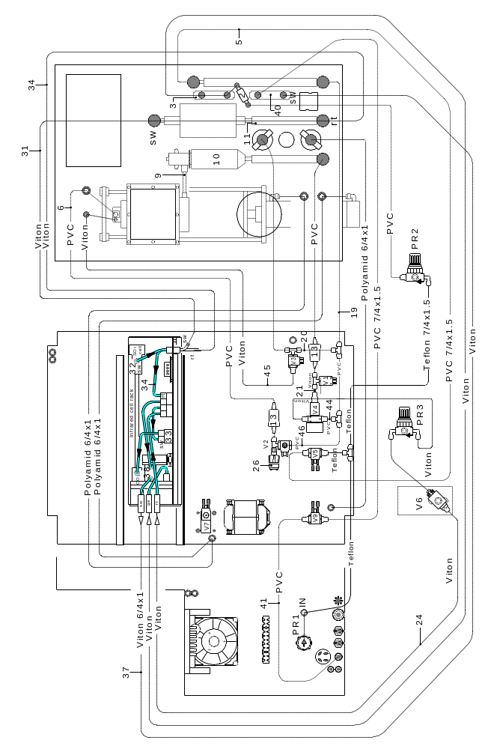

- Release the push button ( 43 ), close the furnace, squeeze the tube ( 6 ) tightly and press and hold the button ( 43 ).
- If the pressure on gauge ( 12 ) remains constant, then the furnace has to be checked for leaks.
- If the pressure shown on gauge ( 12 ) drops, then the leakage has to be found somewhere along the furnace inlet system.

Leaks in the furnace inlet system:
- After following the above instructions, check for gas leakage between inlet tube ( 6 )
and reverse valve ( V2 ).

Leaks in the furnace:
- After following the above instructions, close the furnace, squeeze tube ( 9 ) tightly, press and hold the button ( 43 ), observe the pressure gauge ( 12 ).

- If the pressure drops, then the furnace is leaking. Check whether the O-rings ( 16 ),
( 17 ) and ( 18 ) are soiled or defective see Operation Manual 7. 4 and 7. 5
Check whether the combustion tube ( 15 ) is broken or cracked.
- If the pressure remains constant, then the furnace outlet system is leaking.

Leaks in the furnace outlet system:
- After following the instructions in the section „Leaks in the furnace“, check if the handle ( 8 ) is properly shut, or else there will be a major gas leak from the dust filter. Check the following components for leakage, by squeezing the following tubes,
while pressing and holding the button ( 43 ):

Tube to squeeze: Leak location:
19 Dust trap ( 10 ), glass tube ( 11 ), dust filter cartridge ( 13 ),
outflow valve ( V 1 )

Leaks inside the analyser:
- when pressing the button ( 43 ), the gauge ( 12 ) shows a pressure drop while the furnace is open, then locate the leakage, according to the sequence below.
Keep the furnace opened, squeeze the following tubes tightly, while pressing and holding the button ( 43 ):

Tube to squeeze: Leak location:
4 Exhaust valve ( V9 )
37 Flow meter ( 40 )
34 CO2-Paths ( 38 )
31 SO3-Trap ( 35 ) or oxidising furnace tube ( 36 )
24 SO2-Path ( 32 ) or flow sensor ( 33 )
23 Regulator valve ( V6 )
22 Pressure regulator ( PR3 )
44 Bypass valve ( V4 ), check for 24 VDC on input pins
45 Purging valve ( V3 ), check for 0 VDC on input pins
46 Reverse valve ( V2 ), check for 24 VDC on input pins

ATTENTION: do not cause a short circuit while measuring!

- If the voltages on V2, V3, or V4 are wrong, then replace the electronic drivers, see 1. 6.

3.8 Replacing EPROMs:

- Set the power setting to pos. 1
- Open the furnace.
- Pull out all of the plugs from the electronic unit
- Open the left side of the analyser.
- Unscrew the electronic unit.
- Pull out the electronic unit.
- Carefully, take out the two EPROMs H + L with the aid of a screwdriver ( using it as a lever ), from the CPU board. See drawing below.
- Insert the new EPROMs H + L, notice the comparing marks. See drawing below.
Be sure that they are positioned correctly.
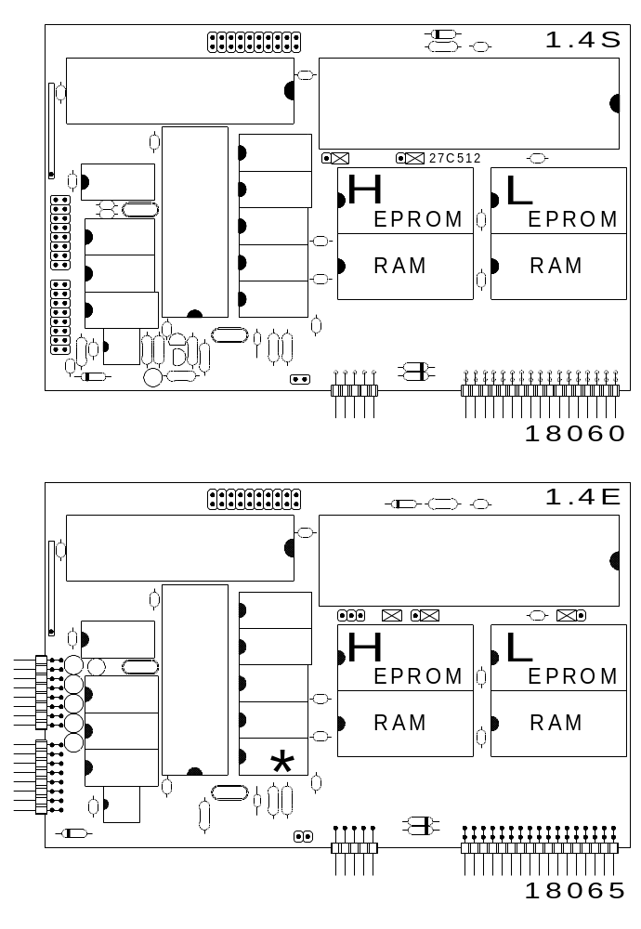

Important: When installing
27C512 EPROMs, check that
the jumpers are connected
as shown in the drawings.
If the instrument has an older
card, follow the first drawing;
else follow the second drawing.

- Exchange the RAMs with each
other to ensure that after switching
on the electronic unit, any stored
data during operation with the
previous EPROMs, will be deleted.

CAUTION: The analyzer has to be
recalibrated, or an application has
to be recalled from the application
memory.

3.9 Clearing memory:
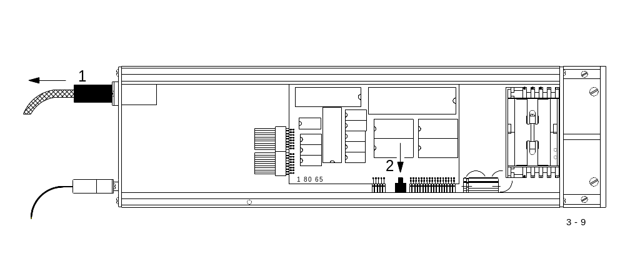

- Set the power switch to pos. 1
- Open the furnace
- Detach the left hand cover of the Analyser
- Detach the power plug ( 1 ) from the electronic unit
- Press the reset key ( 2 ) on the base plate of the electronic unit for 30 seconds
- Restore the unit to its original condition
- Recalibrate.

3.10 Electronic reset:

Should any problems arise with the electronic unit:

- Press STOP

If the problem remains:

- Turn the power switch to pos. 1
- Open the furnace
- Disconnect the cable ( 1 ) from the electronic unit for 10 seconds and plug back in.

- Should the problem remain:

see 3. 9 " Clearing Memory "

3.11 Coding IR- ranges:
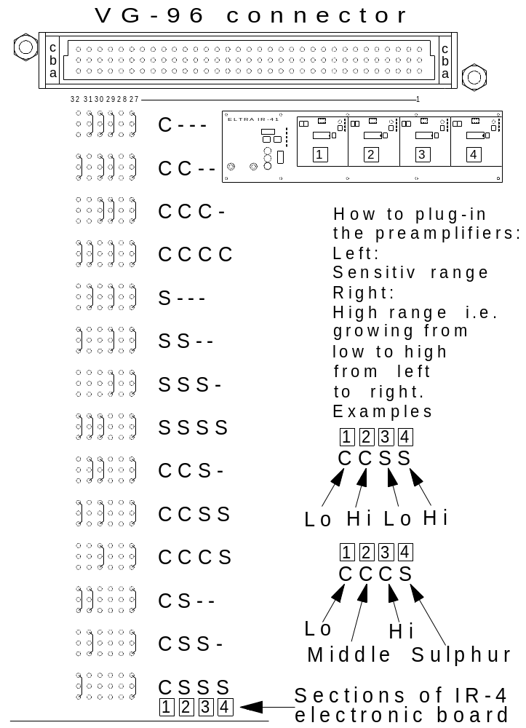

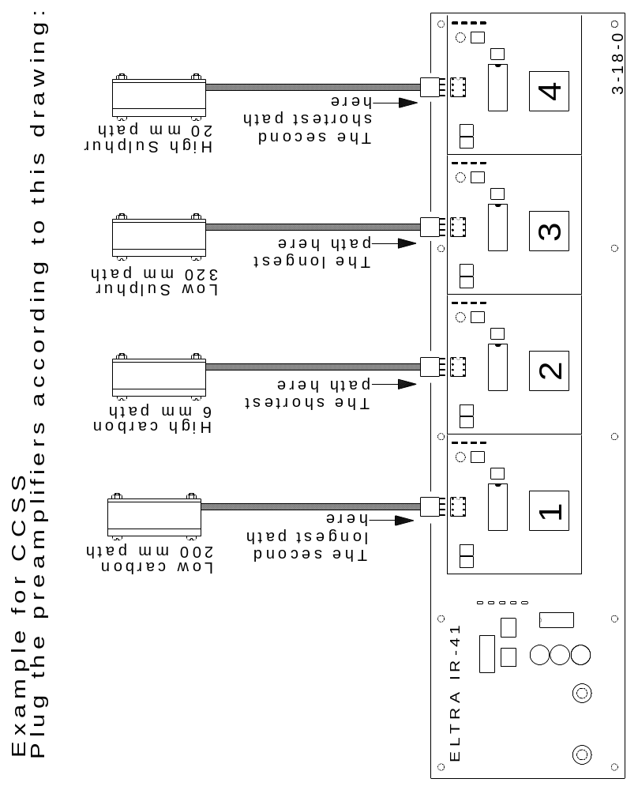

3.12 Adding new IR – rangers:

( from 1 to 2 , from 2 to 3, from 3 to 4 or form 1 to 4 channels )

- The chopper housing with the appropriate number of IR-sources.
Before installing, the IR-source positions should be checked and, if necessary, repositioned, see 3. 2 and 3. 5.

- One, two or three additional pre-amplifiers needed

- One, two or three additional infrared detectors with the appropriate interference filters needed

- One, two or three additional IR-paths of the appropriate length needed

- On the circuit board IR-41, cables must be rearranged correctly, see 3. 3

- Connection of the transformer, matching the number of channels, see 2. 4
"Setting the IR-source voltage "

- Adjustments for the IR-source power, respective for each channel,
see 2. 4 " Setting the IR-source voltage "

- Adjusting the zero,
see 2. 3 " Adjusting the Infrared cell "

- Coding of the channels,
see 3.11 " Coding of the channels "

- The settings for the temperature regulation,
see 2. 5 " Temperature regulation "

- Afterwards, the linearisation of the Analyser,
see 2. 9 " Linearisation "

- Recommended spare parts. See 4.1

The following components may be needed, when adding more IR cells:

05257 Chopper housing, with one IR-source and motor
05254 Chopper housing, with two IR-sources and motor
05251 Chopper housing, with three IR-sources and motor
05244 Chopper housing, with four IR-sources and motor
05066 IR-path: carbon low
05067 IR-path: carbon high
05068 IR-path: sulphur
06741 Printed circuit board IR-41
06032 Infrared receiver with CO2 filter
06034 Infrared receiver with SO2 filter

3.13 Cleaning the solenoid valves:

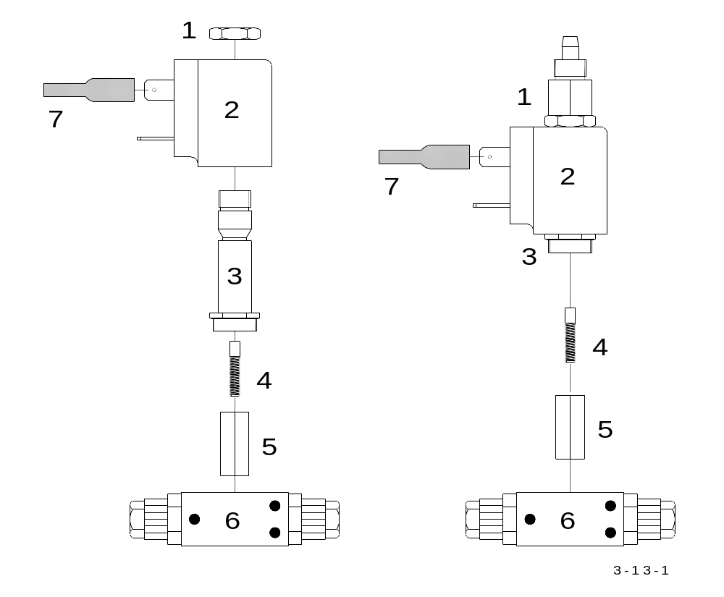

Only with the 2/2 valve Only with the 3/2 valve

- Turn the power switch to pos.0
- Unplug the main power plug as well
- Remove the connector ( 7 )
- Unscrew the nut ( 1 )
- Remove the coil ( 2 ) ( only with the 2/2 valve )
- Unscrew counter-clockwise the hexagon screw on the armature housing.
- Remove the armature ( 5 ) ( only with the 2/2 valve )
Careful ! Do not loose the spring ( 4 )
- With oxygen pressure or compressed air, clean the inside of the armature housing
( 3 ), as well as the armature ( 5 ) and re-assemble the solenoid valve.
With the furnace closed and renewed oxygen pressure, check to ensure that the solenoid valve is sealed, see 3. 7

3.14 Replacing the flow sensor:

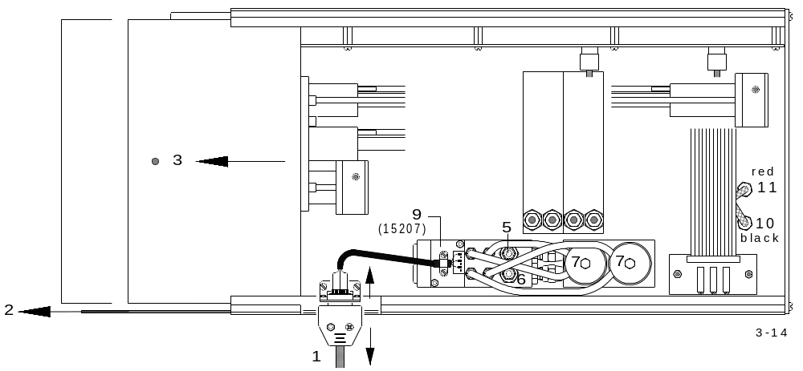

- Set the power switch to pos. 0
- Remove the left side panel of the analyser
- Unplug the two cables at the rear-side of the infrared rack
- Remove the tubes ( 10 ) and ( 11 ) at the bottom-side of the infrared rack
- Unplug the plug ( 1 )
- Pull out the infrared rack from the analyser
- Remove the left side cover ( 2 ), the top cover ( 3 ) and the bottom cover ( 4 ) of the infrared rack
- Remove the two tubes ( 5 ) and ( 6 ) from the flow sensor ( 9 )
- Remove the two screws ( 7 ) underneath the flow sensor.
- Remove the old flow meter, install the new one.
- Reassemble the infrared rack in reverse order.
Pay particular attention to the position of the tubes ( 5 ), ( 6 ), ( 10 ) and ( 11 ).

- Adjust according to 2. 1

3.15 Installing an AC power stabiliser:

When the power voltage sinks below 180 V AC ( even for a short time ), a stabiliser is recommended.
The Analyser can draw, during combustion and according to the power setting, up to 13 A.
The maximum current depends on the type and size of the sample and accelerator.
To stabilise such a high current is not easy and not necessary.
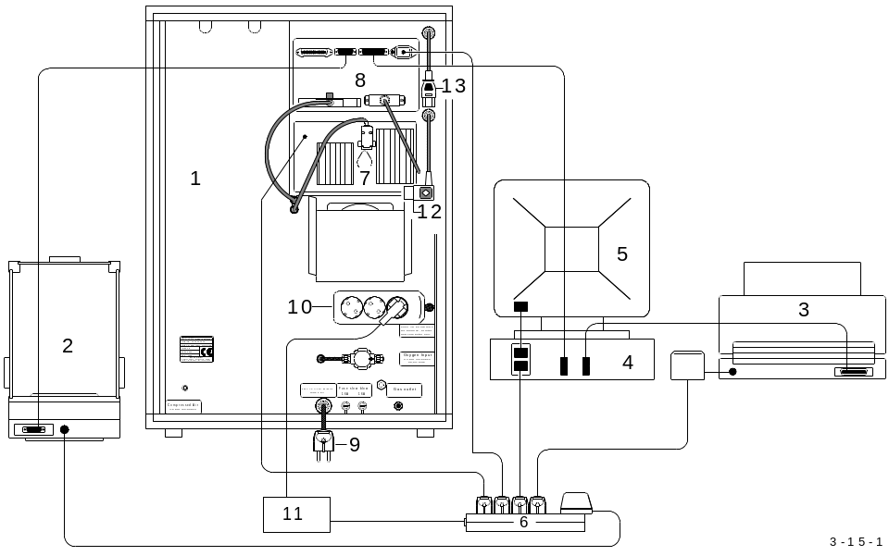

1 Analyser
2 Balance
3 Printer
4 Computer
5 Monitor
6 Power strip
7 Infrared cell
8 Electronic unit
9 Power plug
10 Triple plug
11 Voltage stabiliser
12 Original infrared cell power cable
13 Original electronic unit power cable

It is sufficient that the electronic unit ( 8 ) and the infrared cell ( 7 ) are protected by
the stabiliser ( 11 ). This can easily be done, as both units ( 7 / 8 ) use standard plugs.
It is then advisable to protect the balance ( 2 ), the printer ( 3 ) and the computer ( 4 )
with a stabiliser ( 11 ).

- The stabiliser ( 11 ) is plugged into the triple socket ( 10 ) ( rear of the Analyser ).
- The electronic unit ( 8 ) and the infrared cell ( 7 ) are plugged into a power strip ( 6 ), using a normal power cable ( the device cable ).
- The original power plugs ( 12 / 13 ) of the units ( 7 / 8 ) are simply unplugged and left hanging.

A simple transformer can be used when the voltage of the power line is always too low or temporarily, lower than 200 V AC, instead of a stabiliser.
The power of the transformer should be at least 100 VA. The primary voltage should be 220 V to 240 V. The secondary voltage should be about 20 V higher than the primary voltage. For example Pr 220 V / Sec 240 V or Pr 230 V / Sec 250 V.
The power of the stabilizer should be about 250 VA. The IR-cell and the electronic unit take less than 100 VA, however the power drawn by the PC, monitor, balance and printer, depends on the models connected. Sometimes these devices are provided by the customer himself, so that we can not exactly define the power of the stabilizer. It is advisable to check the power of the above devices before ordering a stabilizer.

3.16 Additional safety features for furnace pneumatics (optional):

The furnace doesn’t change position in case of a power failure:

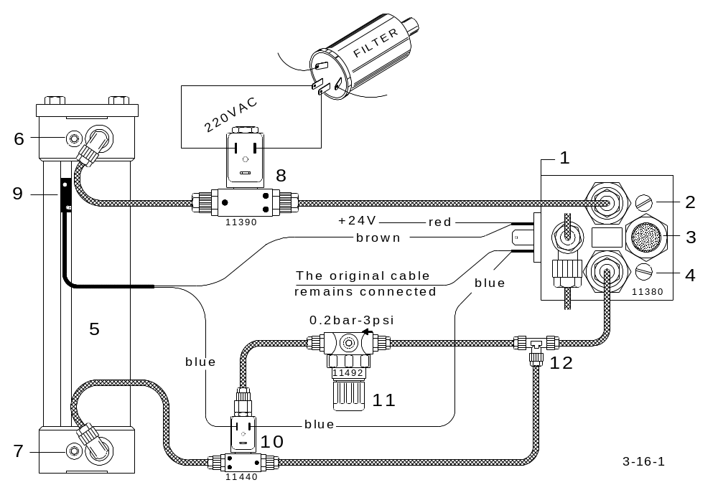

By adding a solenoid valve ( 8 ) and connecting the coil directly to 220 V AC, the piston won’t change position in case of a power failure. If the piston was down, it will remain down; if it was up, it will remain up.

3.17 Installing a halogen trap:

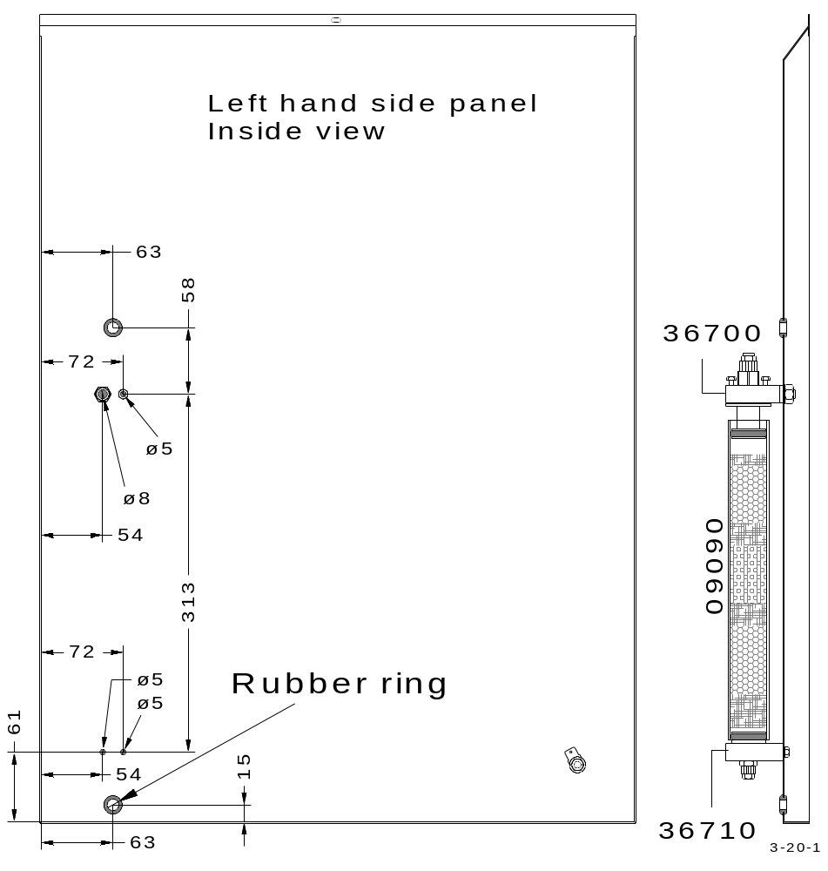

3.18 Gas saving mode:

How to set the jumpers for gas saving mode:

Caution:
This option is functional with EPROMS and PC software versions, later than June
2001.

If the analyser has the HF 41 board:
Set the jumper setting to A1 with A2 on J2

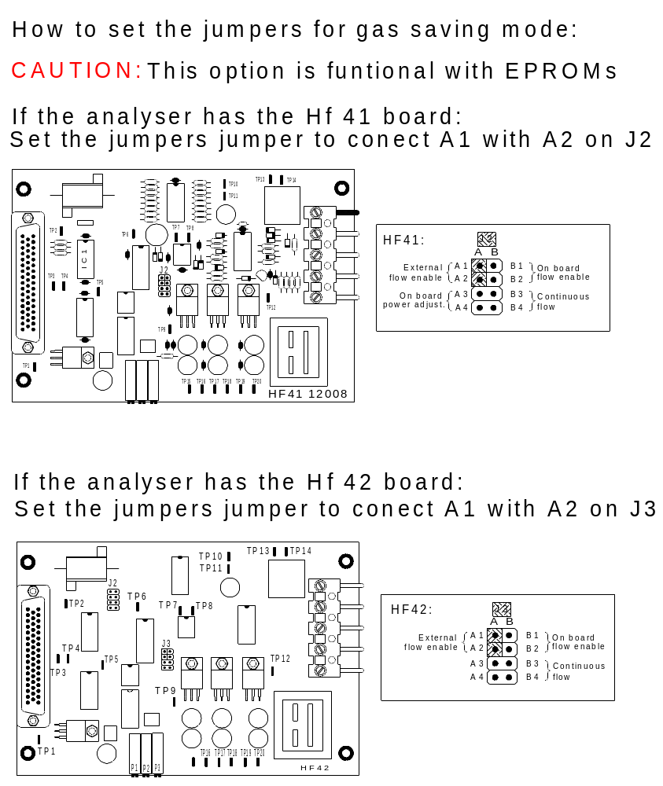

If the analyser has the HF 42 board:
Set the jumper setting to connect A1 with A2 on J3

3.19 Upgrade for copper analysis without accelerators:

The CS-800 ( CS-2000) can analyse Copper of very high weight, without using any
accelerators. Copper sample up to 20 g, or as much Copper sample the crucible can
accommodate.
If the Copper sample has the form of grains or drillings, the standard CS-800 ( CS-2000 )
can do the job.

The condition is:
The furnace control board should have a HF-42 with the corresponding jumper setting for
The correct control mode. See 1.4

If the Copper sample is a solid piece then the temperature may not go high enough to reach
the melting point. In this case the following modifications are necessary:
WARNING ! High voltage

- Switch off the analyser and unplug the main power cable.

- A second capacitor 500 pF ( ordering no. 77330 ) will be added between the adjusting
frame ( Copper band: ordering no. 13135 ) and the metal mountung frame. The distance of the capacitors to the frame, has to amount to 8 mm min. See drawing below and next page.
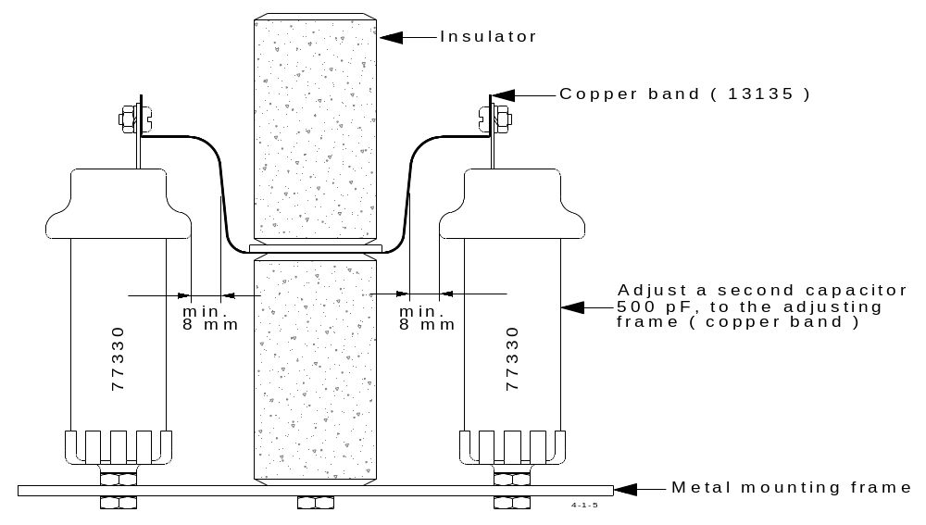

- Install a second 100 pF capacitor ( ordering no. 77320 ) parallel to the first
one between the cooling system and the coil, mounted on a U-form metal frame.
( ordering no. 13085 )

- Place a high voltage capacitor ( ordering no. 96V/ 700 10 ) on top of the oscillator’s
housing, fixing it with tape. A red cable ( + ) will be joined from the high voltage
capacitor to the lower capacitor that is fixed on the bottom housing.
A black cable also from the high voltage capacitor ( - ) will be jointed to the capacitor
coil, also mounted on the bottom housing. See drawing below.

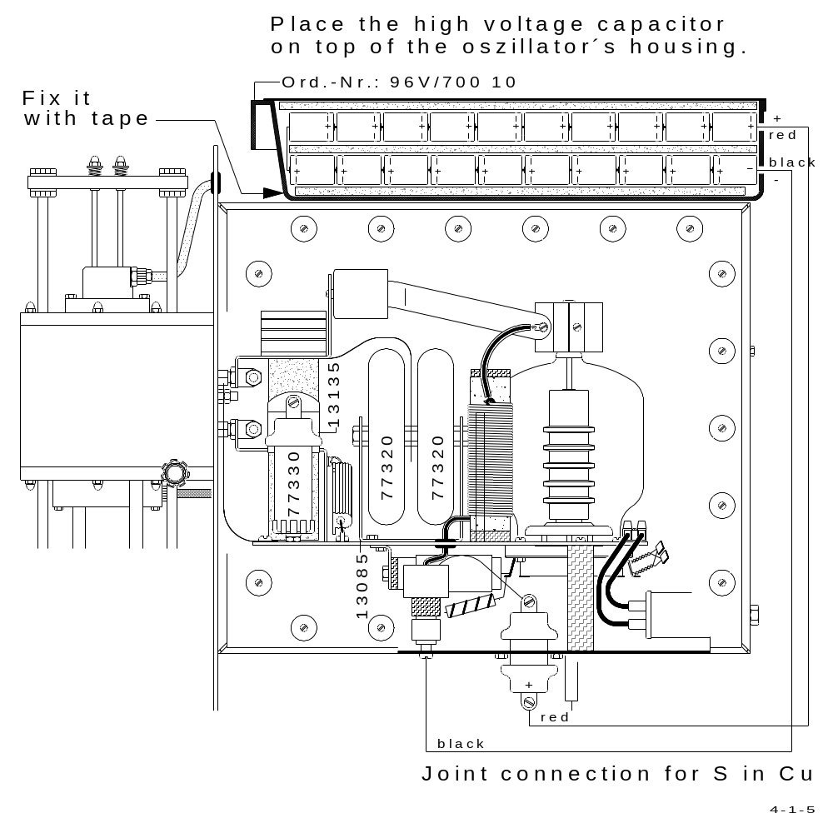

3.20 Upgrading of analysers with electronic rack for using the new
Windows software:

Late analysers (from S/N 0767xxxxxx) equipped with the new flow sensor (pressure transducer) can easily be upgraded as follows:
 Remove the electronic rack.
 Install the new hardware at the same place.
 Connect the adapters and the new cables for PC and balance.
 Install the front frame and the rear frame.

Upgrading of older analysers equipped with the previous flow sensor (rotameter in the IR-cell) is theoretically possible but practically difficult. The new software is made for the latest versions of analysers with the electronic flow sensor and with two oxygen inlets furnaces. Therefore, older analysers can not run with the new software, unless the analyser is first modified to correspond to the later version. This means replacement of the wiring, new HF board, new upper furnace part with two oxygen inlets and modifications of the tubing and new flow sensor in the IR-cell.

4 MISCELLANEOUS

4.1 Ordering numbers:

see also Operation Manual, chapter 8.
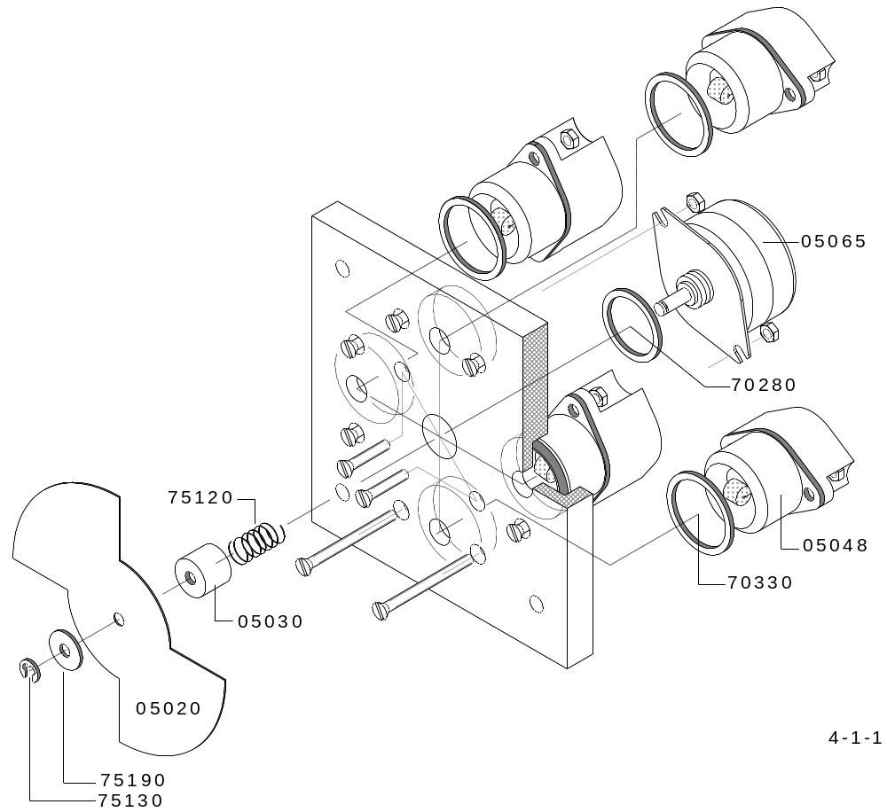

05020 Chopper blade
05030 Chopper blade holder
05065 Chopper motor
05048 Infrared source ( emitter )
70280 O-ring
70330 O-ring
75120 Spring
75130 Retaining washer
75190 Washer

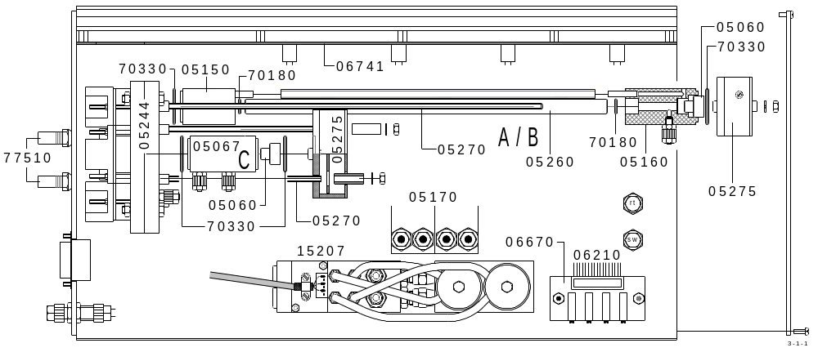
Infrared cells:

05060 Reflector
05067 IR-path for high carbon
05150 IR-path connector with window source side
05160 IR-path connector with window detector side
05170 Gas conditioner
05244 IR 4 chopper
05260 IR-path tube ( advice the length )
05270 Threaded rod ( advice the length )
05275 Infrared preamplifier
06210 IR-cable
06670 IR-zero adjustment board
06741 Infrared electronics board
15207 Gas flow sensor
70180 O-ring
70330 O-ring
77510 Heaters for IR-cell

Left side:

Separator plate side
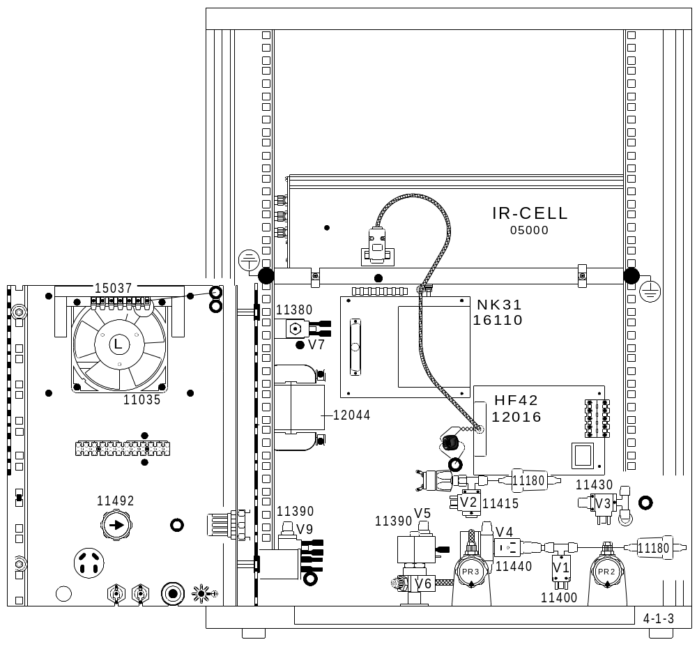

05000 IR-cell
11035 Cooling fan
11180 Dust cartrige
11380 Pneumatic valve
11390 Oxygen solenoid valve
11400 Pressure outlet solenoid valve
11415 Oxygen stop solenoid valve
11430 Purge solenoid valve
11440 Bypass solenoid valve
11492 Inlet pressure regulator
12016 Gas flow and furnace control board HF 42
12044 Transformer
15037 Temperature control board NR 32
16110 Power supply board NK 31
Right side:

Ventilation

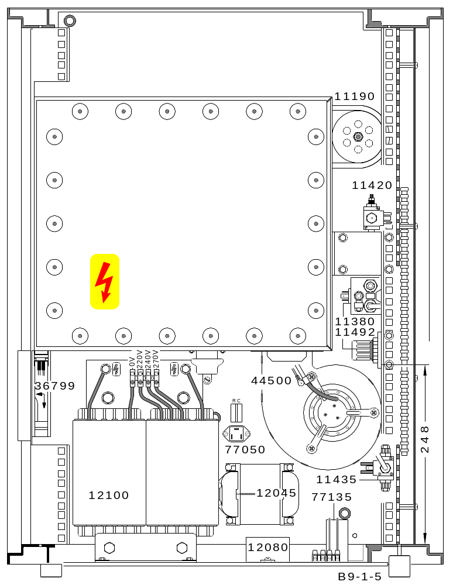

11190 Exhaust muffler
11380 Pneumatic valve
11420 Coil cooling solenoid valve
11440 Pressure switch-over solenoid valve
11492 Pressure regulator
12045 Transformer
12080 Rectifier
12100 Transformer
36799 Fan
44500 Centrifugal blower
77050 Triac
77135 Capacitor 2 µF
Oscillating circuit:

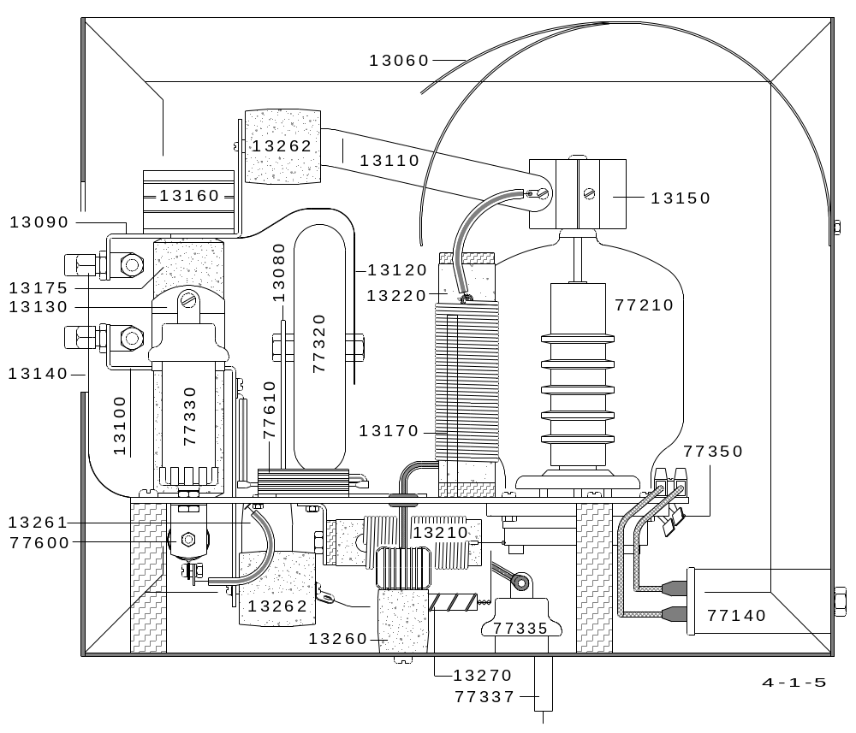

13080 Capacitor support 77140 HF-filter 250V
13090 Upper coil connector 77210 Oscillator tube
13100 Lower coil connector 77320 Capacitor 100 nF
13110 Anode connector 77330 Capacitor 500 pF
13120 Capacitor connector 77335 Capacitor 600 pF
13130 Capacitor connector 77337 10 A Filter
13140 Ground connector 77350 Capacitor 100 nF
13150 Anode heat sink 77600 Resistor 2.7 KΩ, 100 W
13160 Coil heat sink 77610 Resistor 100 KΩ, 50 W
13170 Radiation shield
13175 Insulator
13210 Grid choke
13220 Anode choke
13250 Chassis support
13260 High voltage filter
13261 Capacitor 600 pF
13262 Capacitor 600 pF
13270 Resistor 22 Ω

Furnace:

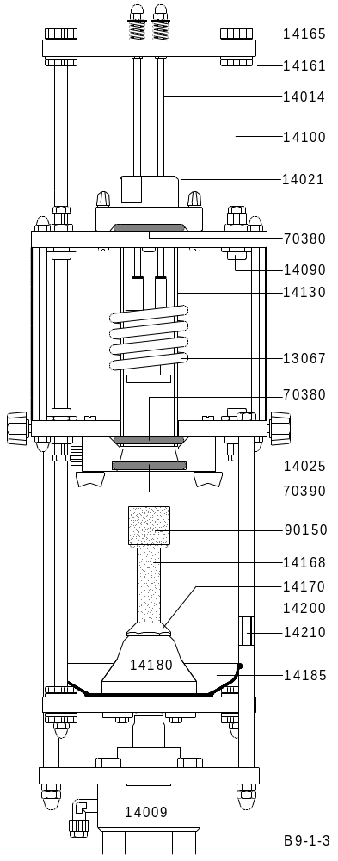

13067 Combustion coil
14009 Pneumatic cylinder for furnace lift
14021 Upper furnace lock
14025 Lower furnace lock
14090 Bearing
14100 Mounting rod
14130 Combustion tube
14161 Lower knurled nut
14165 Upper knurled nut
14168 Pedestal
14170 Pedestal mount
14180 Furnace closure
14185 Tray
14200 Metal tube
14210 Threaded rod
70380 O-ring
70390 O-ring
90150 Crucibles od =25.5; h =27.5 mm

Furnace cleaning:
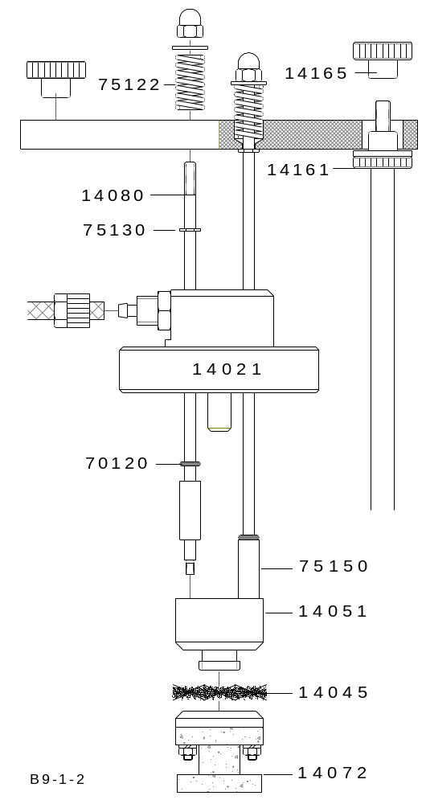

14021 Upper furnace lock
14045 leaning brush for combustion tube
14051 Brush holder
14072 Ceramic heat shield for brush
14080 Cleaning mechanism rod
14161 Lower knurled nut
14165 Upper knurled nut
70120 O-ring
75122 Spring
75130 Safety spring
75150 Metal tube

Oxygen purifying furnace:

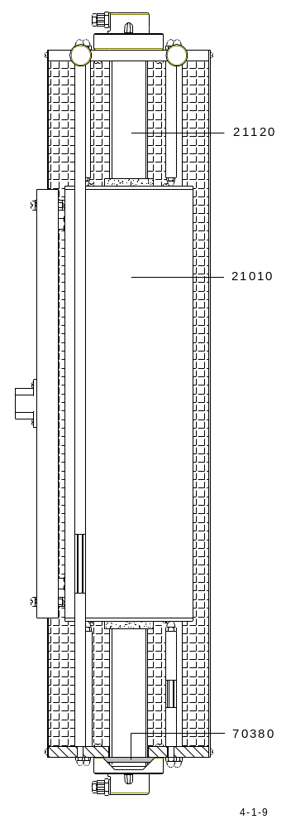

21010 Heather section
21120 Quartz tube
70380 O-Ring

4.2 Wiring and gas flow diagrams:

Right side:

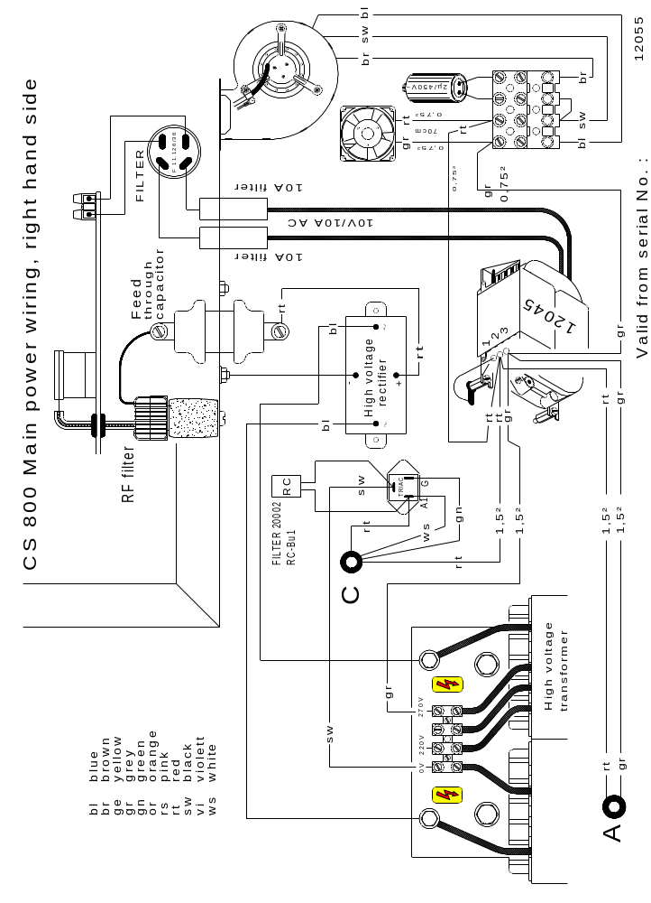

Left side:
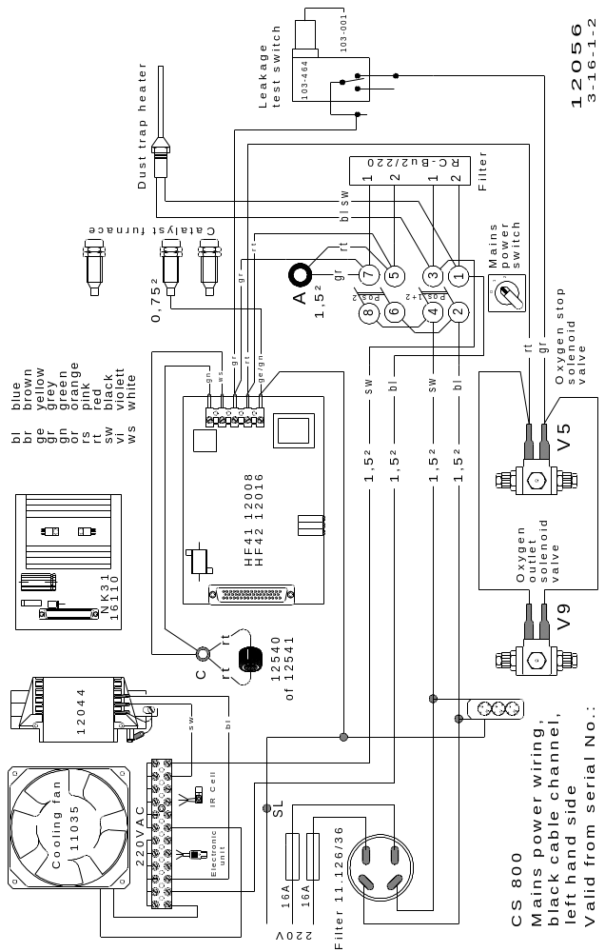

Valve wiring:

A To rear ( V8 )
V1 Outflow valve
V2 Shuttle valve
V3 Purging valve
V4 Bypass valve
V5 Oxygen valve
V6 Regulating valve
V7 Pneumatic valve
V8 Coil cooling valve
V9 Outlet valve
V10 Pressure switch over valve for furnace lift
S1 Pressure switch
I1 Panel meter

Control wiring:

IR-current supply:
Attention:
The next four drawings consider
the IR-rack with four IR-cells
The pages after, Connection
between TH 62 and NR 32
are for the older Model ( S/N 1080
till S/N 1079 )

Infrared cell:

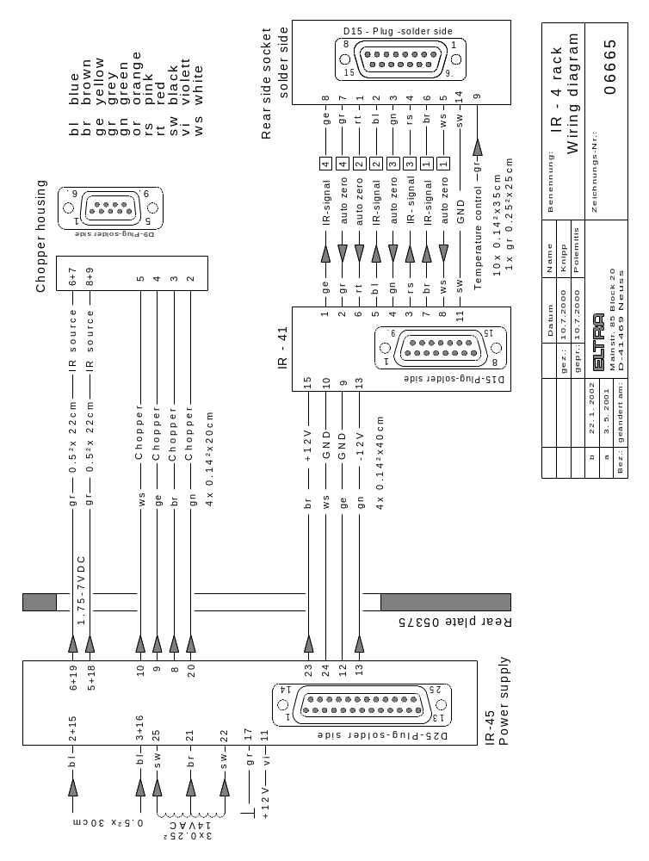

Chopper motor and IR-source:

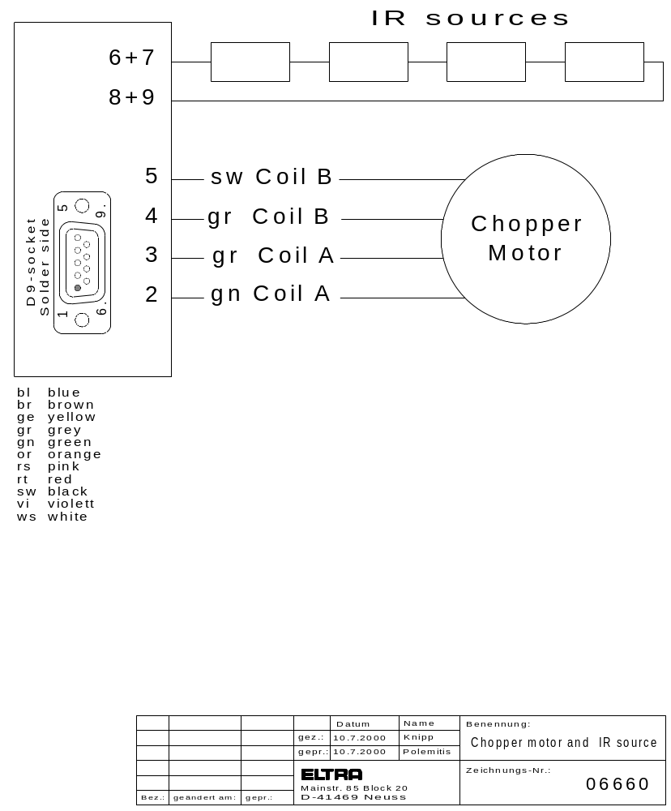

Connections between TH62 and NR32:

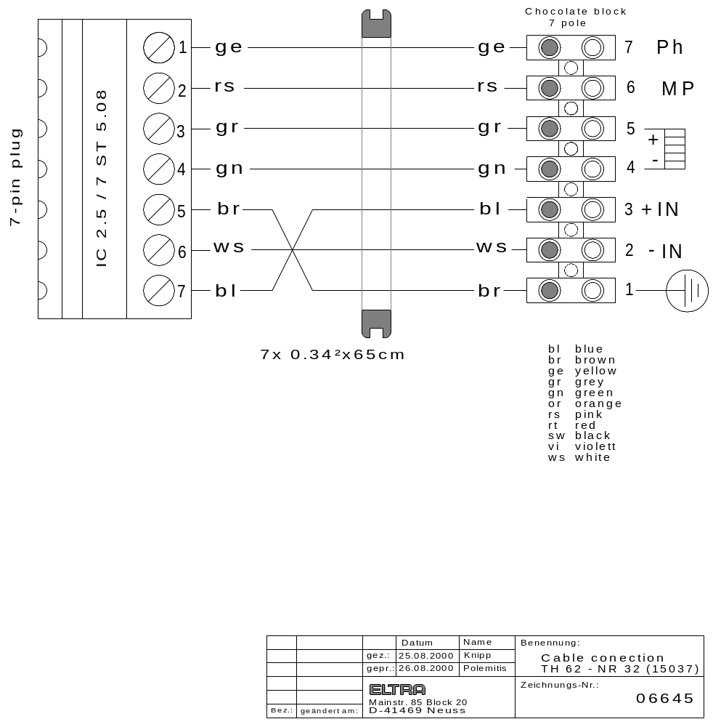

Attention:

Some CS-800 analysers may be furnished with the previous model of IR-rack, which was designed for maximum three IR-cells. The wiring and the plugs of that rack are different to the rack IR-4 which is described in this manual. The adapter of the drawing below is used to adapt the new IR-rack to the CS-800 analyser. The drawings of the previous rack wiring can be found in the following 5 pages, these are the older models.

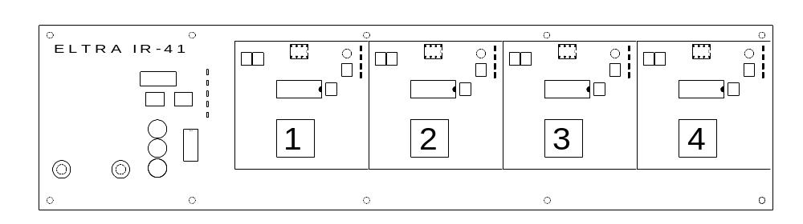

Use they adapter below to install the new IR-cell IR-4 in a previous analyzer wired for the previous IR-cell model.
The EPROMs and the Windows software must also correspond to the new IR-cell. Also the coding of the IR-ranges must match. See 3.11-1.
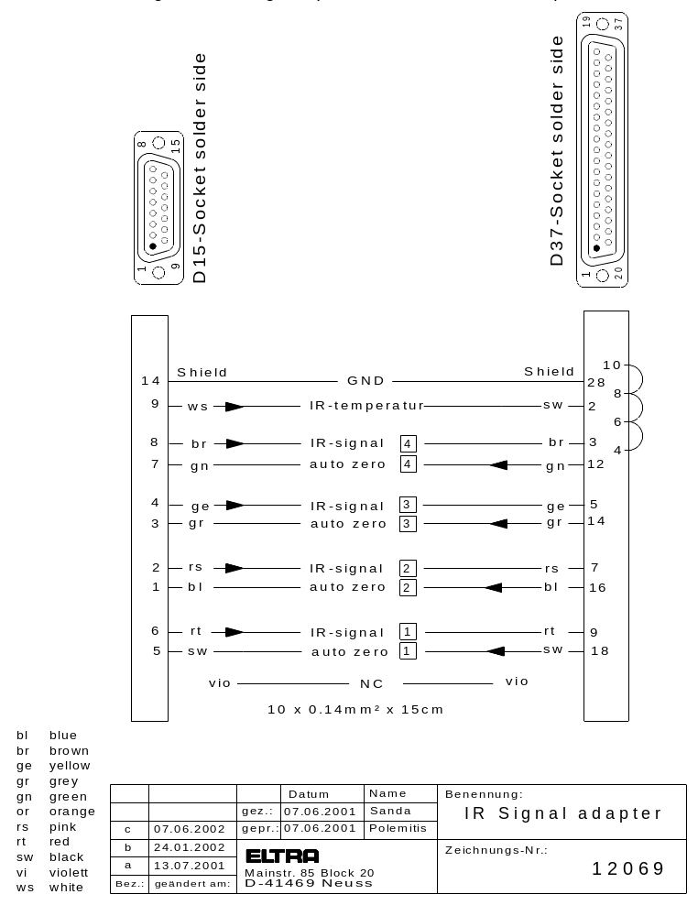

IR-current supply:
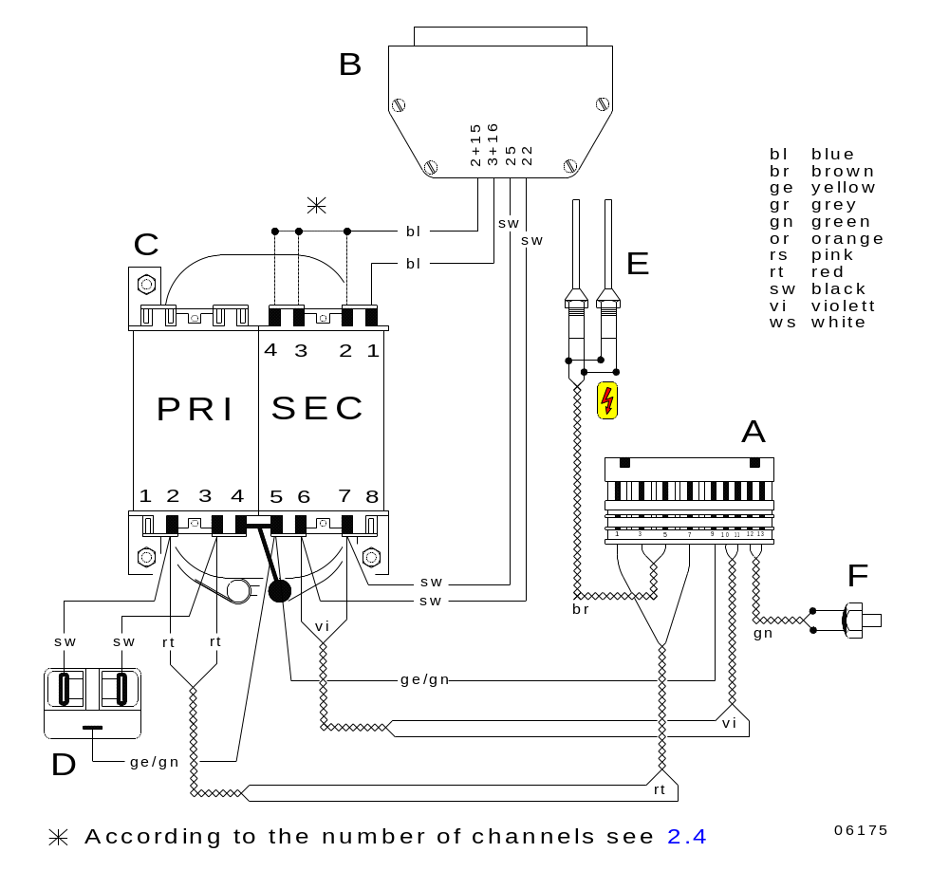

A 13-pin plug connector
B 25-pin plug
C Transformer
D Energy filter
E Heating elements
F Temperature sensor
* According to the number of channels, see 2.4

Infrared cell:

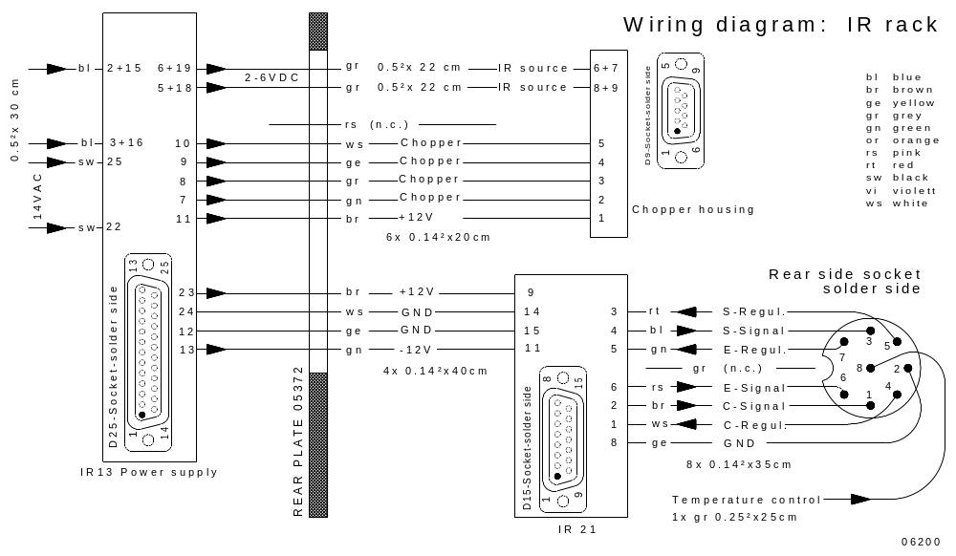

1 C-signal
2 GND
3 S-signal
4 Control voltage
5 Control voltage
6 Control signal for low channel
7 Regulating voltage for low channel

Chopper motor and IR-source:

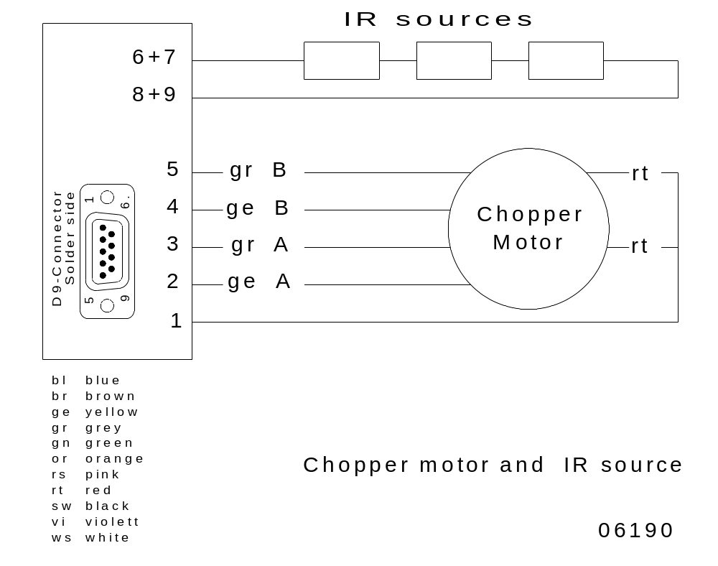

Connection between TH 61 and NR 32:

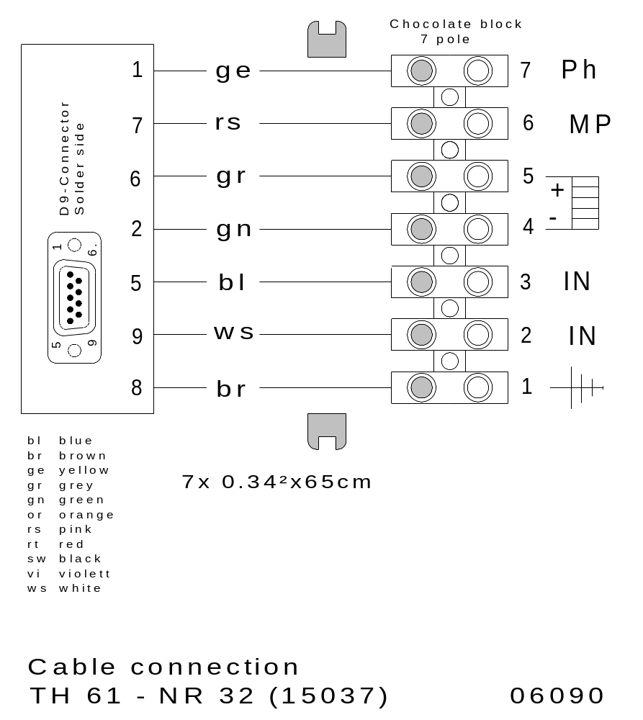

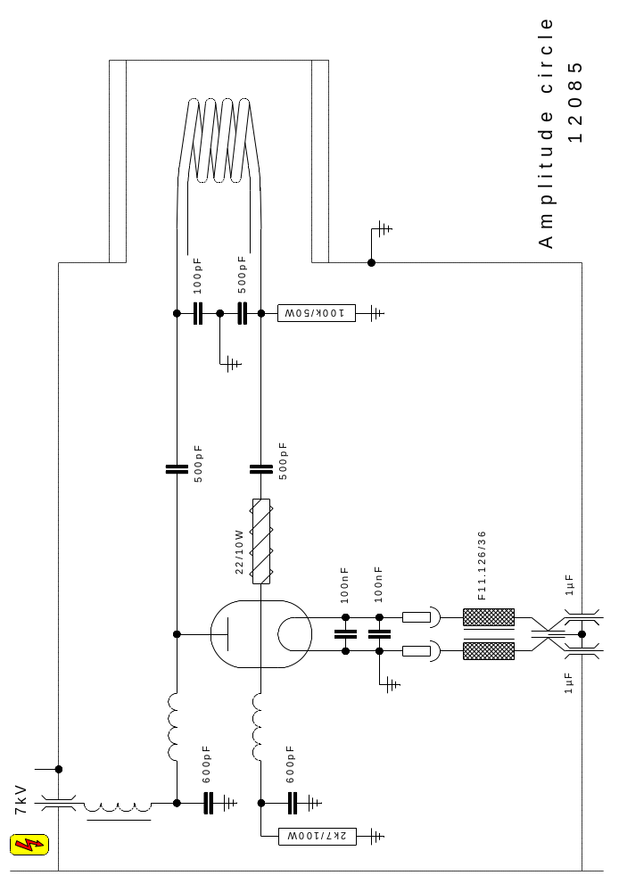

Connecting cables:

Analyzer-Parallel printer
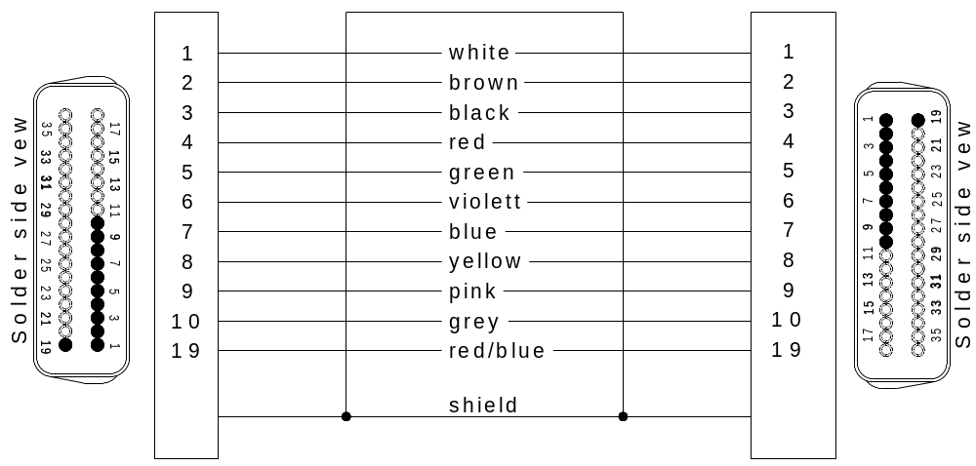

Analyzer-Sartorius balance
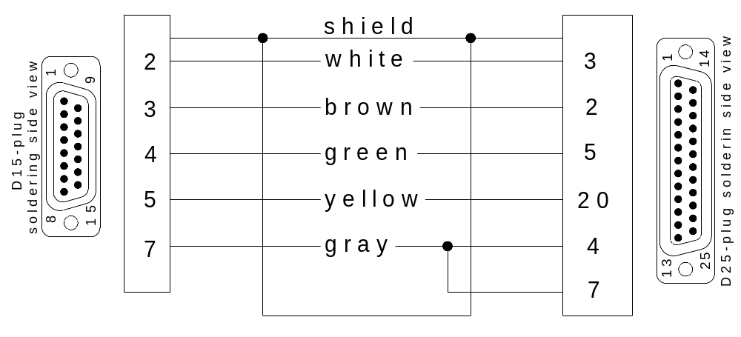

Analyzer-PC
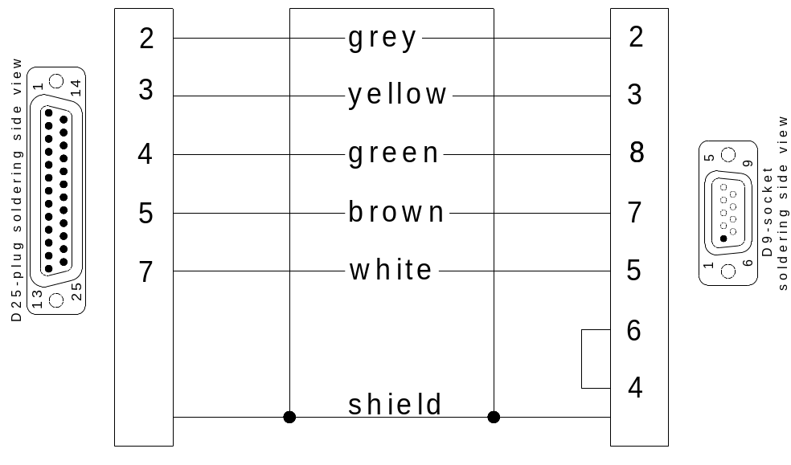

CAUTION! Connect the shield on both connector frames.
Gas flow diagram:
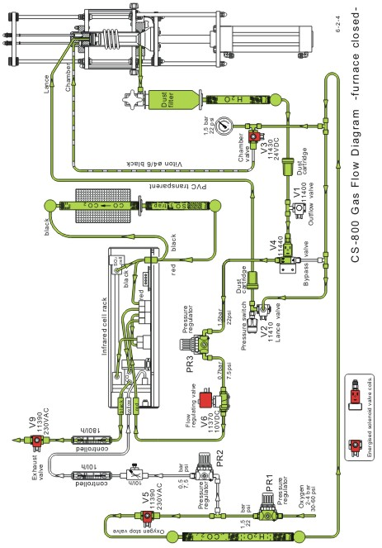

Gas flow diagram:
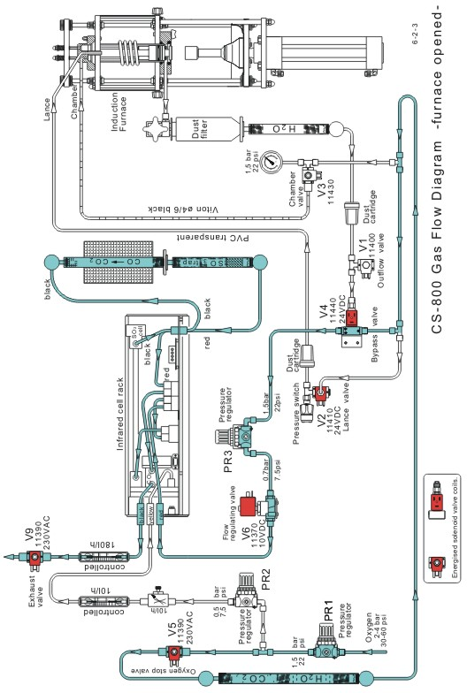

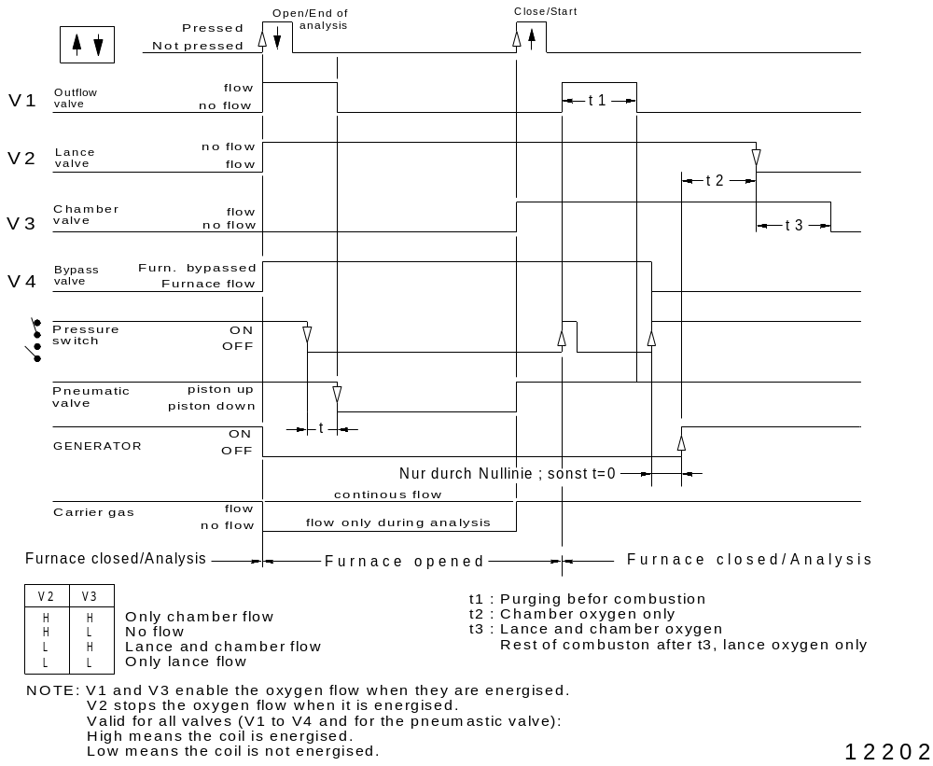

Low = de-energised ( Zero volts on the coil )
High = energised ( 24 V DC on the coil )

Opening and closing of the furnace, sequence:
( Please refer to above drawing )
Opening the furnace:
At the moment when the key is pressed to open the furnace,
V1, V2 and V4 are energised.
V1 releases the oxygen out of the furnace.
V2 stops the oxygen supply to the furnace.
V4 keeps the oxygen flow to the IR-cell, bypassing the furnace.
About one second later, the pressure in the furnace drops lower than one bar ( 15 psi ) so that the pressure switch opens ( no contact any more )
resp. 24V DC between its two leads.
After a short delay produced by the software, thus allowing sufficient time for the oxygen pressure in the furnace to fall practically to zero, the pneumatic valve is de-energised, causing the piston to move down, opening the furnace.

Closing the furnace:
By pressing the key to close the furnace, the pneumatic valve is energised and the piston moves up. At the same time V3 is also energised, letting oxygen into the furnace area from the top and from the bottom ( through the dust filter ).
Before the furnace closing cone reaches the O-ring to seal, the oxygen which enters the furnace area escapes, purging the air out of the furnace. After the cone seals the furnace, the incoming oxygen leads to a growing pressure in the furnace.
When this pressure reaches approx. one bar ( 15 psi ) the pressure switch will close
( zero volts between its two leads ).
After a short delay by the software, V2, V3 and V4 will be de-energised.
The closed furnace condition is now reached.
Analogue I/0 signals of the electronic unit:

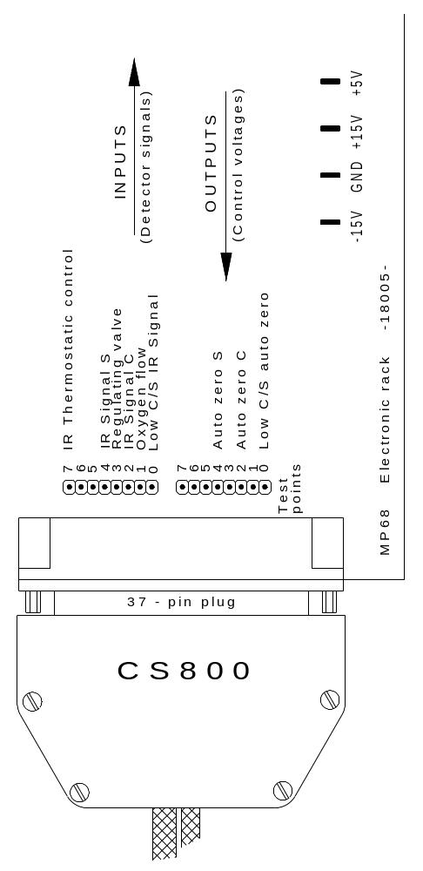

4.3 Starting through external key:

The analysis can be started by means of an external connected key, if desired.

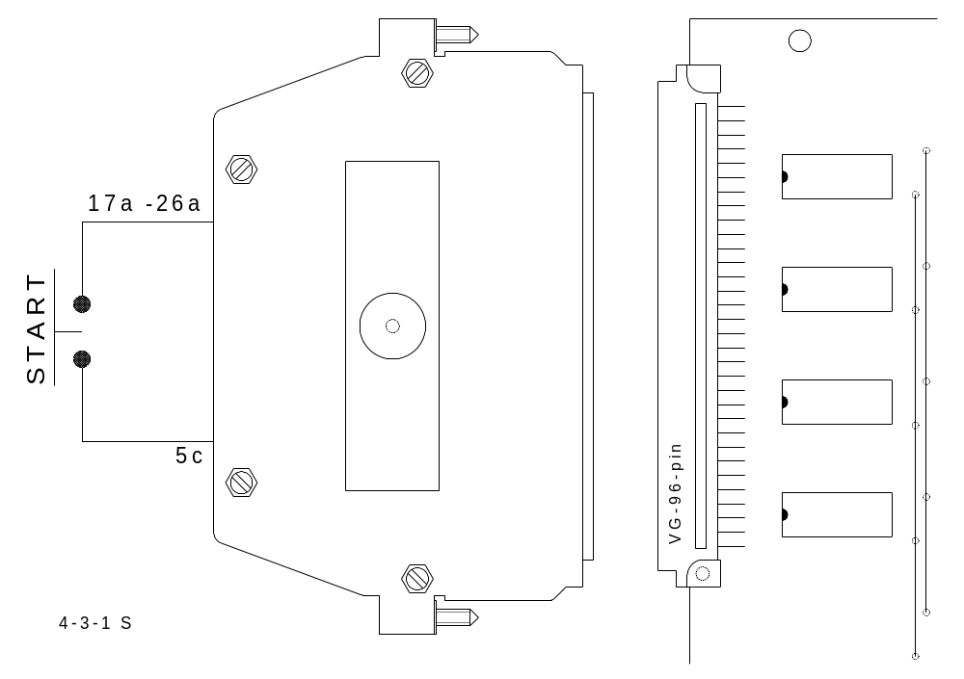

- The key is connected to a 96-pin connector on the rear-side of the electronic unit.
For this purpose, remove the case of the 96-pin plug and connect a wire to the key
( pins 17a to 26a ). ( All carry +24 volts )

- The second wire is connected to pin 5C.

4.4 External report of analysis conditions:

The analysis is running; while the word "ANALYSIS" stands on the display; the pin 24B on the 96-pin connector on the rear-side of the electronic is switched to zero.

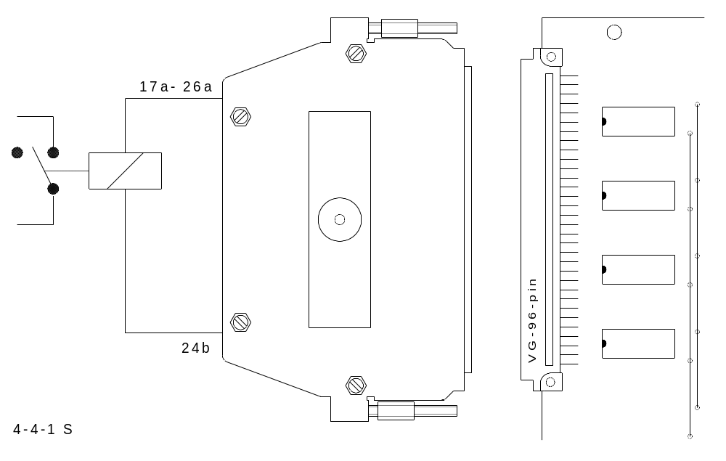

One could, for example, attach a 24 V relay in order to receive a potential-free
contact message that an analysis is underway.

- The relay is attached to the 96 - pin connector, on the rear-side of
the electronic unit. To do this, remove the cover of the 96-pin
connector and attach a relay wire to 17a to 26a
( all carry +24 volts ).

- The second wire is attached to pin 24B.

4.5 Spare parts kits:

Common spare parts kit for all analysers

92610 Tube of grease 1
11064 Reagent tubes 280mm x 16mm 2
11480 Adjustable flow restrictor 1
15087 Gasflow meter 300 l/h 1
15095 Gasflow meter 600 l/h 1
18175 Electronic unit 1
72010 Pressure gauge 2,5 bar ( 37.5 psi ) 1
11035 Cooling fan 1
11492 Inlet pressure regulator 1
11390 Oxygen solenoid valve 1
35310 Pressure switch 1
05067 IR path for high carbon 1
05068 IR path for sulphur 1
05150 IR path connector with window source side 1
05160 IR path connector with window detector side 1
05260 IR path tube (80 to 320 mm) 1
05275 Infrared preamplifier 1
06005 Infrared electronics board IR 21 1
06741 Infrared electronics board IR 41 1
06032 Infrared detector with CO₂ filter 1
06034 Infrared detector with SO₂ filter 1
06421 Infrared power supply assembly IR13 1
06675 Infrared power supply assembly IR45 1
06058 IR Temperature control board TH61 1
06630 IR Temperature control board TH62 1
15037 IR Temperature regulation board NR32 1
11408 Pressure switch 1
15063 Gasflow sensor 300 l/h 1
05042 Chopper motor 1
05065 Chopper motor 1
05048 Infrared source ( emitter ) 1
05060 Reflector 1
75120 Spring 1
75130 Retaining washer 1
75190 Washer 1
18150 Printer interface-cable 1
18160 Balance interface-cable 1
18171 PC-cable 1
73020 Tube transparent 5m
73030 Tube black id = 4 od = 5 5m
73040 Tube black id = 6 od = 9 1m
90290 Copper oxide 100g
11062 Reagent tubes 160 x 16mm 2
21120 Quartz tube for purification furnace 1
15083 Gasflow meter 15 l/h 1
72020 Gauge 10 bar/140 psi 1
78010 Mains power switch 1
11380 Pneumatic valve 1
16110 Power supply board NK 32 1
77140 HF-filter 250 V 1
15098 Gas flow control board FC 21 1
71004 PLOTON Windows software ( for OH/ON 900 ) 1
71006 PLOTCS Windows software ( for CS 500/800 ) 1
70280 O-ring 18 x 2 VT for chopper motor 2
70330 O-ring 21 x 2 VT for infrared source 6
70120 O-ring 3.4 x 1.9 VT furnace cleaning rods
( CS 800 )and for furnace platform 1
70150 O-ring 6 x 2.5 VT 1
70210 O-ring 8 x 3.5 VT for catalyst tube ( CS 800 )and
for reagent tube ( OH/ON 900 ) 1
70230 O-ring 9 x 3 VT for reagent tubes and dust filter 1
70320 O-ring 20 x 5 VT for dust filter( CS 800 ) and for
furnace glass tube ( CS 500 ) 1
70350 O-ring 29 x 5 VT for dust filter ( CS 800 ) 1
70370 O ring 34 x 3 VT for dust filter ( CS 800 ) 1
70380 O-ring 35 x 5 VT for combustion tube ( CS 800 )
and for furnace internal ( CS 500 ) 1
70390 O-ring 38 x 5 VT for furnace ( CS 800 ) 1
70285 O-ring 19 x 3 VT for furnace ON/OH 900 ( top ) 1
70405 O-ring 47.2x 5.7 VT for furnace closure ON/OH 1
70410 O-ring 48 x 3 VT for furnace internal ( CS 500 ) 1
70415 O-ring 62 x 3 VT for furnace ON/OH 900 (centre) 1
70425 O-ring 90 x 2.5 VT for furnace ON/OH ( bottom ) 1

Spare parts kit for CS-800

90220 Tungsten 2500g
90260 Iron chips 908g
91300 Steel standards (advice %C and %S) 100g
91600 Cast iron standards (advice %C and %S) 100g
92200 Alloy steel standards (advice %C and %S) 100g
11105 Metal dust filter 1
11180 Dust filter cartridge 2
11185 Paper filters 10
13067 Combustion coil 1
14045 Cleaning brush for combustion tube 1
14130 Combustion tube l=145 id=32 od=36 mm 2
77210 Oscillator tube 1
14072 Ceramic heat shield for brush 1
14168 Pedestal 1
20040 Catalyst tube 200 x 16mm 1
80925 Sets of fuses 3
11115 Plastic tube 75mm
11120 Paper filter holder 1
11370 Gasflow regulating valve 1
11400 Pressure outlet solenoid valve 1
11410 Oxygen stop solenoid valve 1
11430 Purge solenoid valve 1
11440 Bypass solenoid valve 1
11470 One way valve 1
12005 Gasflow and furnace control board HF3 1
12016 Gasflow and furnace control board HF42 1
12080 Rectifier 1
77050 Triac 1
77135 Capacitor 2µF for blower (at the generator unit) 1
13175 Insulator 1
13260 High voltage filter 1
77337....10V/10A filter 2
13270 Resistor 1
77320 Capacitor 100 pF/30KVA 1
13262 Capacitor 700 pF/40KV 1
77350 Capacitor 1µF/50V 2
77600 Grid resistor 1
77610 Resistor 1
14080 Cleaning mechanism rod 1
75122 Spring 1
75130 Safety ring 1
20000 Catalyst furnace 1
11490 Pressure regulator 1
15116 Gas flow sensor 1

4.6 Maintenance CS 800:

Is the furnace closure cone still firm? See 2.8
Check whether the imprint of all the O-rings exceeds 2 mm.
Is the inlet pressure regulator set on 1,5 bar ( 22.5 psi )?
Are the other two pressure regulators set on 0,35 bar ( 5 psi )? See 2.7
Check for leaks. See 3.7
Is the gas flow rate correct? See 2.1
Pressure switch: change over at___________ bar. See 2.2
Does the thermostabilisation work correctly? See 2.5
Check the infrared baseline. See 2.3
Check if all the screws of the generator housing are tightened.
Check whether all four „high voltage“ stickers are still in place.
Check if the 96-pole plug at the back of the CS 800 is firmly plugged in.
Check if all the warning labels are still attached to the side-panels.
Calibration of all measuring ranges.

