Flow problems at CS-800 and CS-2000

Close the piston (F2)
Log in a power user by clicking on Start Uni, or from Programs, Uni, Start Uni
Click on "Password", enter "etna"

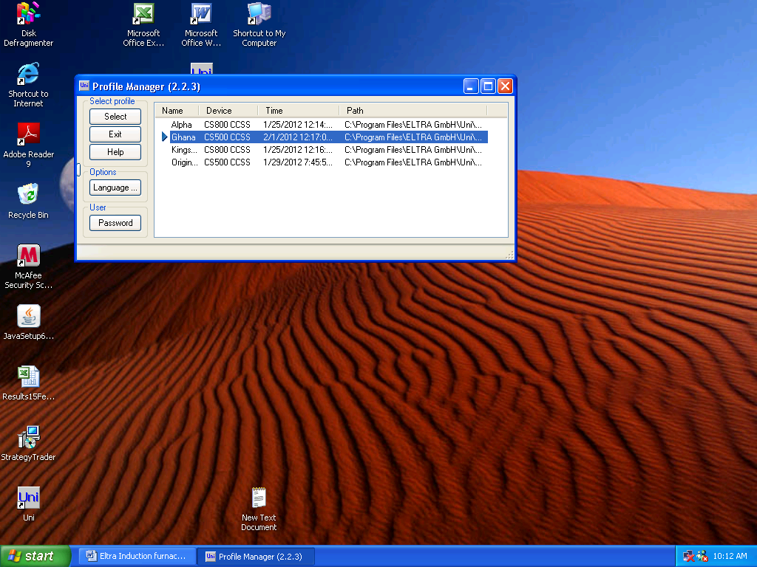

Enter the password

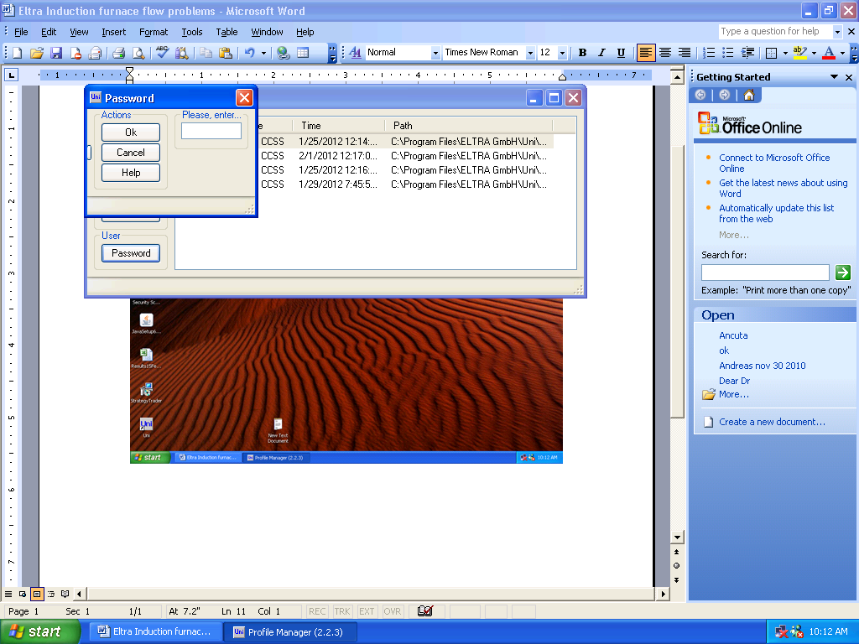

Open Device State Window

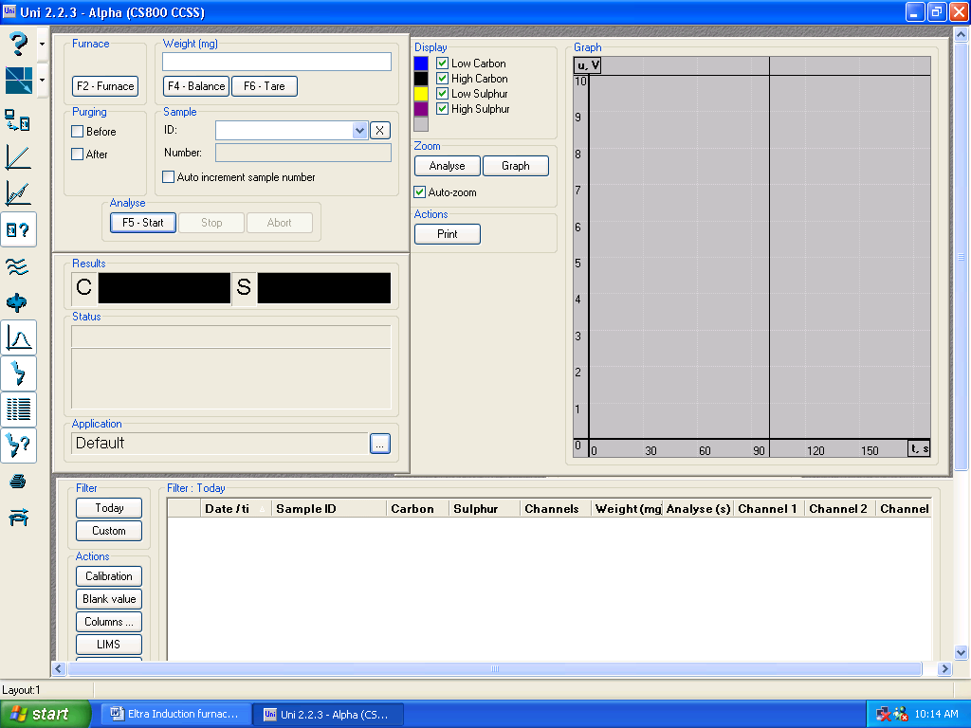
Device state
Configuration

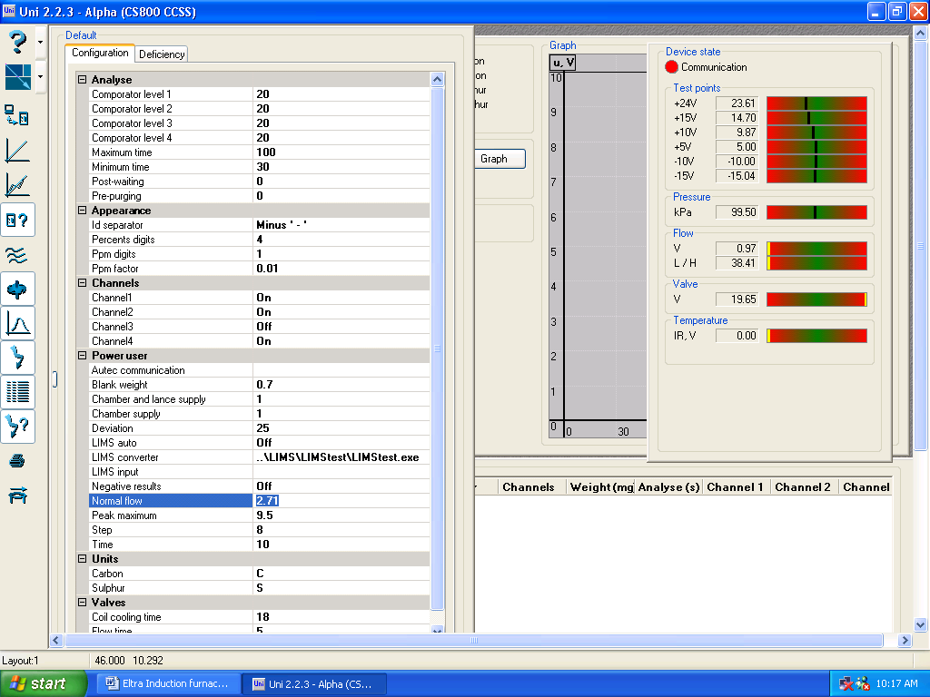
The flow in litres/hour, needs to be 180 l/h
Select this number and then adjust the voltage up and down until you see the flow in the right window, reach 180 l/h, +-5

When you're done, just click on the two icons Configuration and Device State and the two windows will close. Then start using the instrument.

