Changing the Com Port
You can start from the Start menu, and this Uni icon is different from the one on the screen, you have the option to enter the password

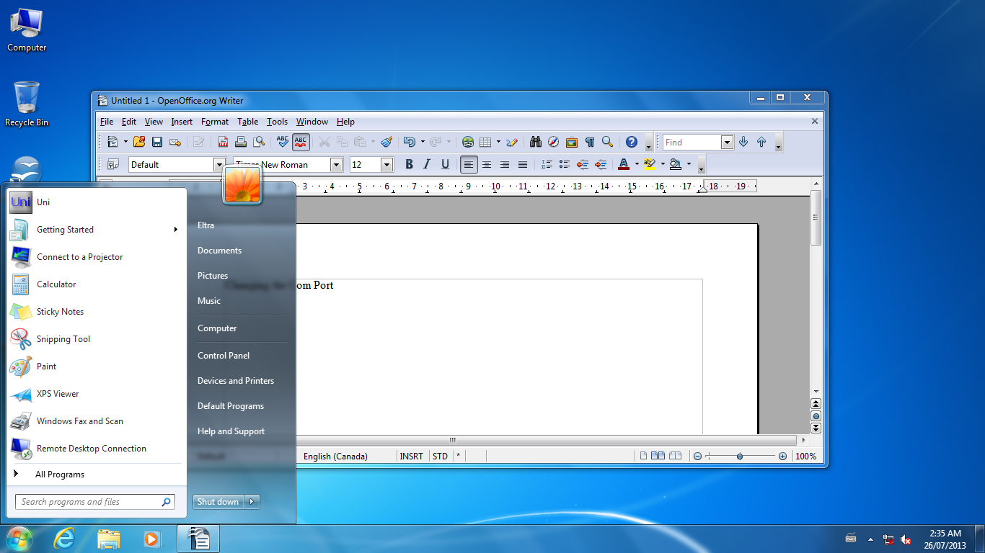

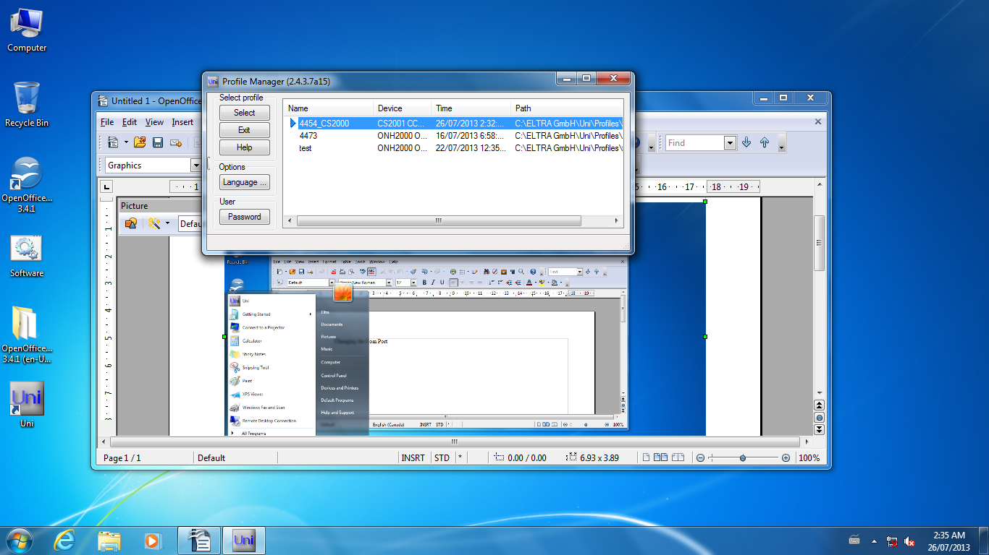

Also, you can start from AllPrograms, click on Eltra Gmbh..., and this Uni icon also will give you the option to enter a password...
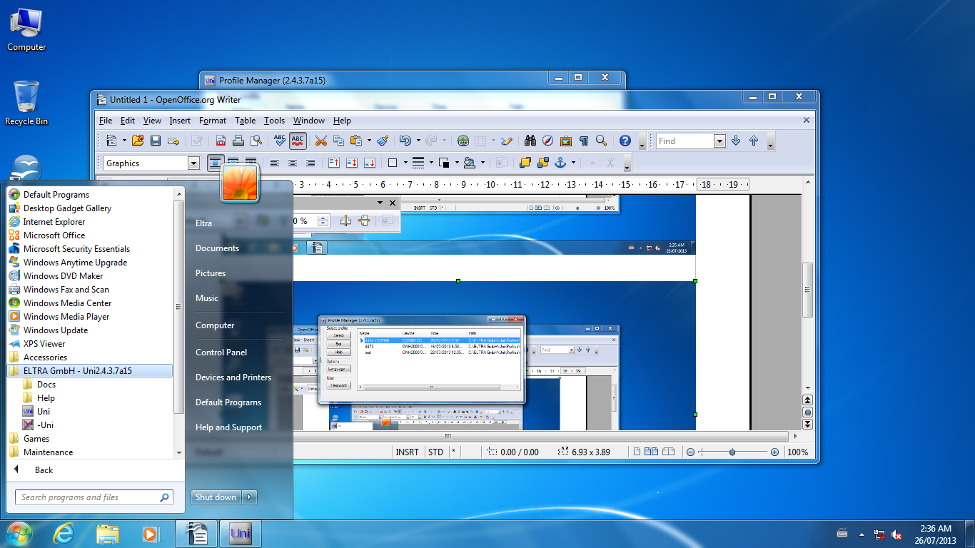

Go to the folder where uni is installed, find the folder Profiles, and copy all the profiles on a USB memory stick.
Then change the PC, install two serial ports ( Dual serial PCI, ex made by Lava http://lavalink.com/ ).
Install the Uni software downloaded from our Web, and copy the profiles from the stick into the Profiles folder on the new PC .
Log in as a power user ( start Uni from Start menu, not the one on the screen ), use password etna. Change the com ports according to the installed card. ( one for the instrument and one for the Balance ).
Then start the Uni software normally.

this is the card I have installed already many times and it worked well..

http://lavalink.com/products/pci-bus-io-cards/

DSerial-PCI (PCI 2 port RS-232)

I would buy 2 or 3, just in case...

Do not use the serial port on the motherboard, if there is any one installed already (chances are, that on a new computer, there are none anymore).

Let me know how it goes.

